**Lab manual**

**Roll Number : info-Tech-15024**

**Subject : Database Systems**

**Submitted to : Ma’am Samia**

**Submitted by : Wafa Zainab**

**Task 1: ERD Diagrams Lab exercises.**

**Question 1:**

The Company sells a number of different furniture products. These products are grouped into several product lines. The identifier for a product is Product ID, while the identifier for the product line is Product Line ID. Referring to the customer invoice, we identify the following additional attributes for product: Product Description, Product Finish and Unit Price. Another attribute for Product line is Product Line Name. A product line may group any number of products but must group at least one product. Each product must belong to exactly one product line. Customers submit orders for products. The identifier for an order is Order ID, and another attribute is Order Date. A customer may submit any number of orders or may not submit any orders. Each order is submitted by exactly one customer. The identifier for a customer is Customer ID, and other attributes include Customer Name and Customer Address. A given customer order must request at least one product. Any product sold by Pine Valley Furniture may not be requested on any order, or may be requested one or more orders. An attribute associated with each order and product is Quantity, which is the number of unit is requested.

**Question 2:**

Assume you have been contracted by a university to develop a database system to keep track of student and accommodation records. The university courses are offered by facilities. Depending on the student’s IQ, there is no limitations to how many courses a student can enroll in. The faculty are not responsible for student accommodation. The university owns a no of Hostels and each student is give a room key after enrollment. Each room has furniture attached to it.  
Draw the ERD diagram with the additional enhanced concept.

**Task 2: Create tables for students’ data of IT 5th whole record of previous semesters.**

**Design View:**

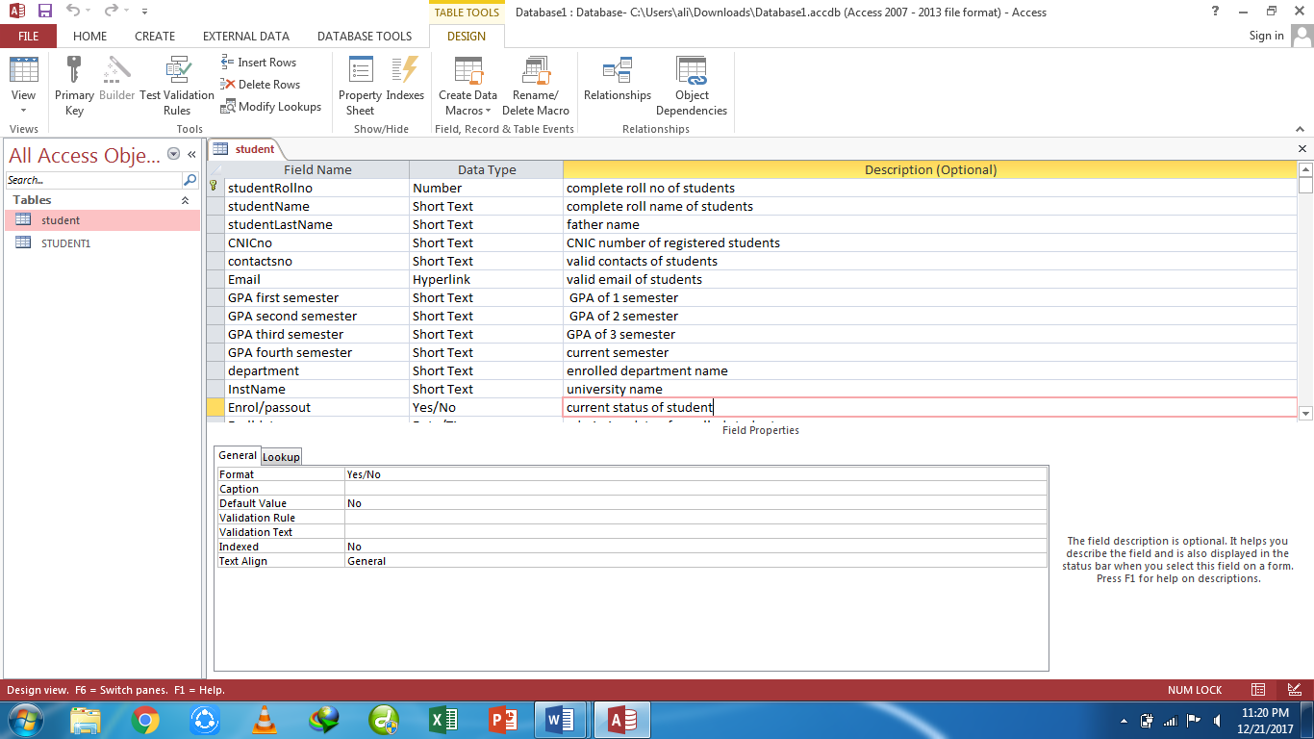

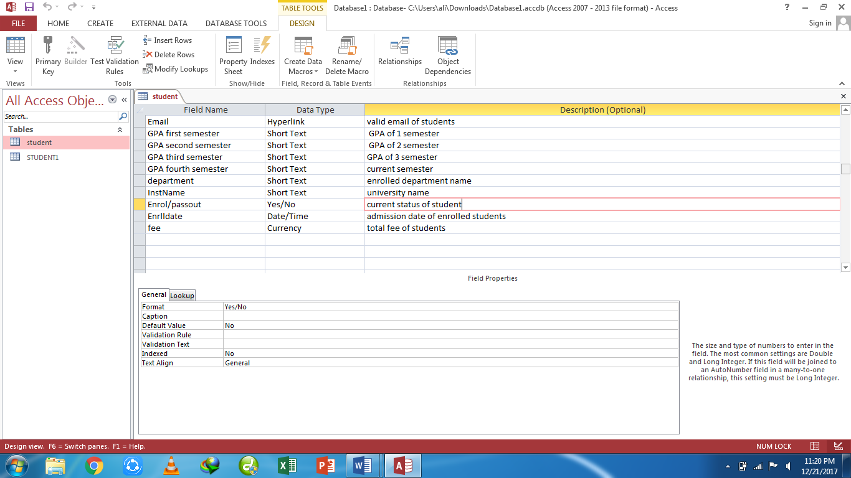

**Datasheet View:**

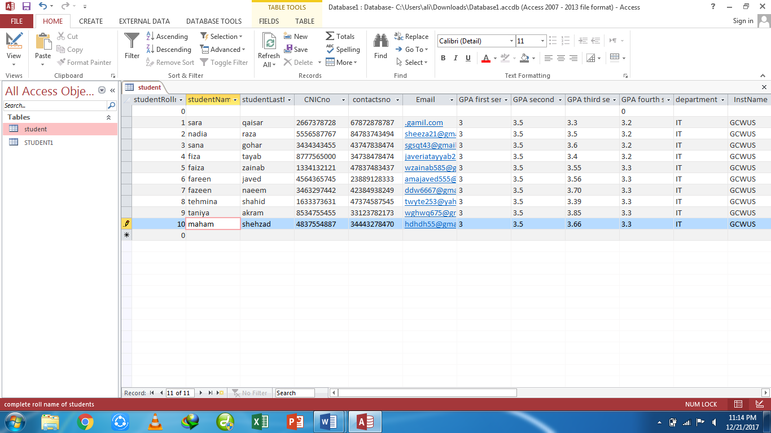

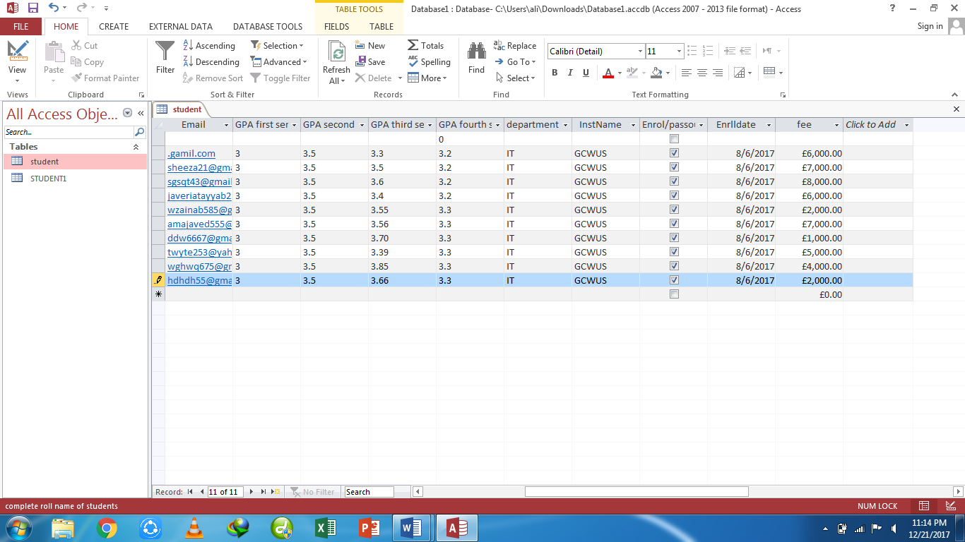

**Task 3: Airplane System.**

**Tables**

**Table1:** Airplane

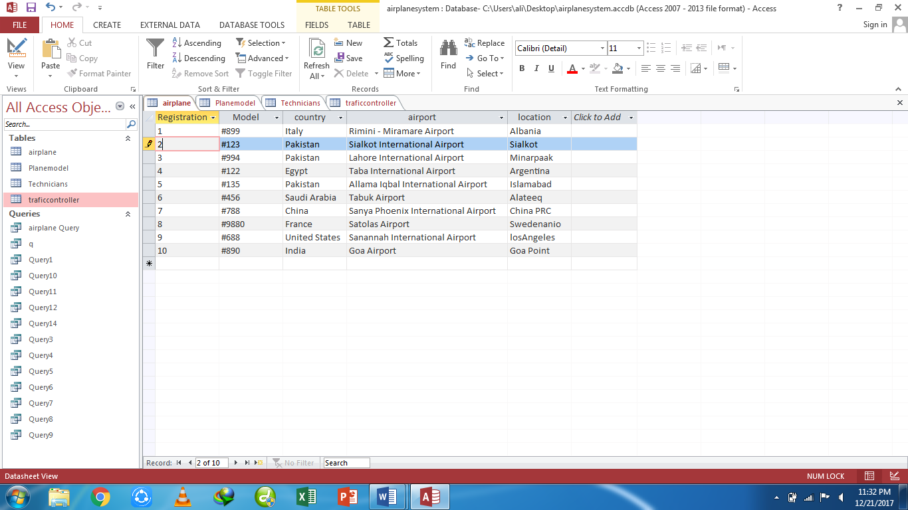

**Table2:** Plane model

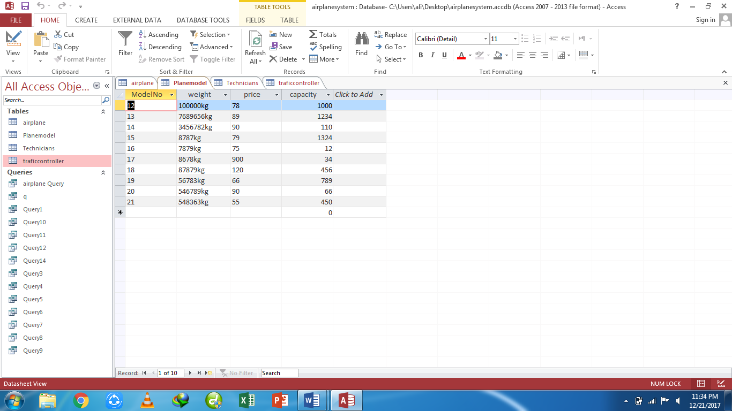

**Table3:** Technicians

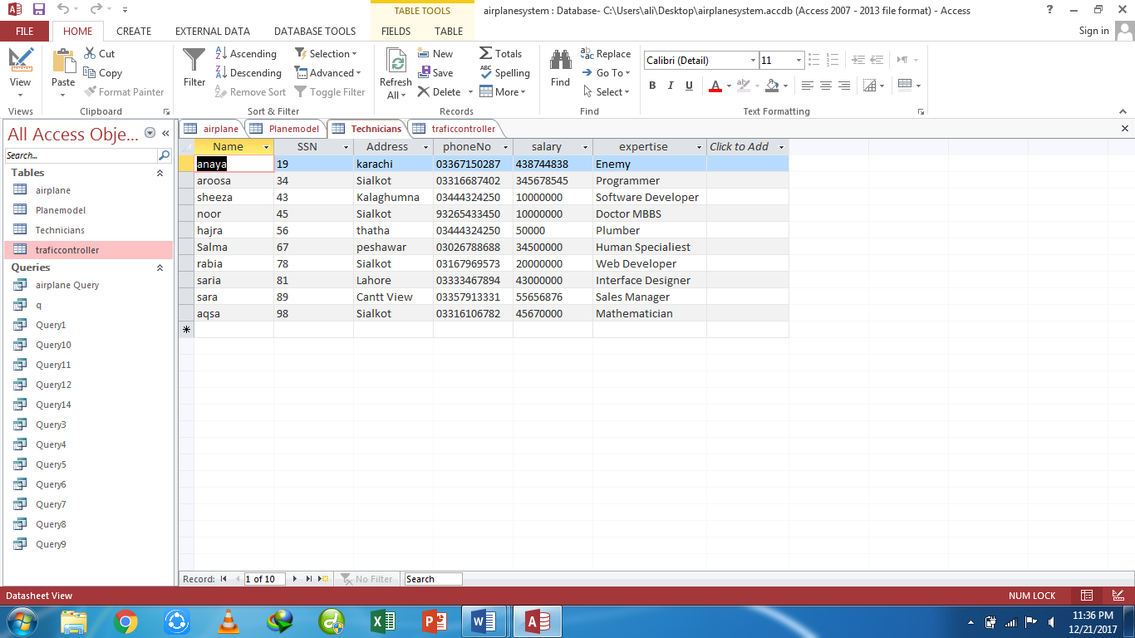

**Table4:** Traffic controller

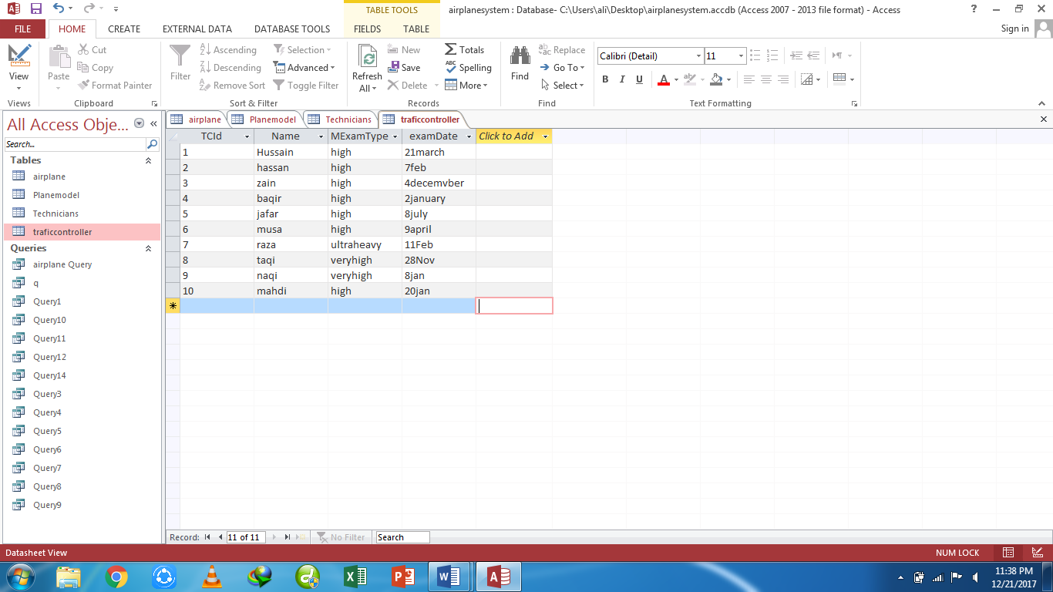

**Queries**

**Query1**- Display details of all airplanes.

**Design view:**

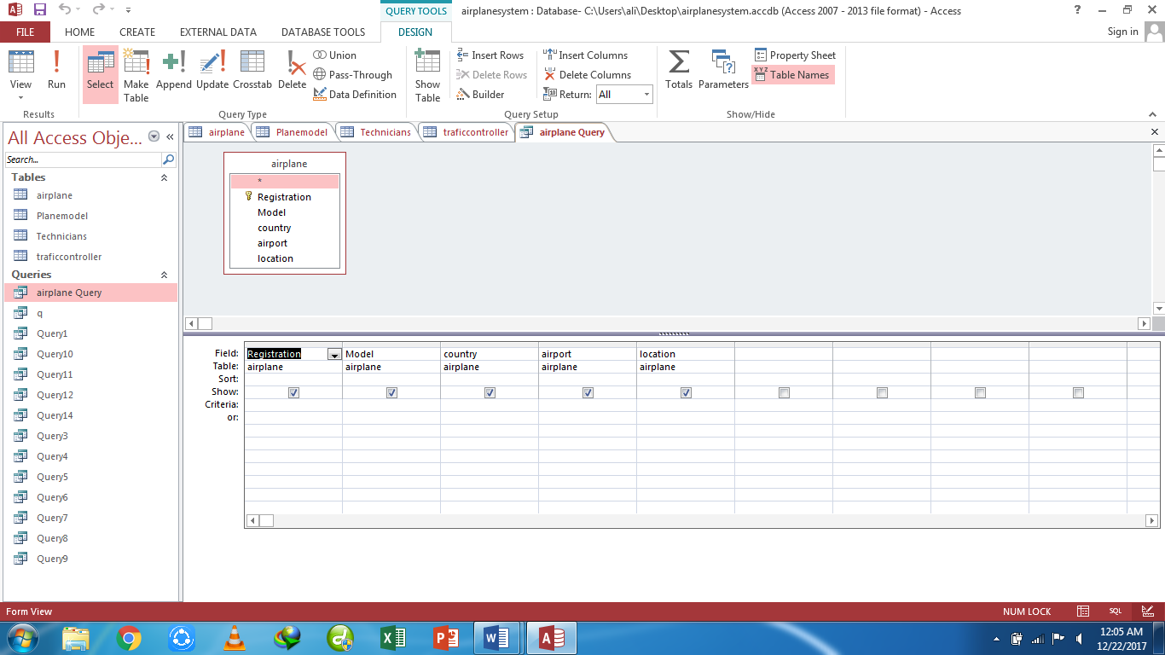

**Datasheet view:**

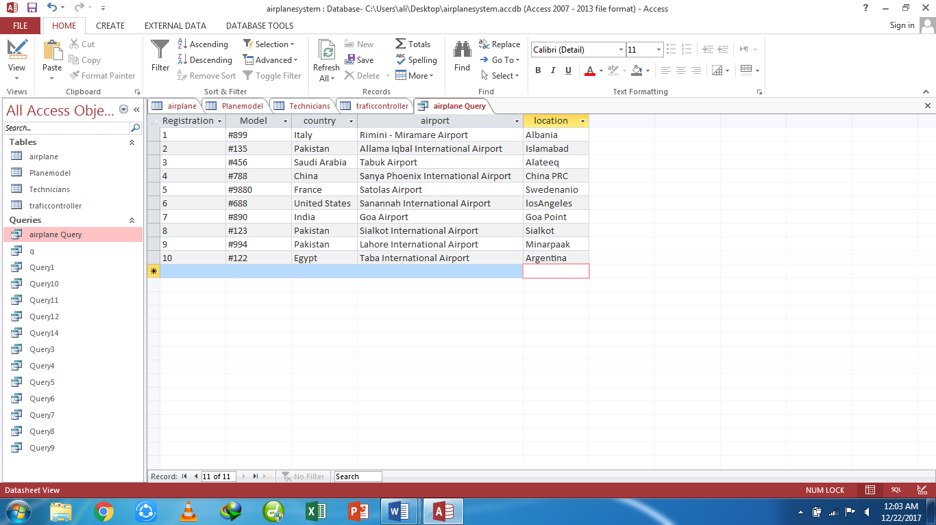

**Sql View:**

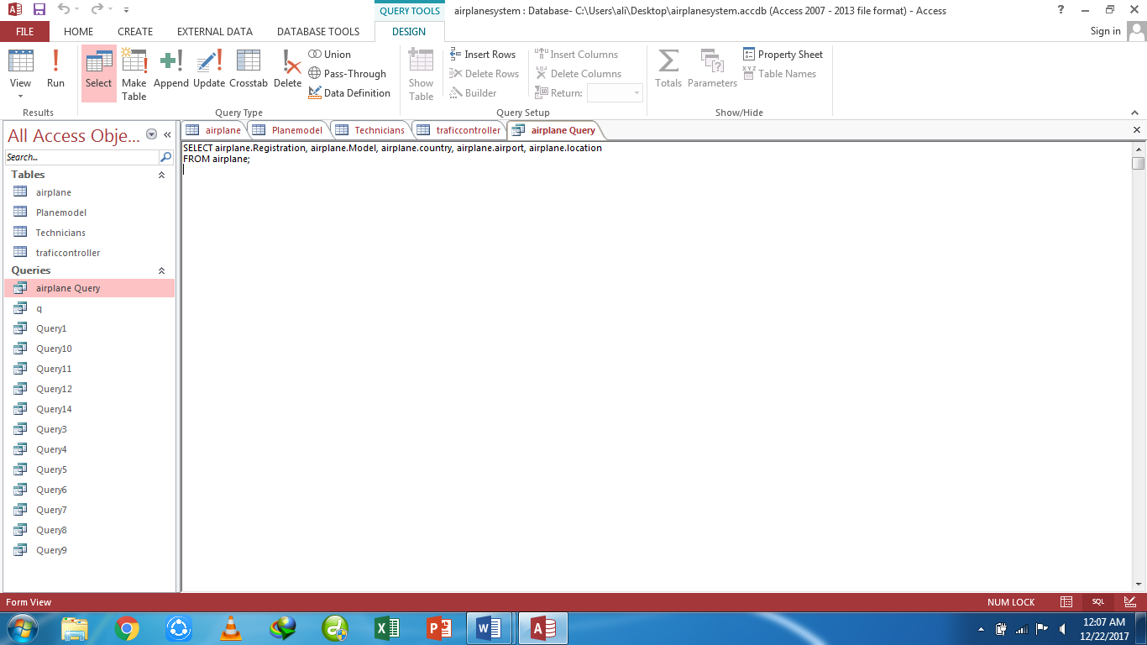

**Query2-** List detail of total exams conducted and exam type

**Design view:**

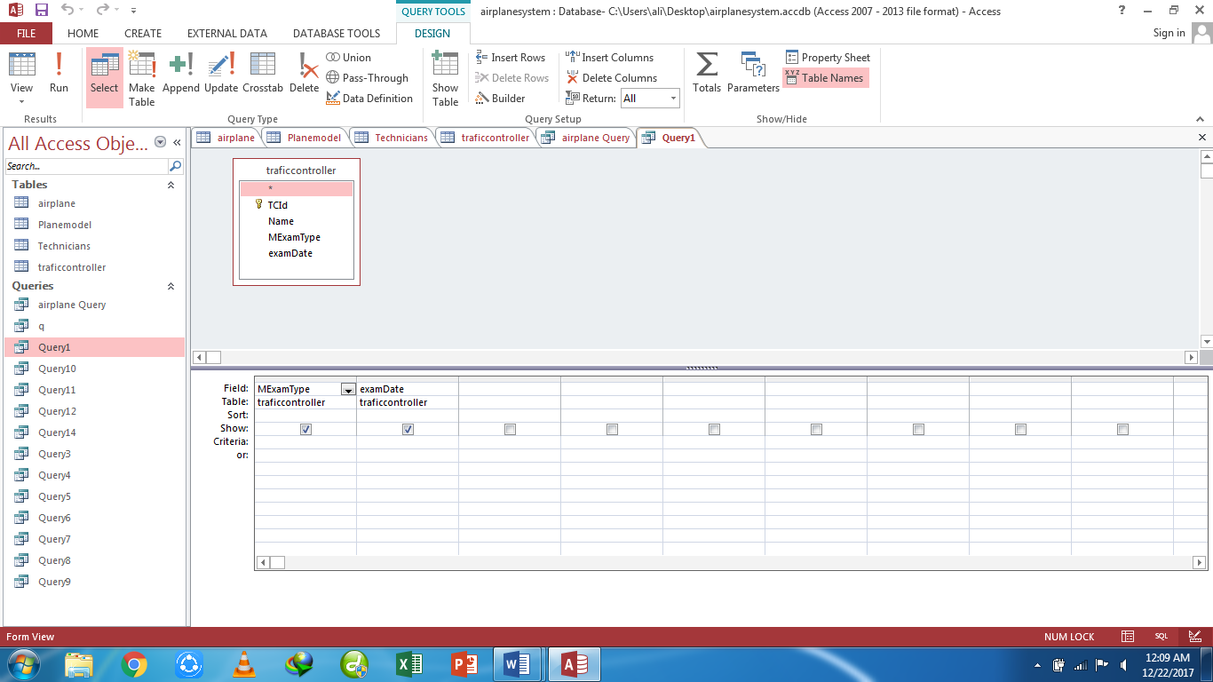

**Datasheet view:**

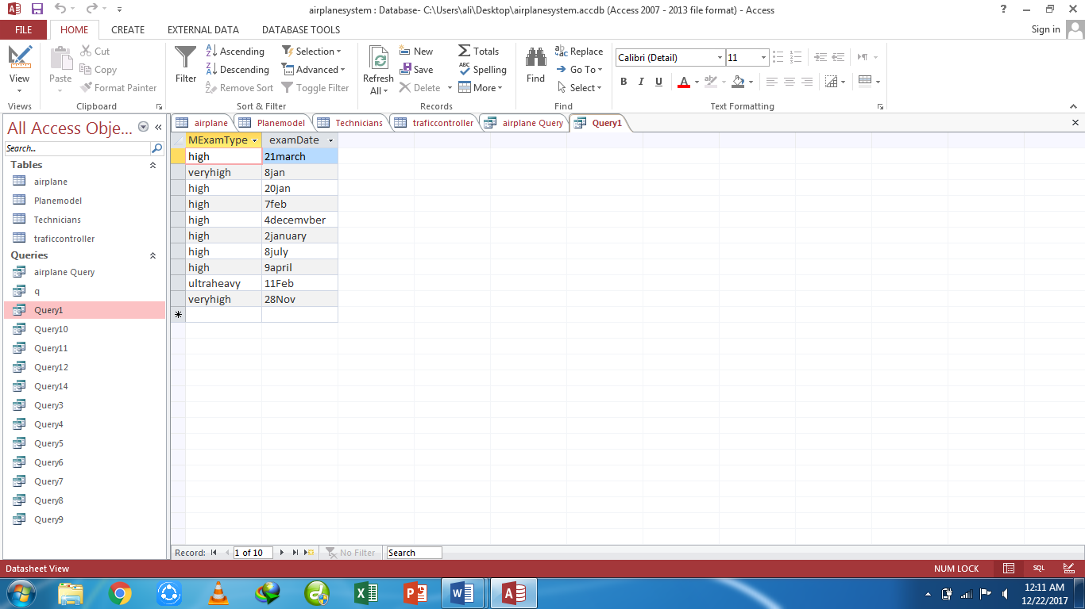

**Sql View:**

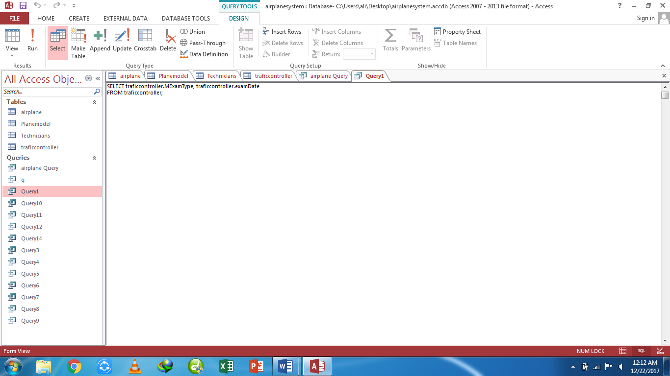

**Query3**- list model and price of all planes

**Design view:**

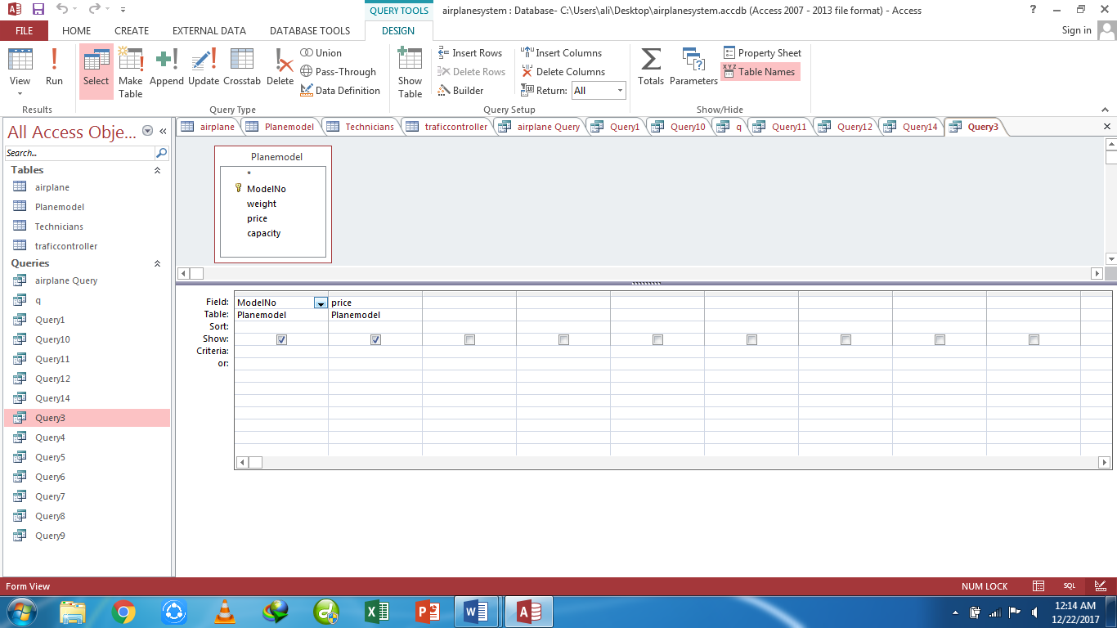

**Datasheet view:**

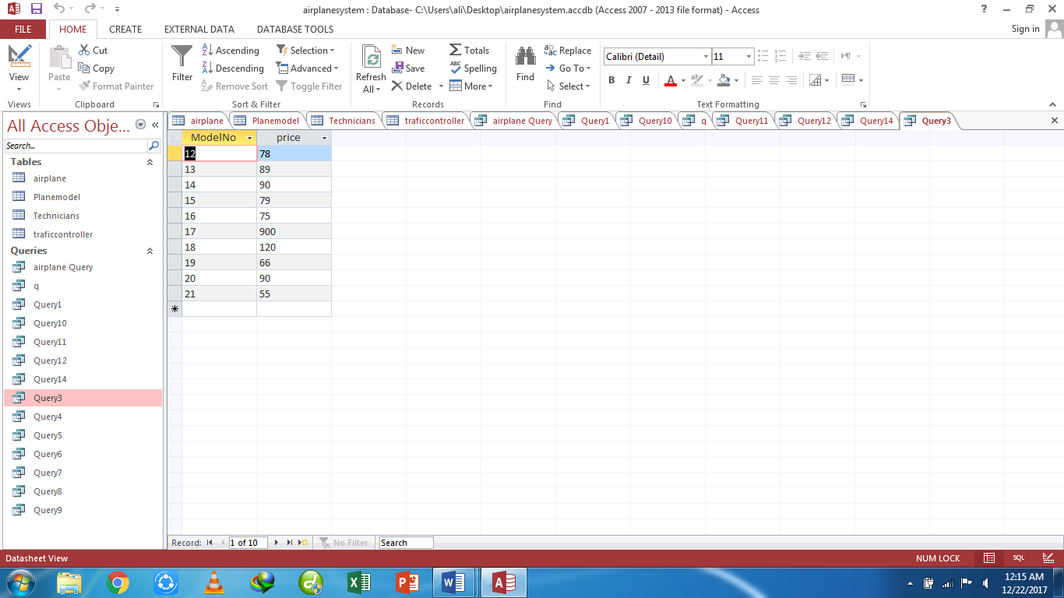

**Sql View:**

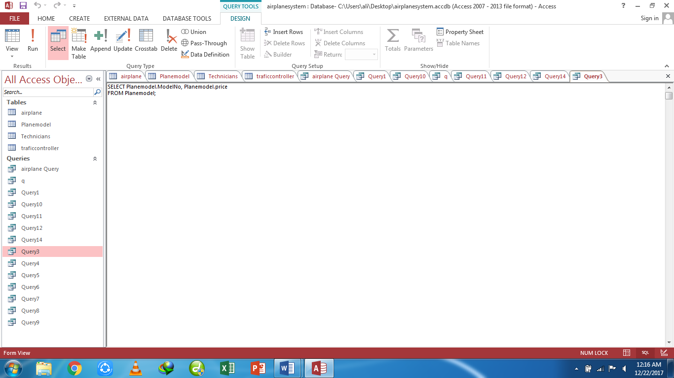

**Query4-** list price and capacity of all planes

**Design view:**

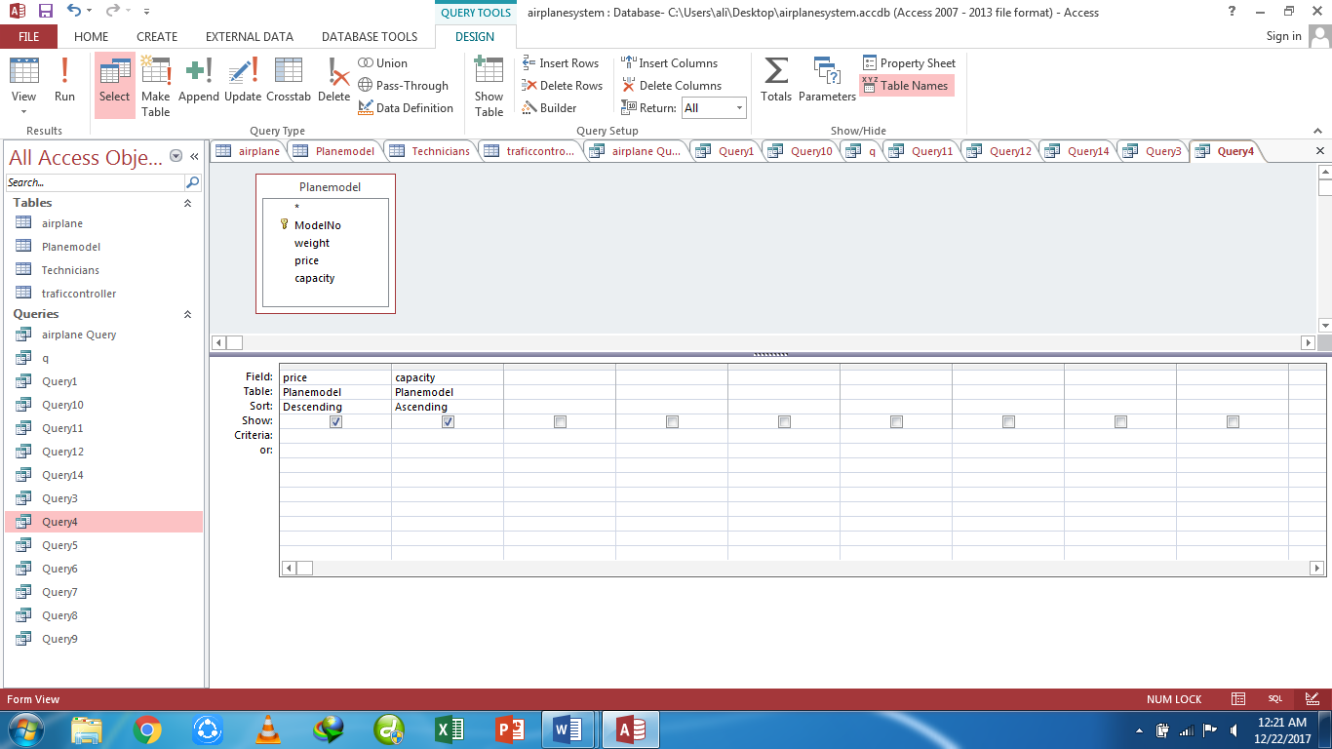

**Datasheet view:**

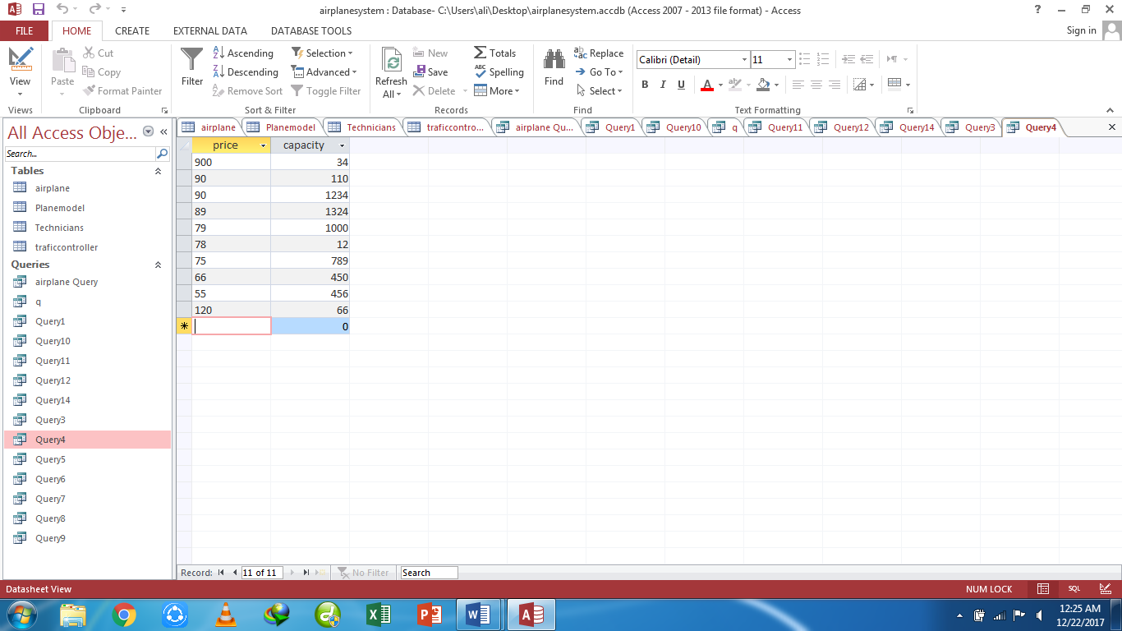

**Sql View:**

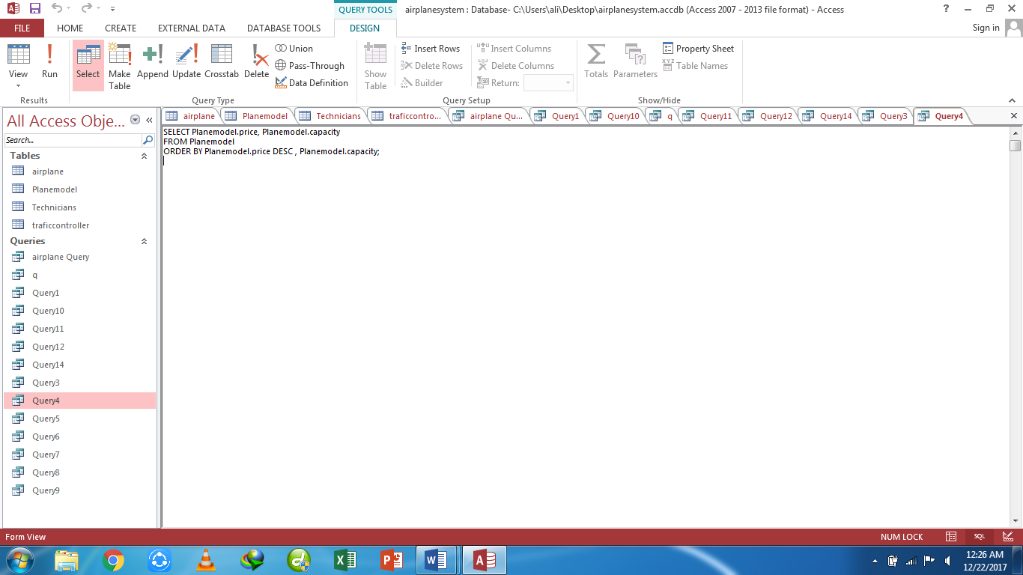

**Query5-** list those planes whose prices are between 20 and 80 millions

**Design view:**

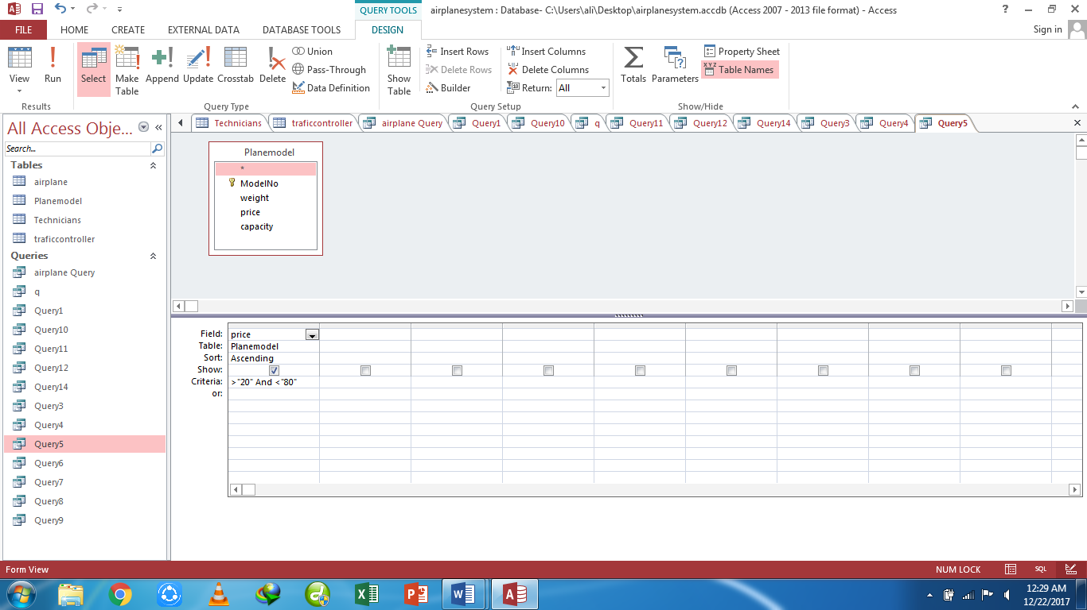

**Datasheet view:**

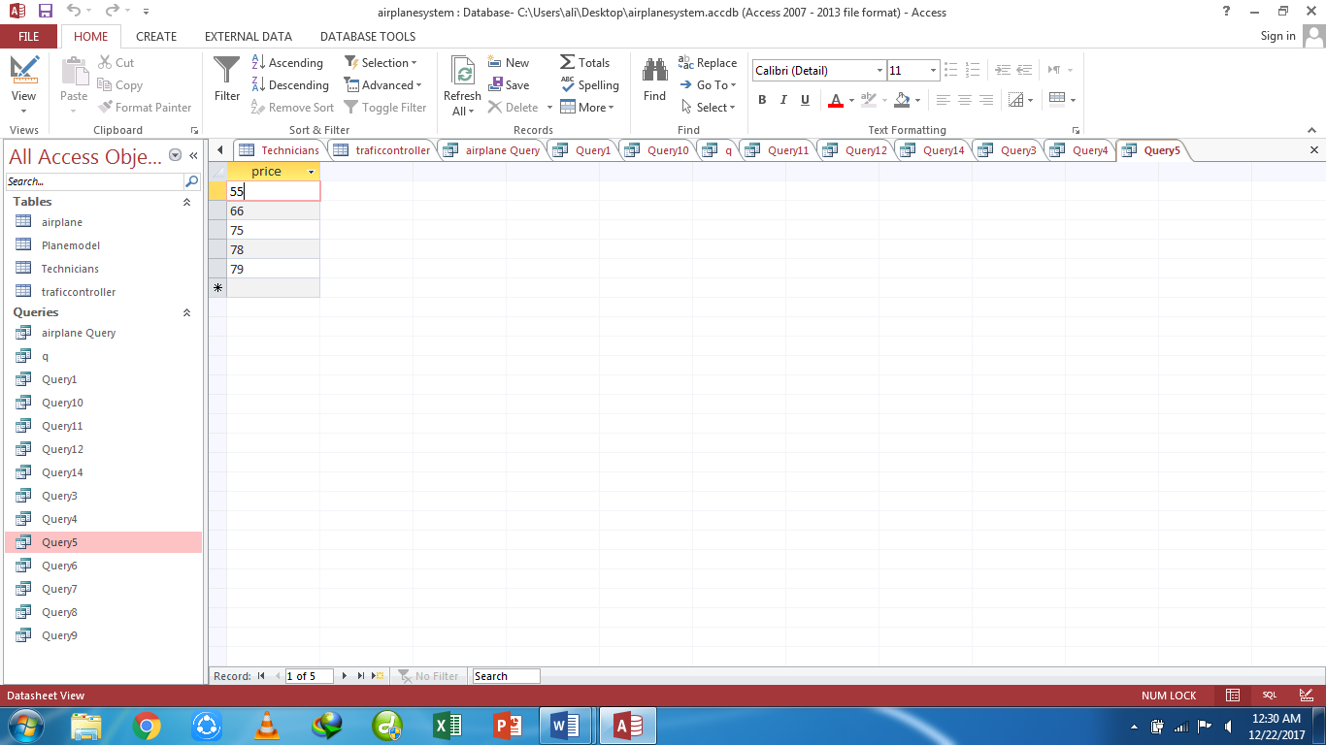

**Sql View:**

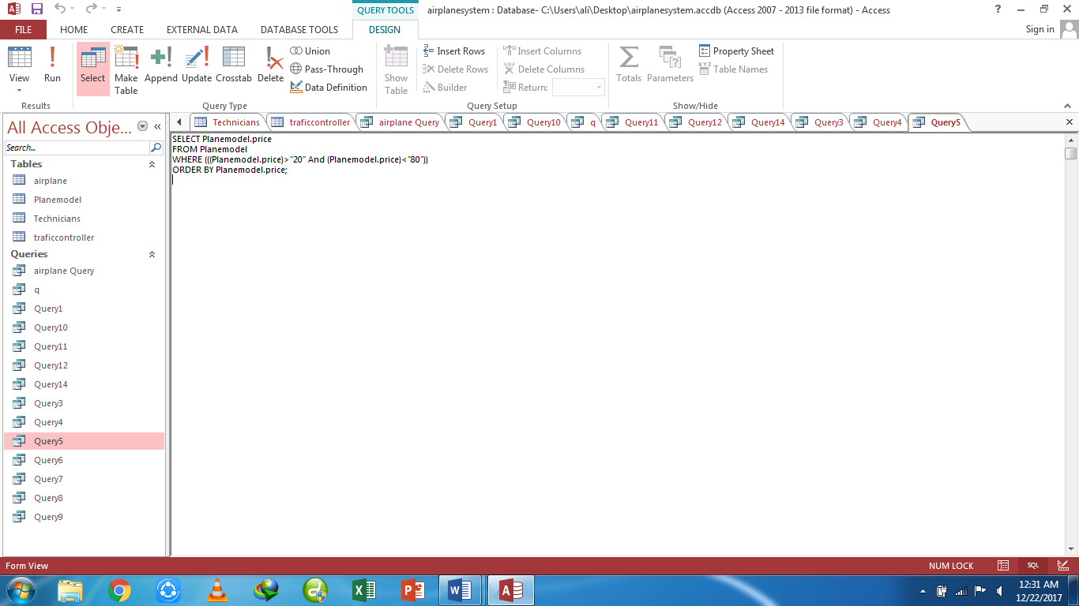

**Query6-** list total plane models

**Design view:**

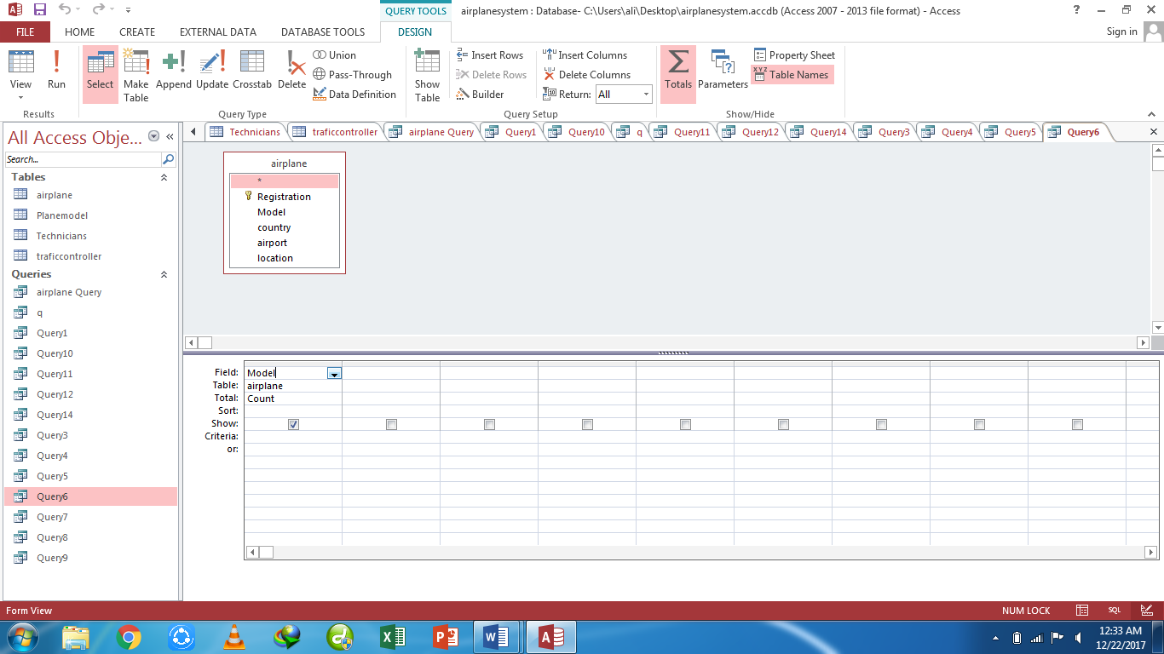

**Datasheet view:**

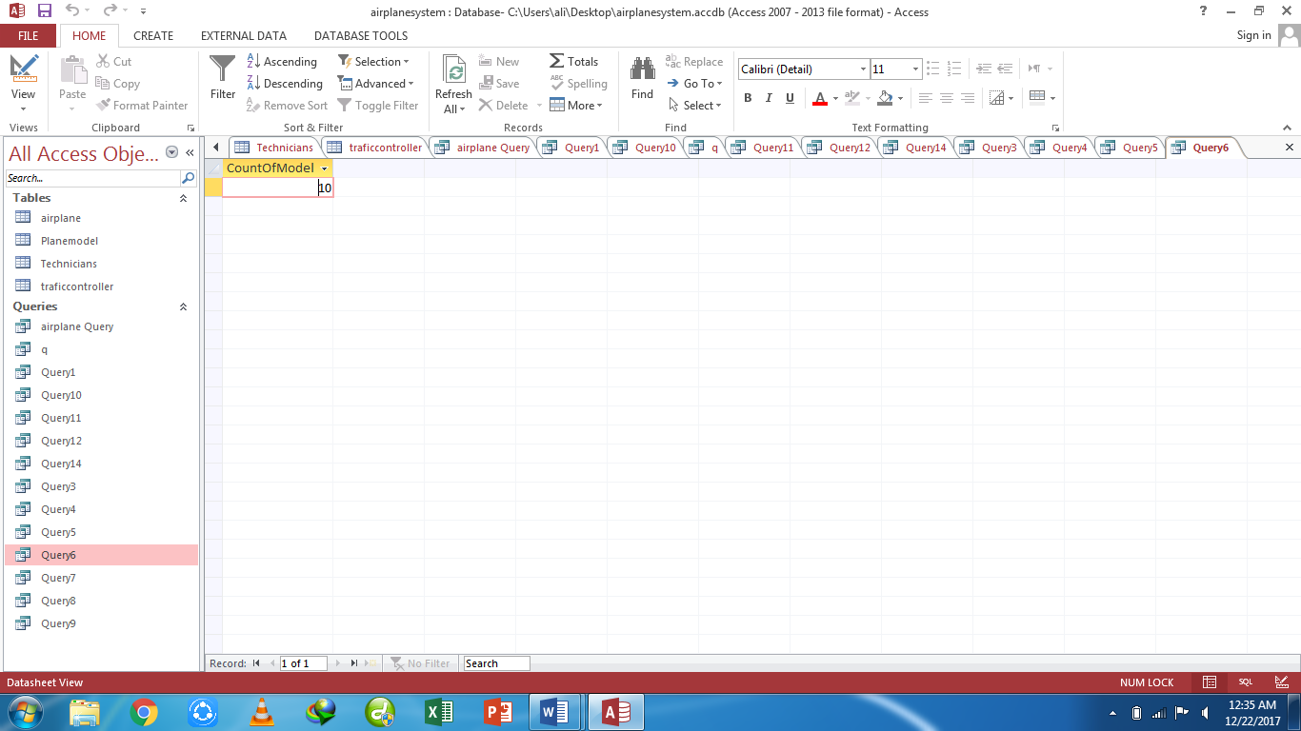

**Sql View:**

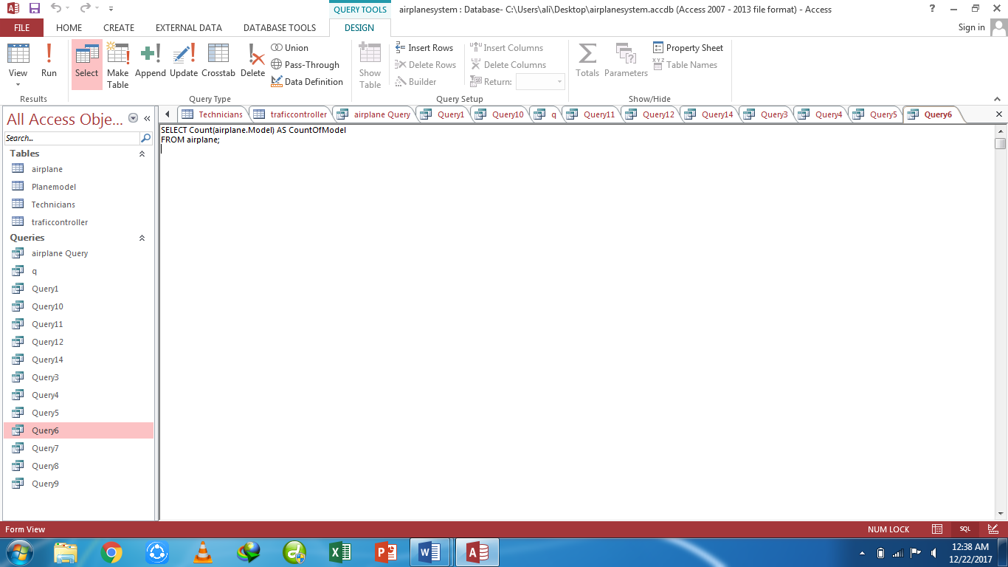

**Query7-** List average price of planes

**Design view:**

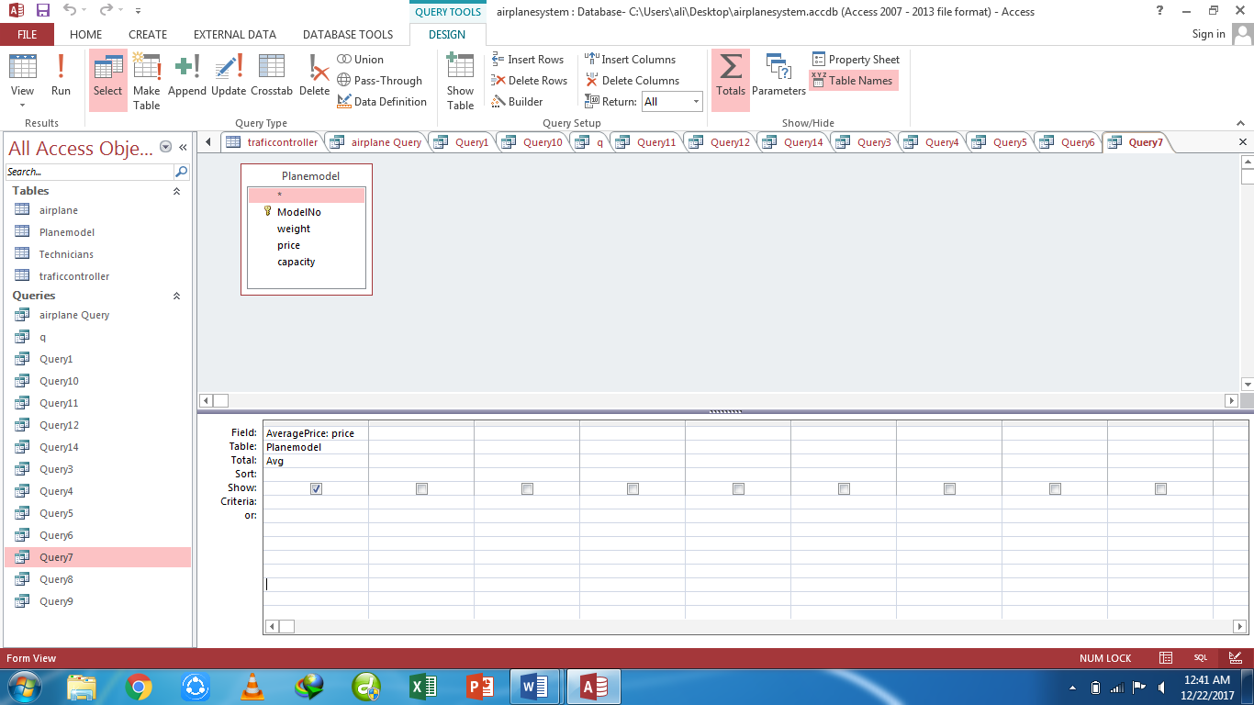

**Datasheet view:**

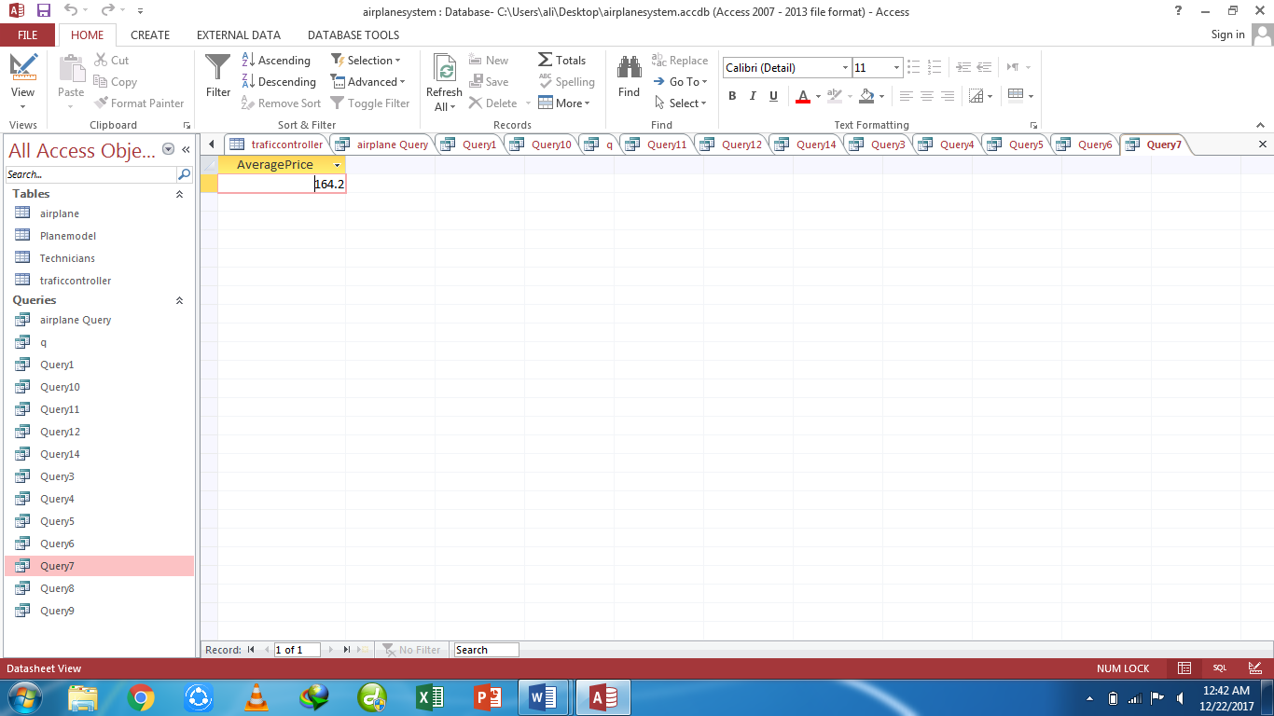

**Sql View:**

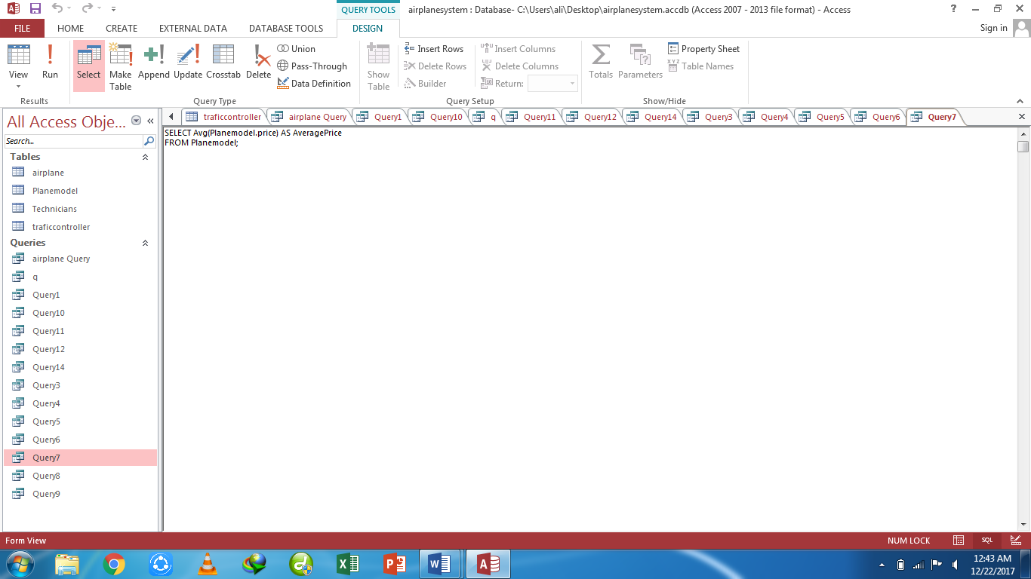

**Query8**- list number of total exams conducted

**Design view:**

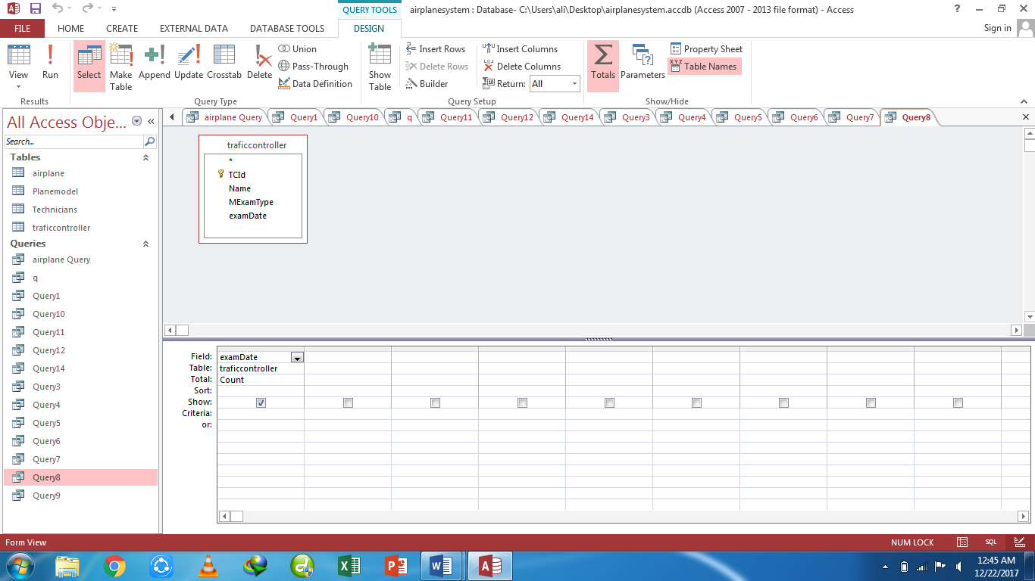

**Datasheet view:**

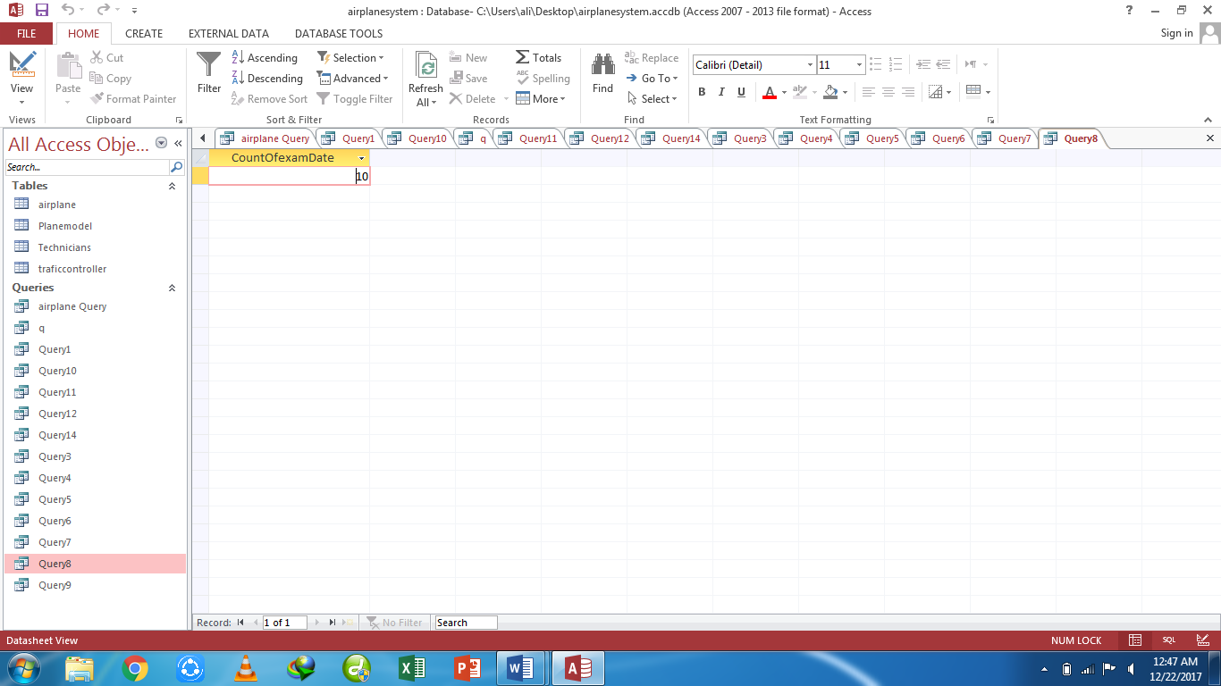

**Sql View:**

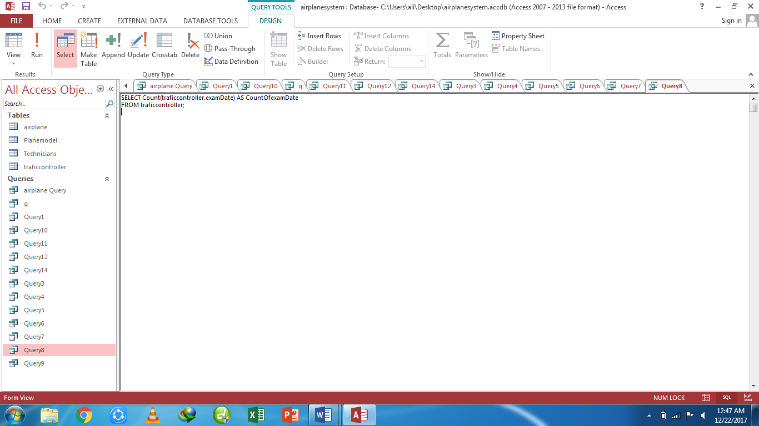

**Query9-** list the name of technicians from Sialkot

**Design view:**

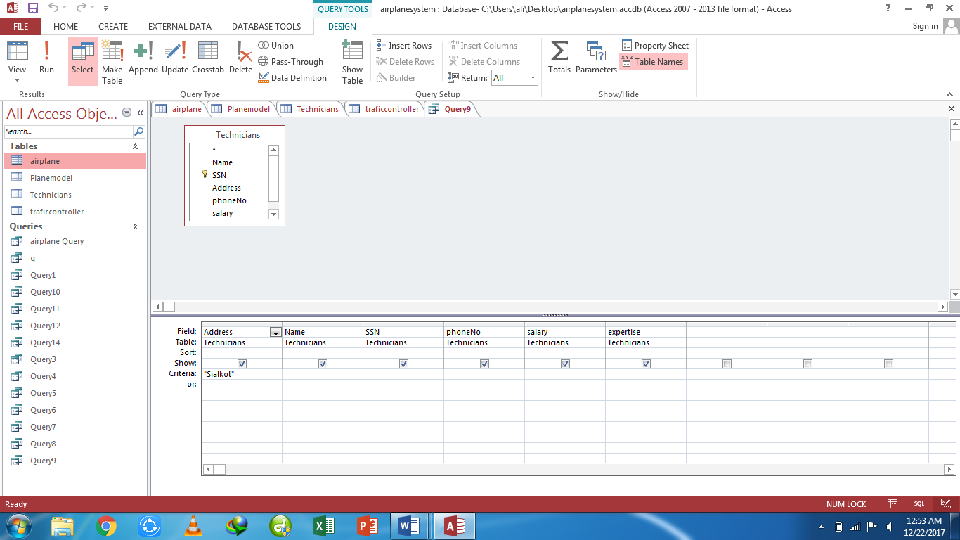

**Datasheet view:**

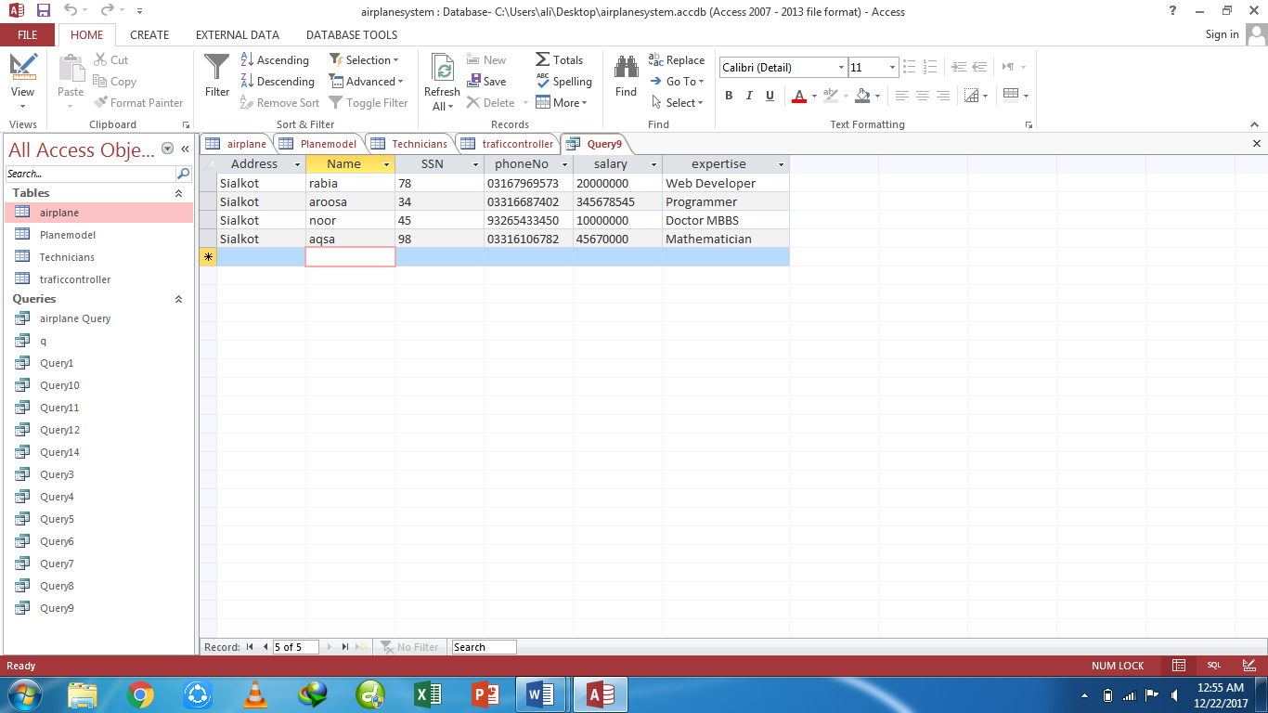

**Sql View:**

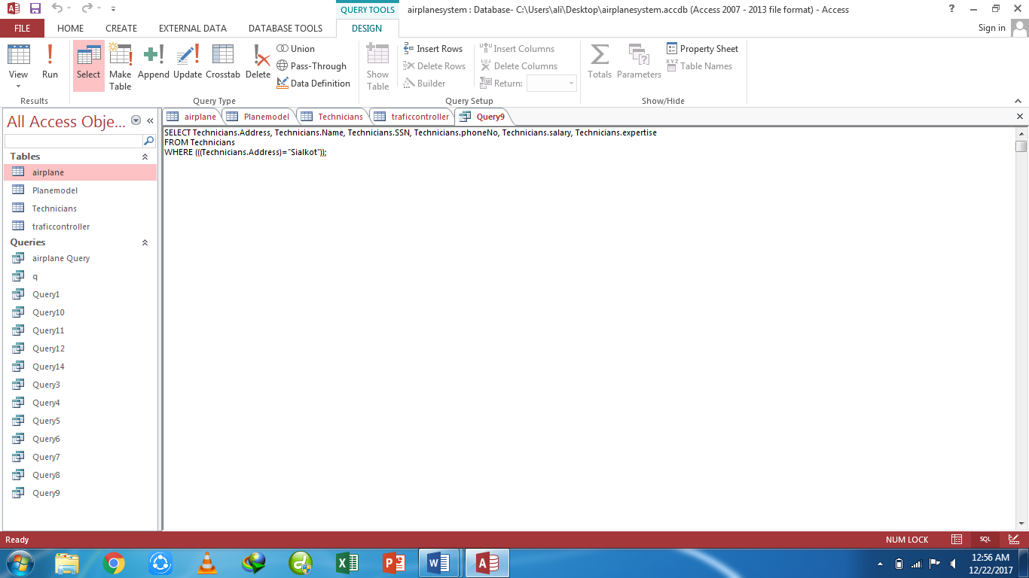

**Query10-** list name of those technicians whose names contains “sa”

**Design view:**

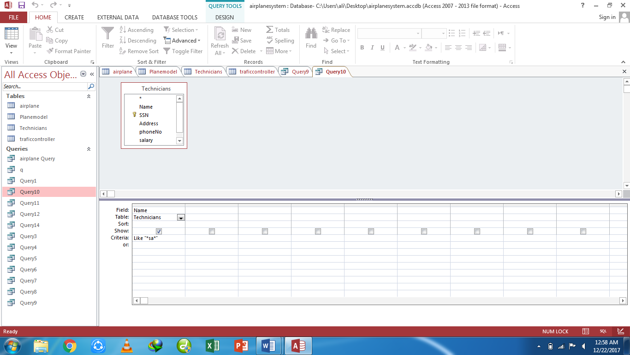

**Datasheet view:**

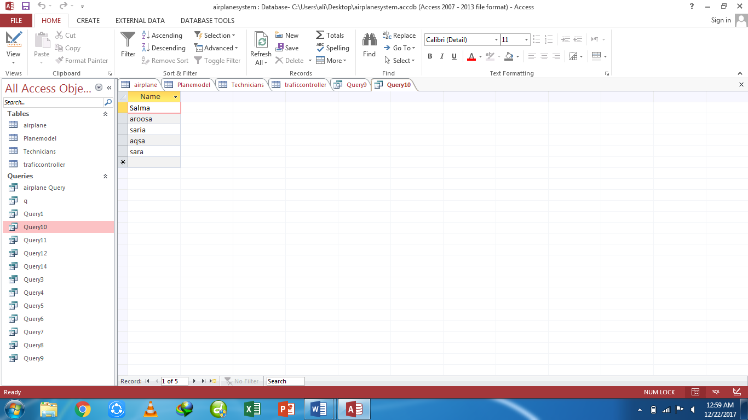

**Sql View:**

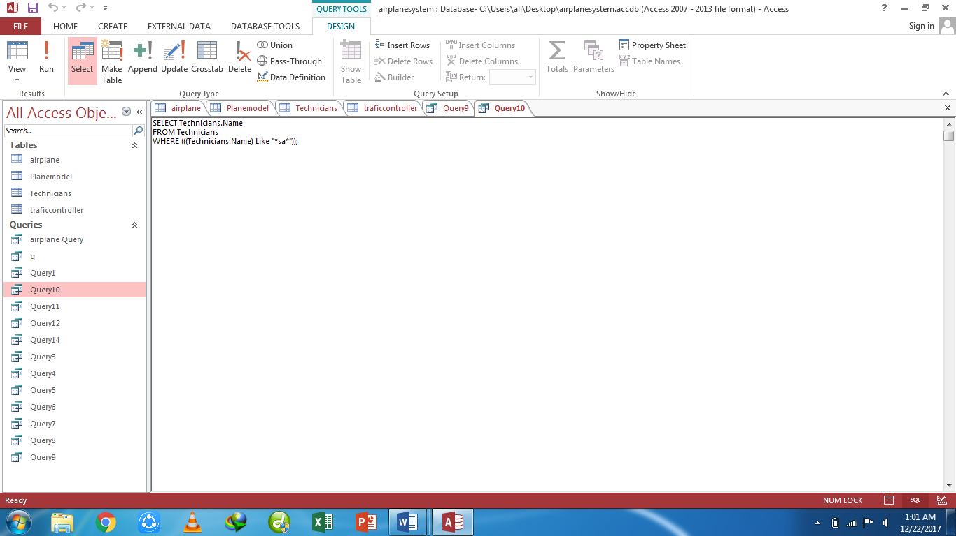

**Query11-** list the planes which can carry passengers more than 110

**Design view:**

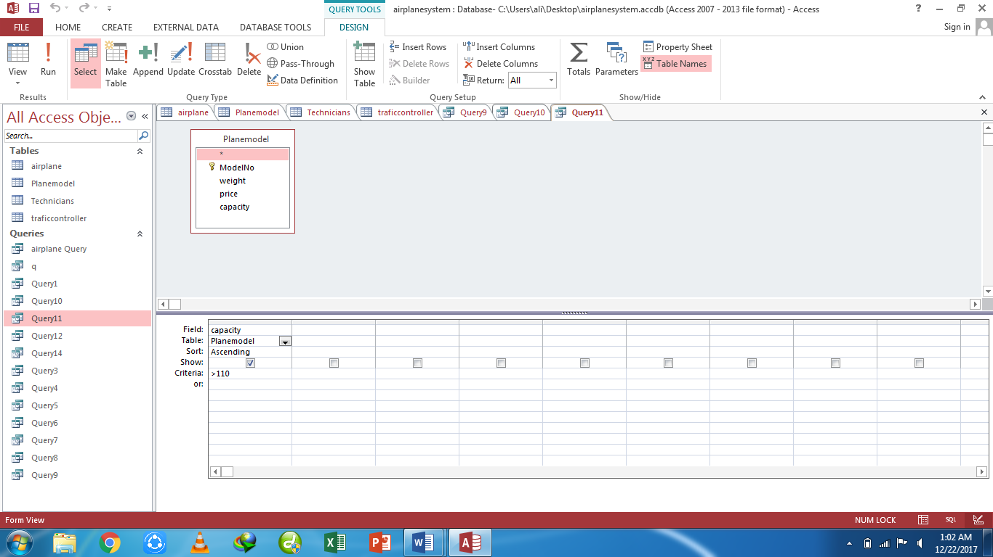

**Datasheet view:**

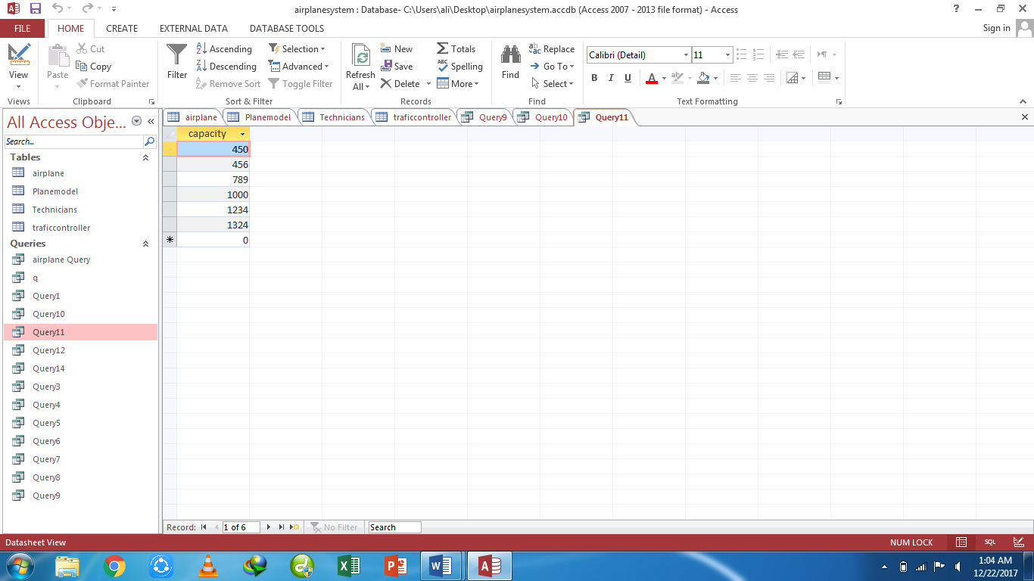

**Sql View:**

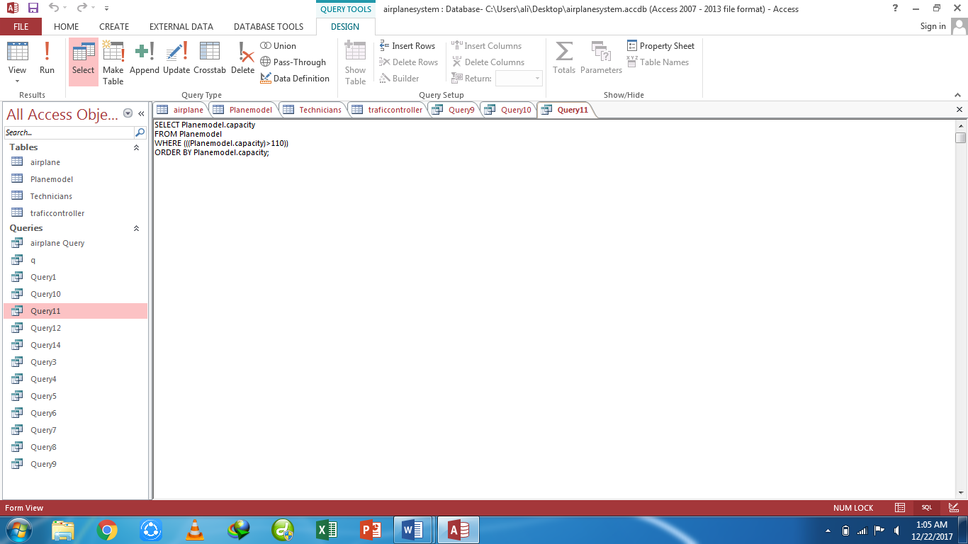

**Query12-** list the minimum capacity and maximum capacity of planes

**Design view:**

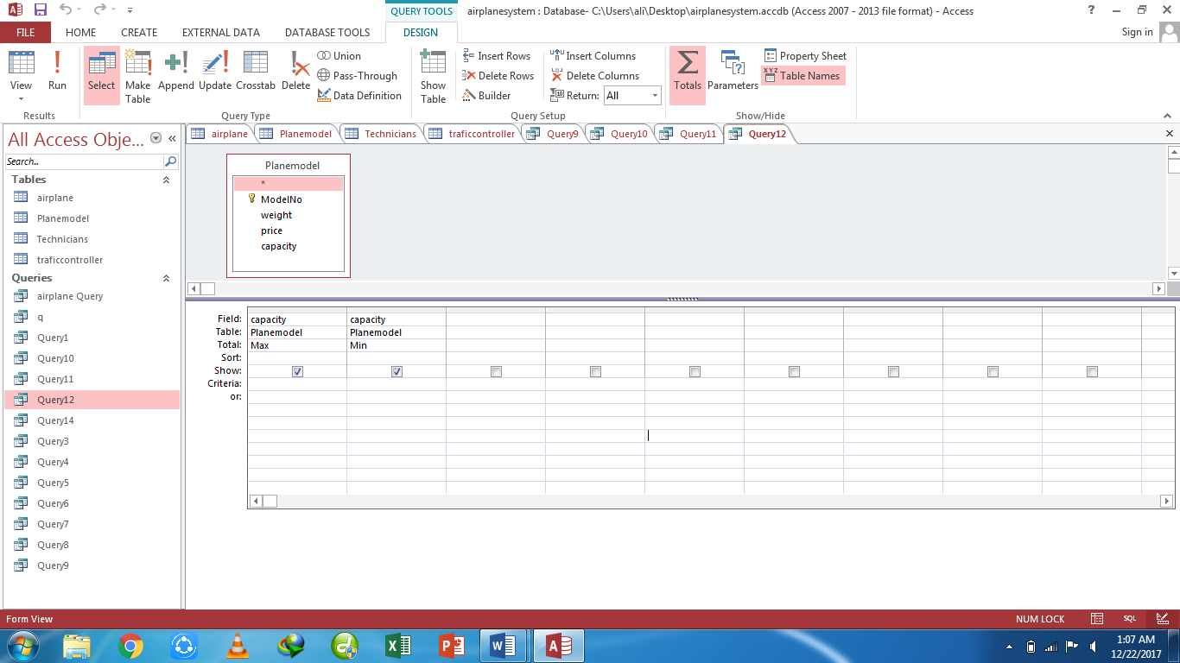

**Datasheet view:**

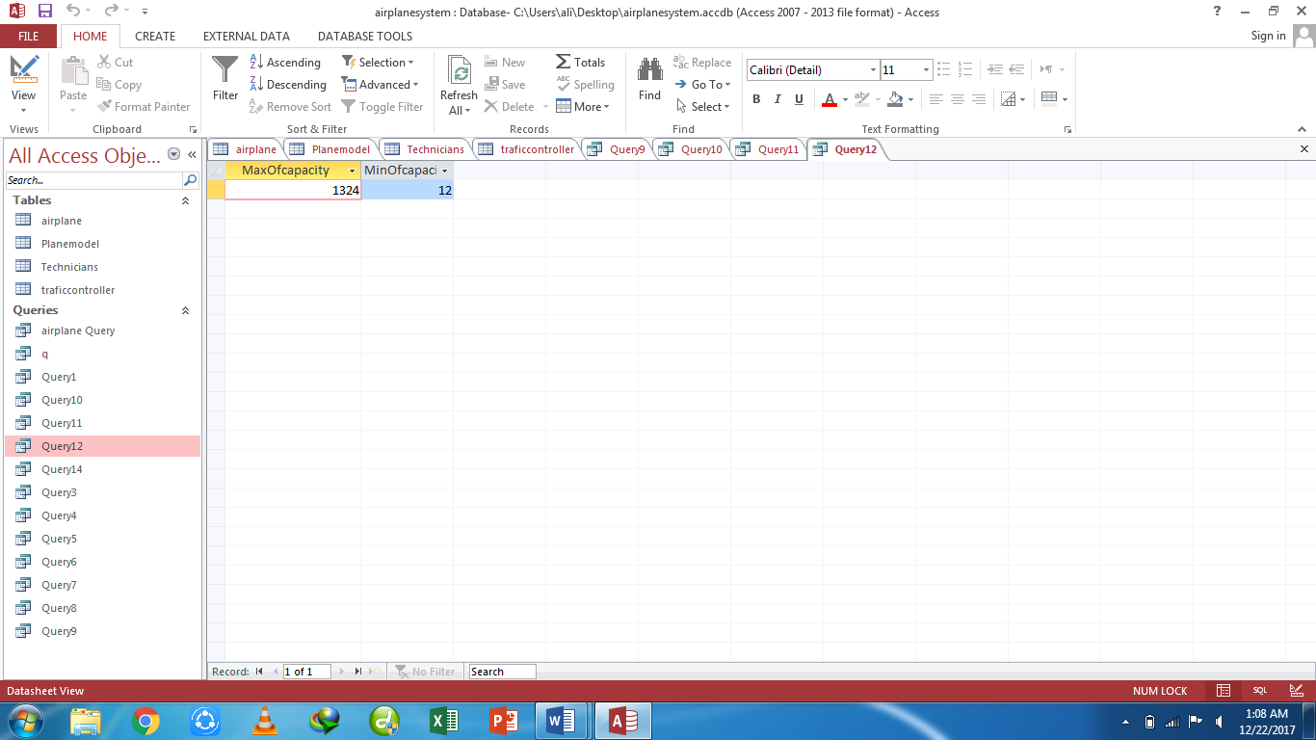

**Sql View:**

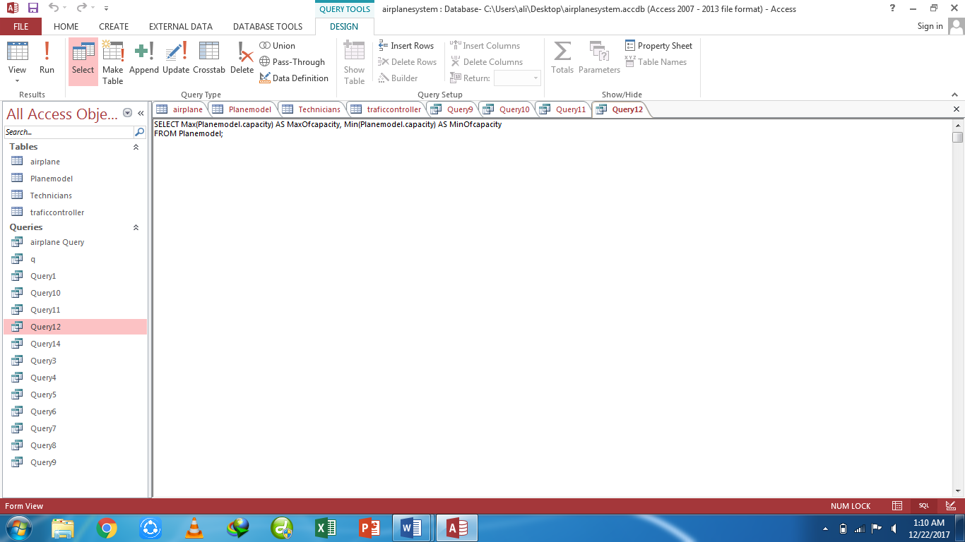

**Query13-** list the planes which location is Sialkot and Islamabad

**Design view:**

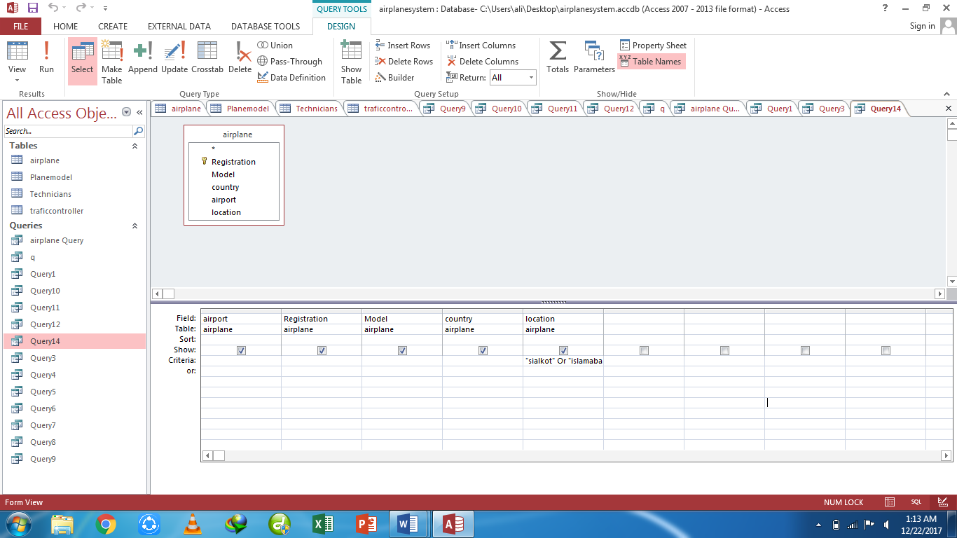

**Datasheet view:**

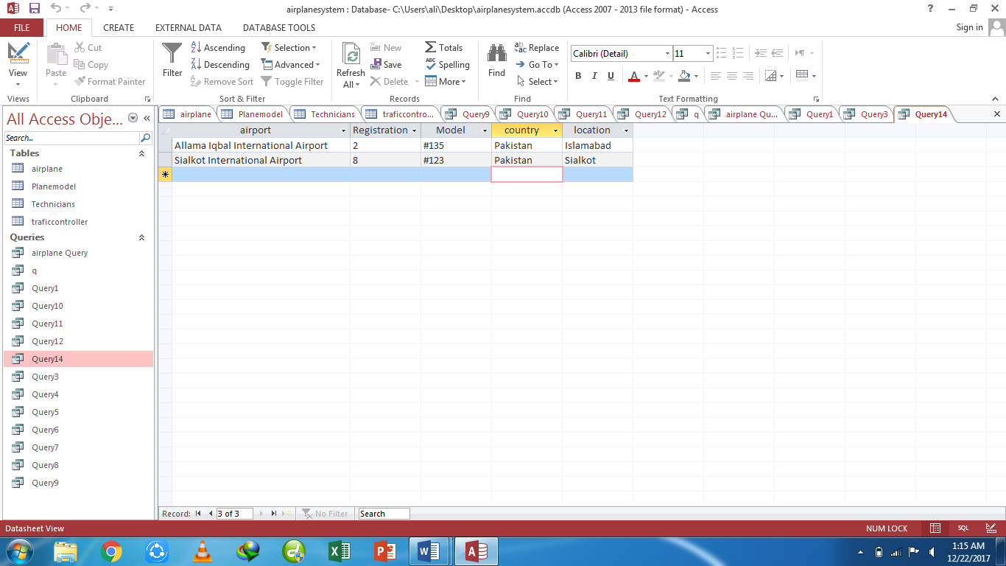

**Sql View:**

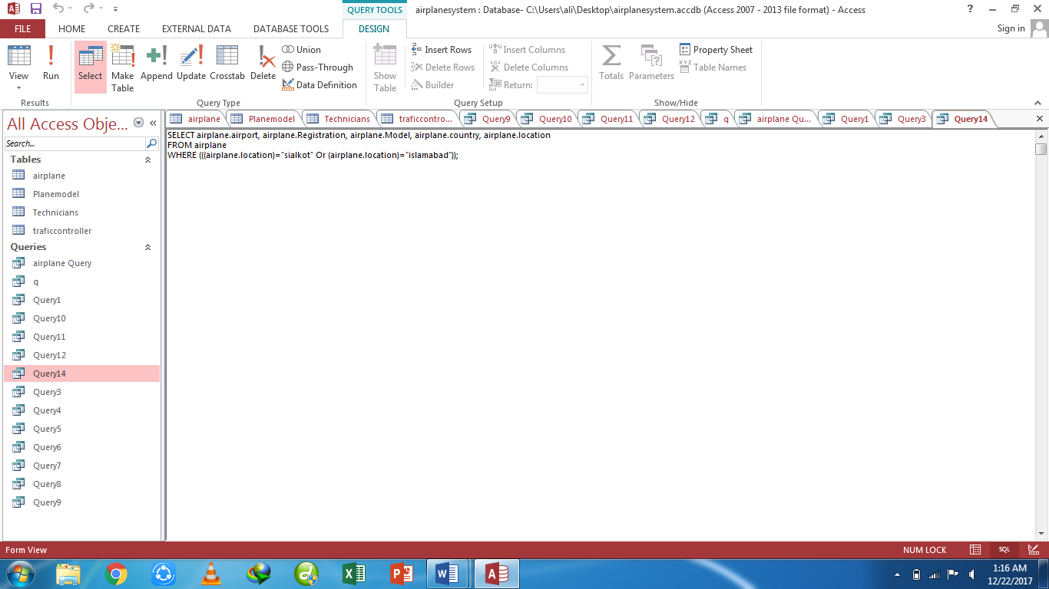

**Query14-** List the data of those technicians whose exam type contains

**Design view:**

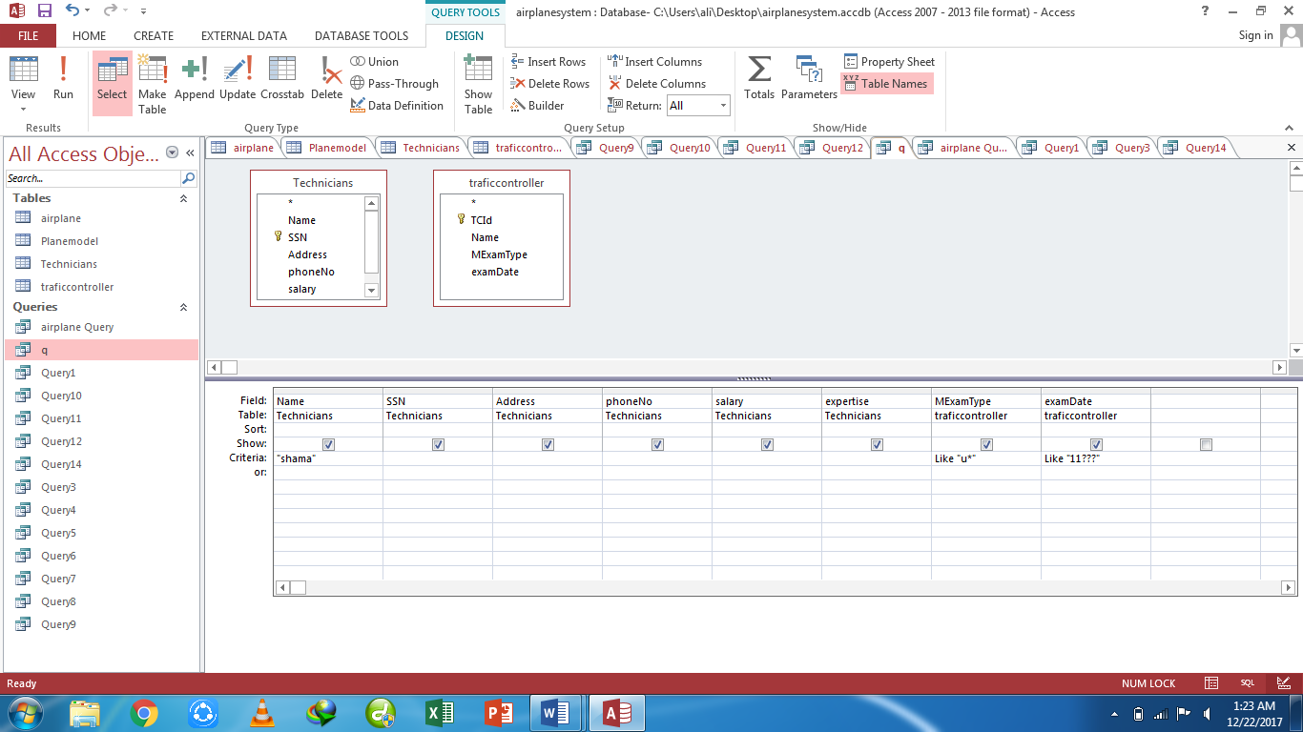

**Datasheet view:**

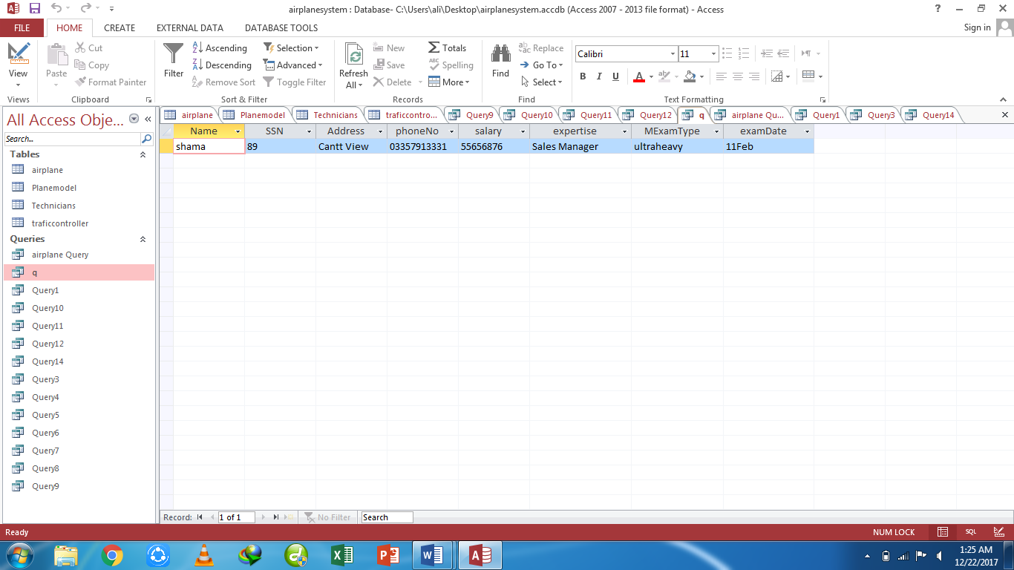

**Sql View:**

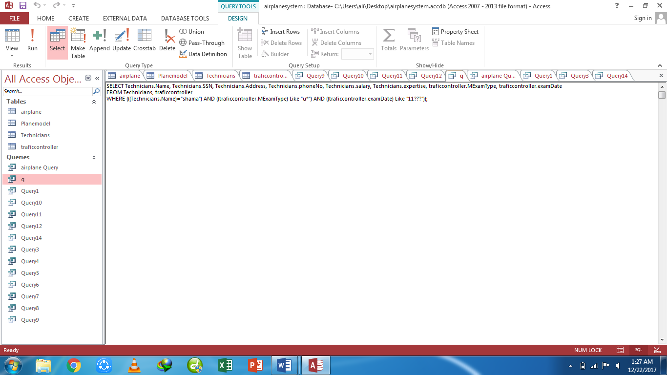

**Task 4:** ManagerManagement system**.**

**Tables**

**Table1:** Company

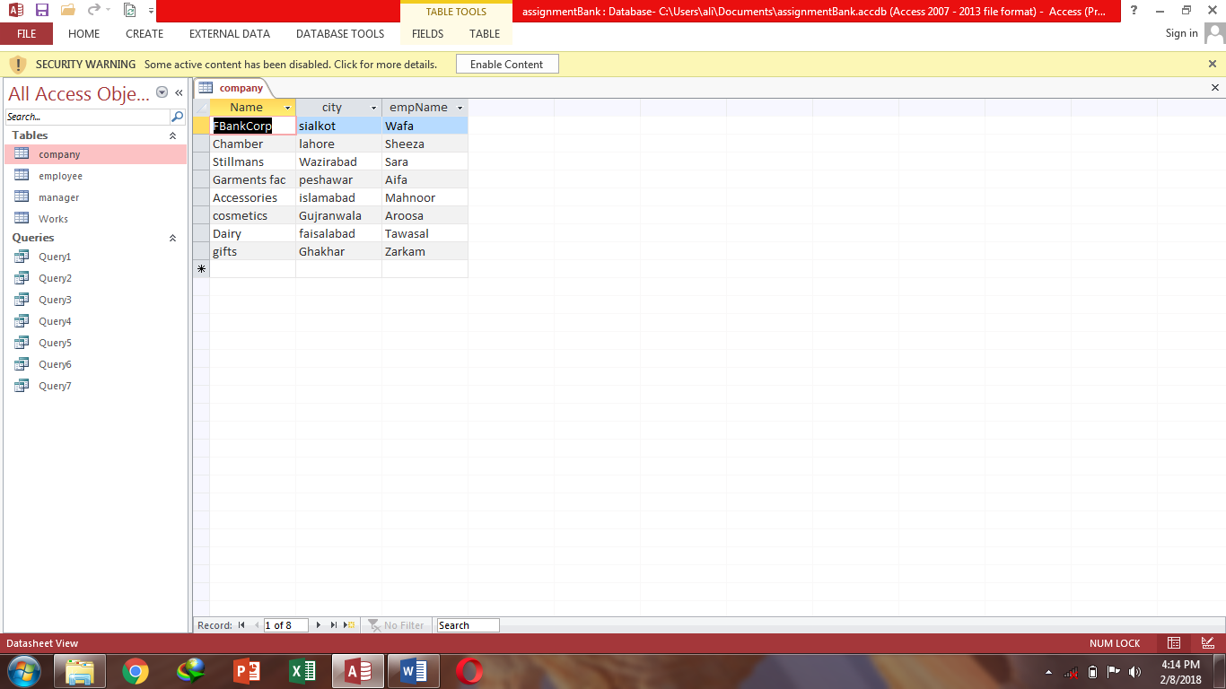

**Table2:** Employee

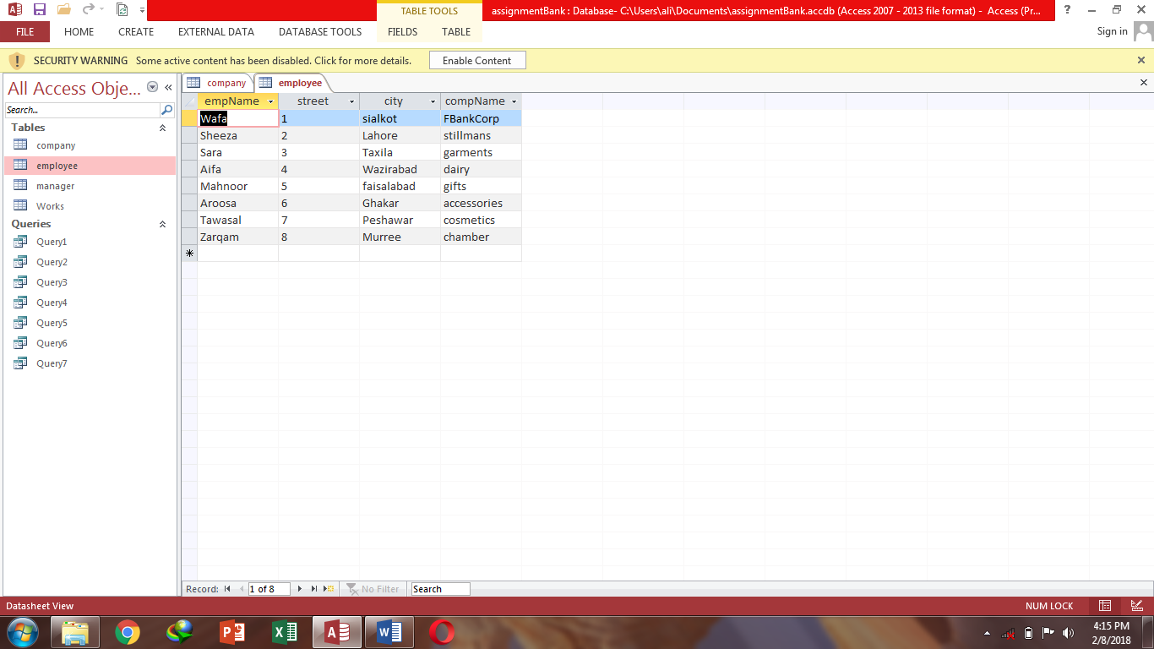

**Table3:** Manager

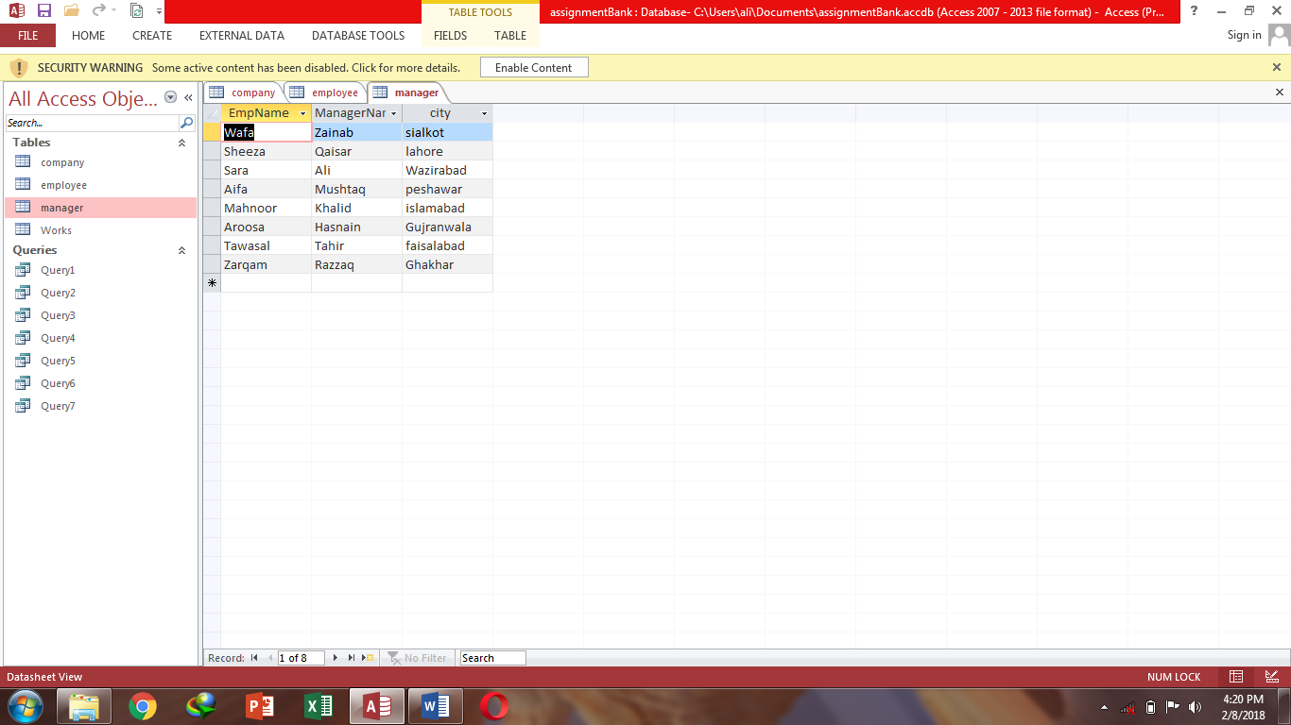

**Table4:** Works

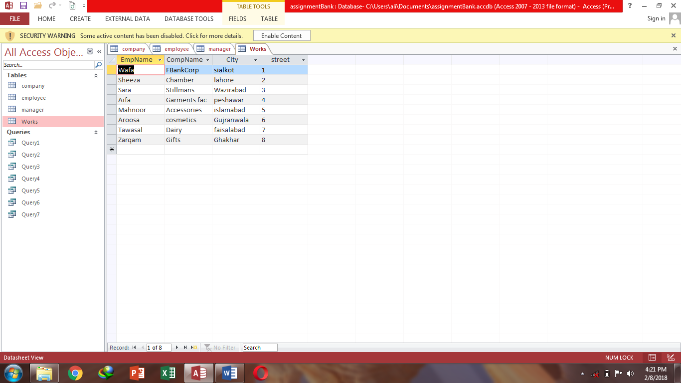

**Queries**

**Query1-** Show employee name, street & city where company name is First Bank Corporation.

**Datasheet view:**

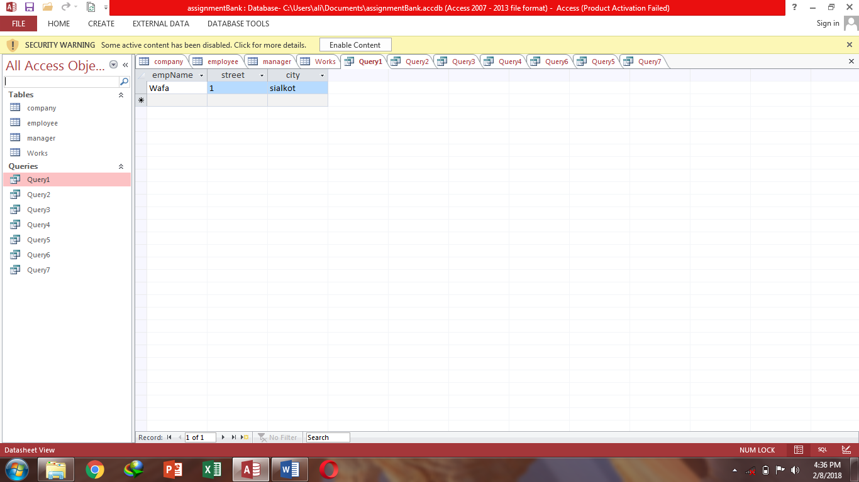

**Sql View:**

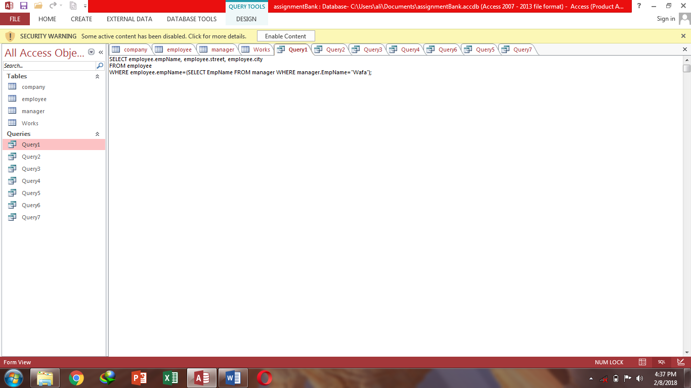

**Design view:**

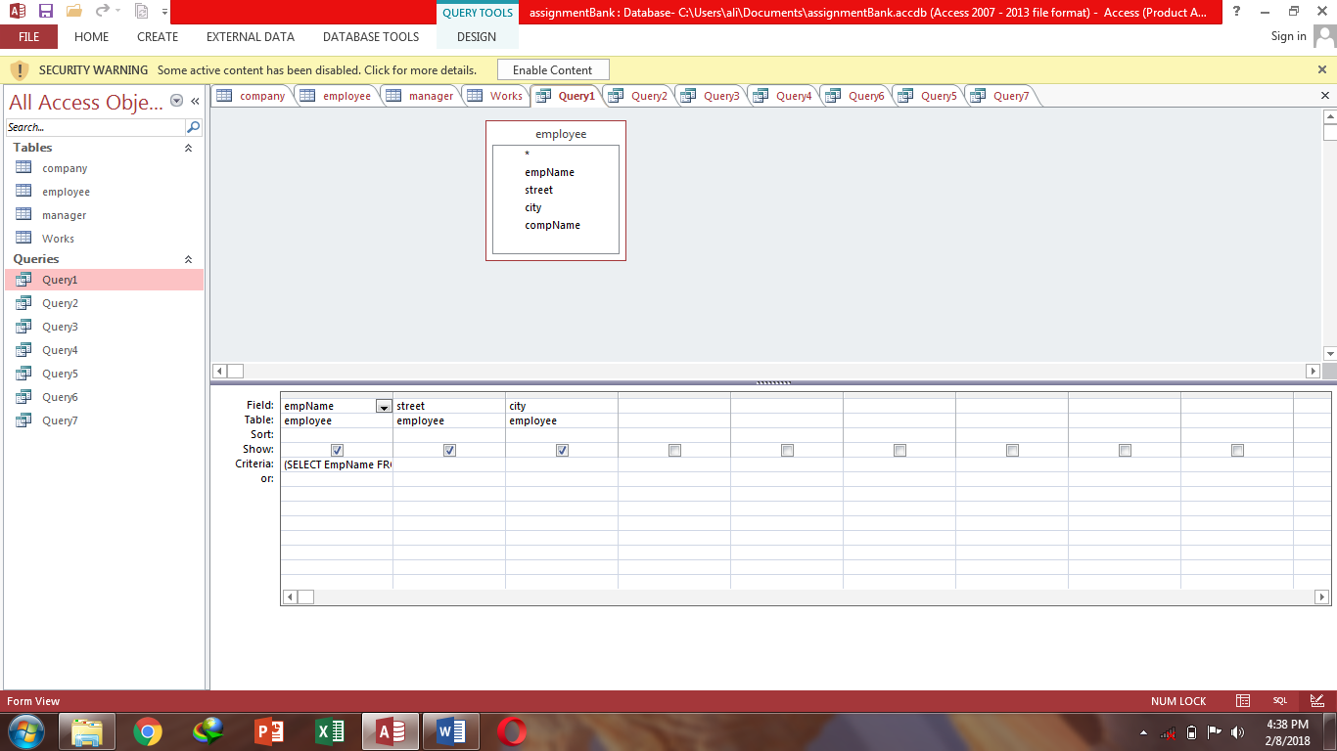

**Query2-** Show employee name where employee works in the same city where they live.

**Datasheet view:**

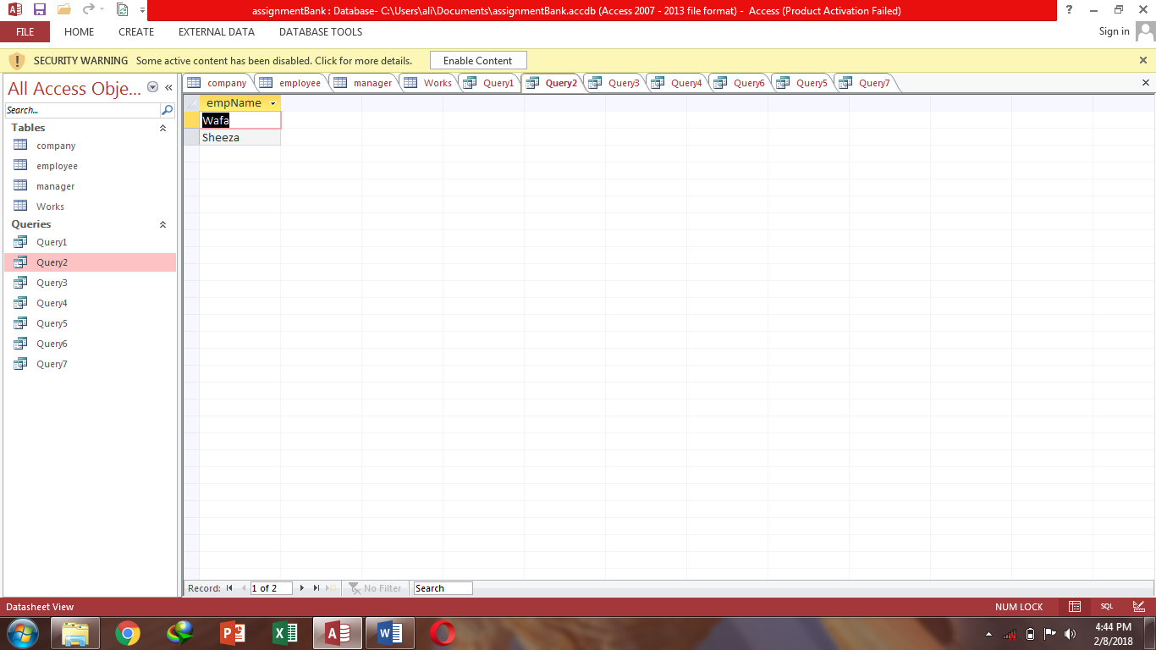

**Sql View:**

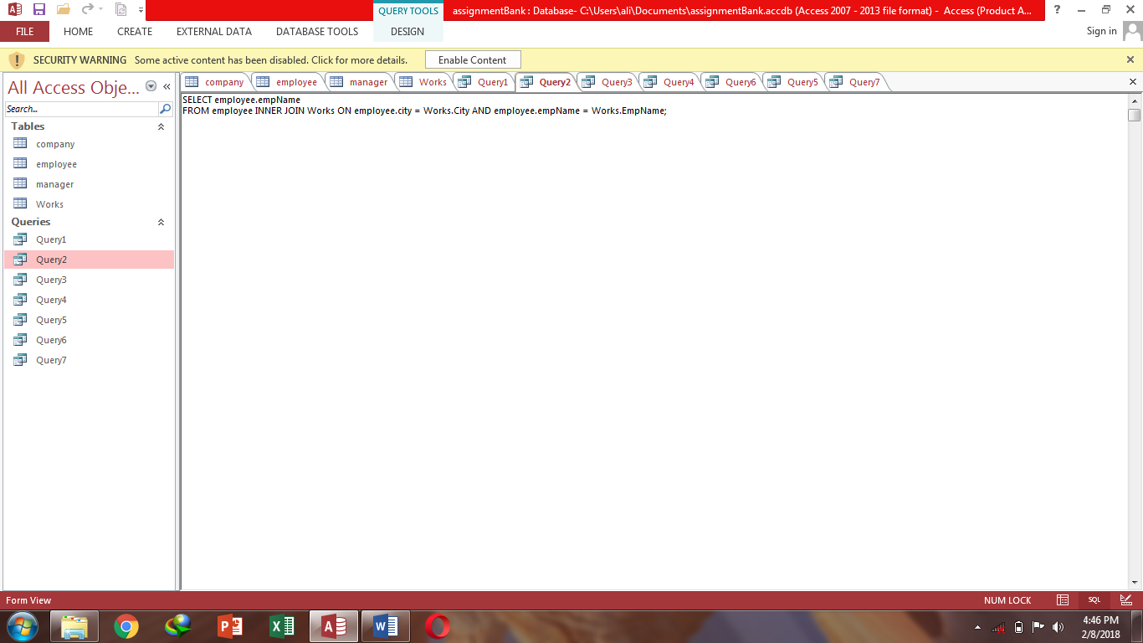

**Design view:**

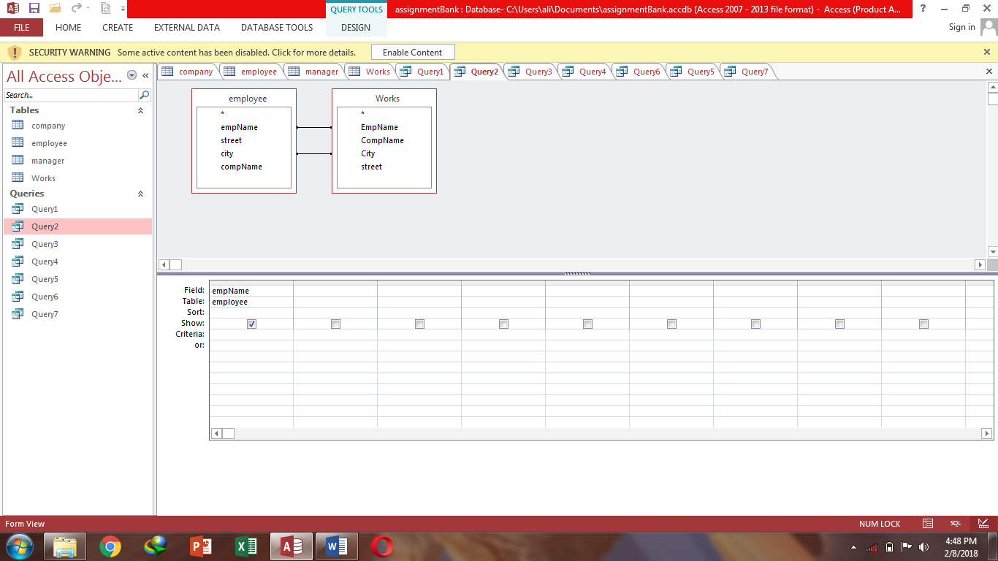

**Query3-** Show all detail of employee where company name is First Bank Corporation.

**Datasheet view:**

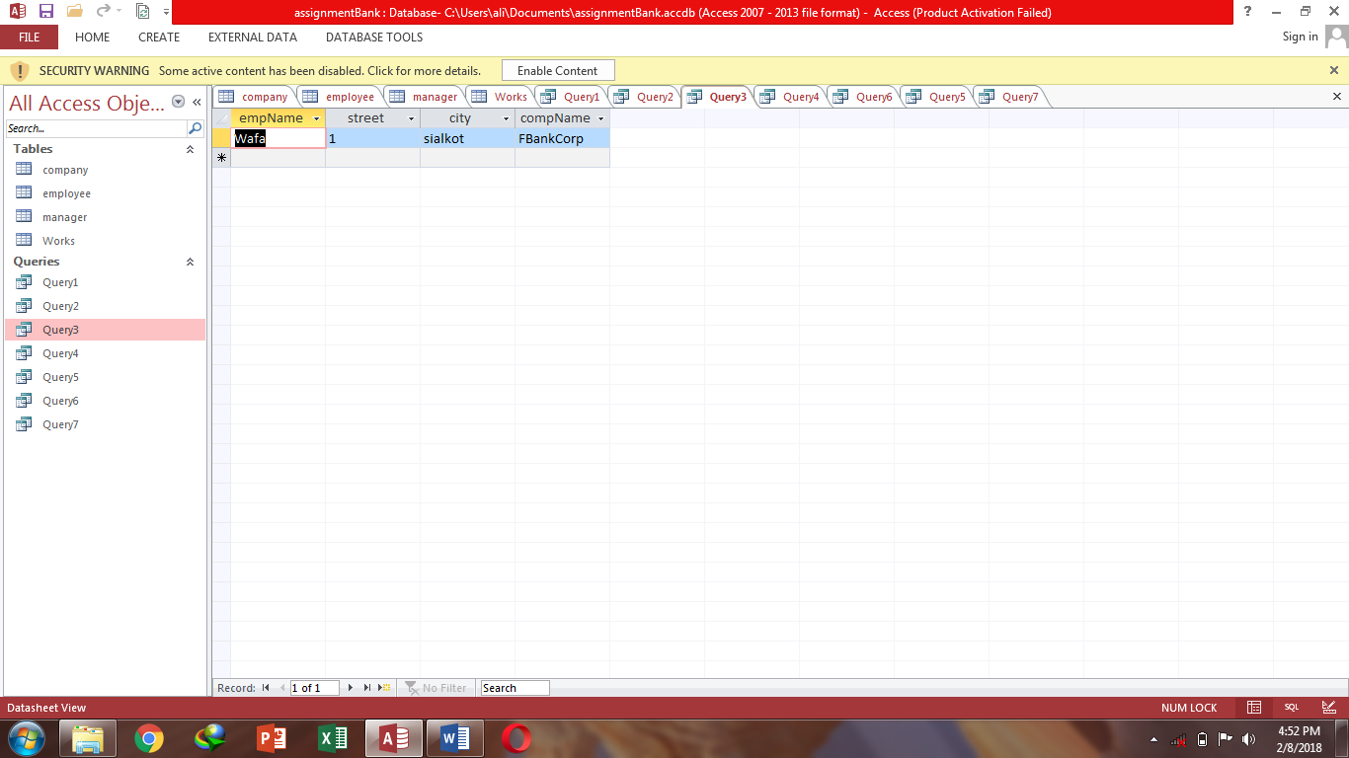

**Sql View:**

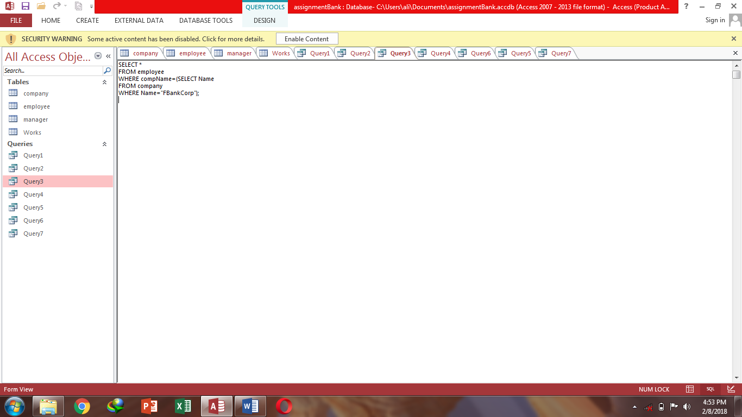

**Design view:**

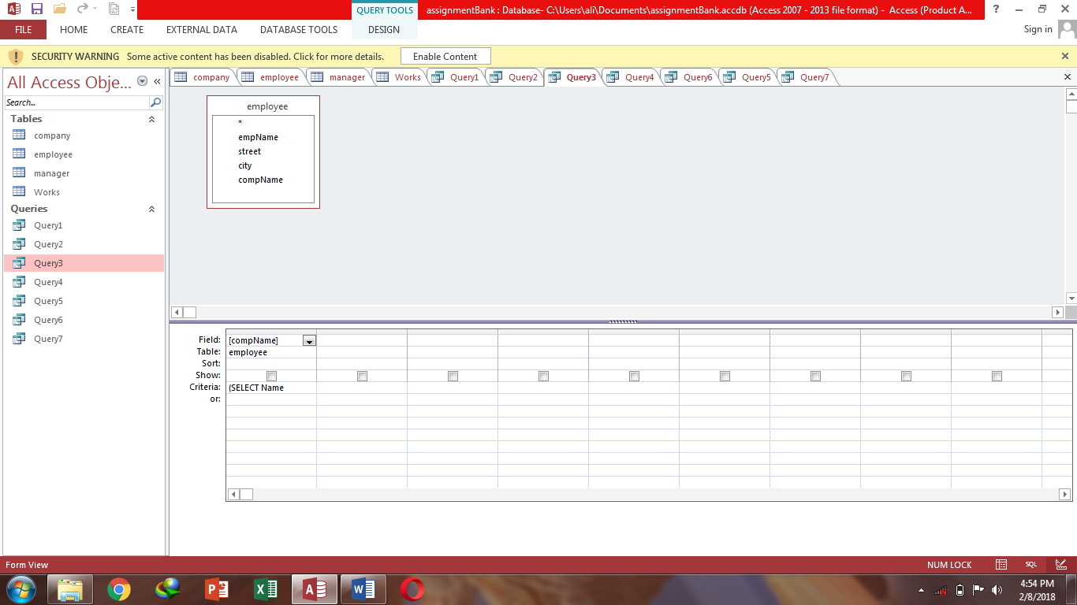

**Query4-** Show employee name from company table where employees belong to same city where they work.

**Datasheet view:**

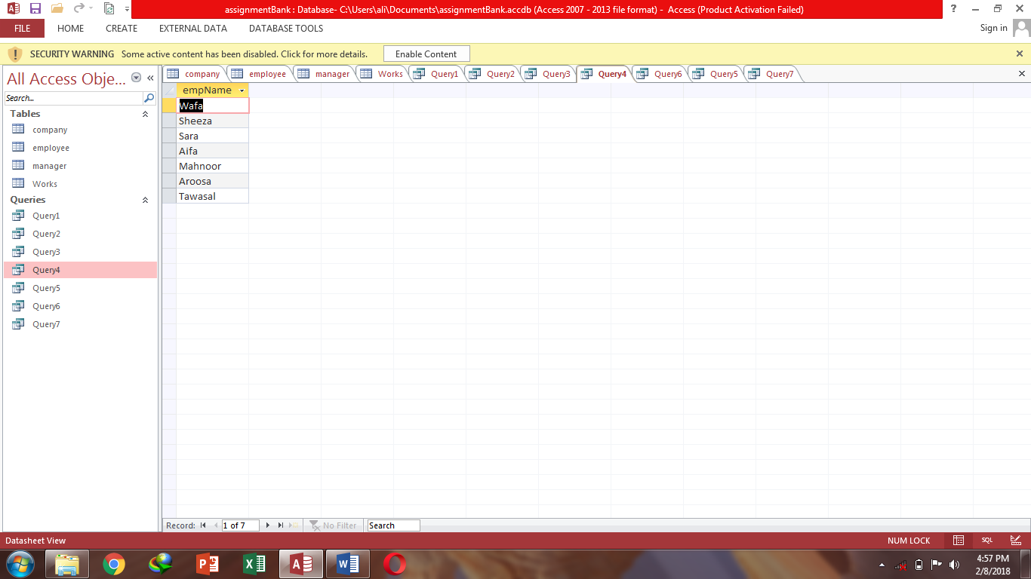

**Sql View:**

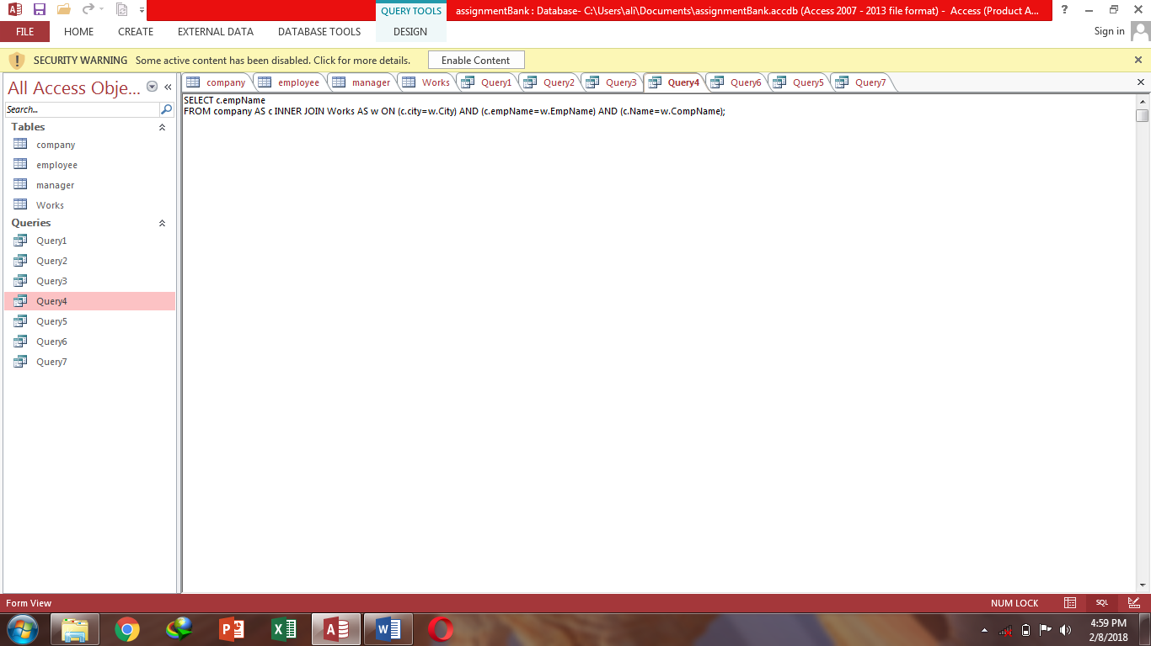

**Design view:**

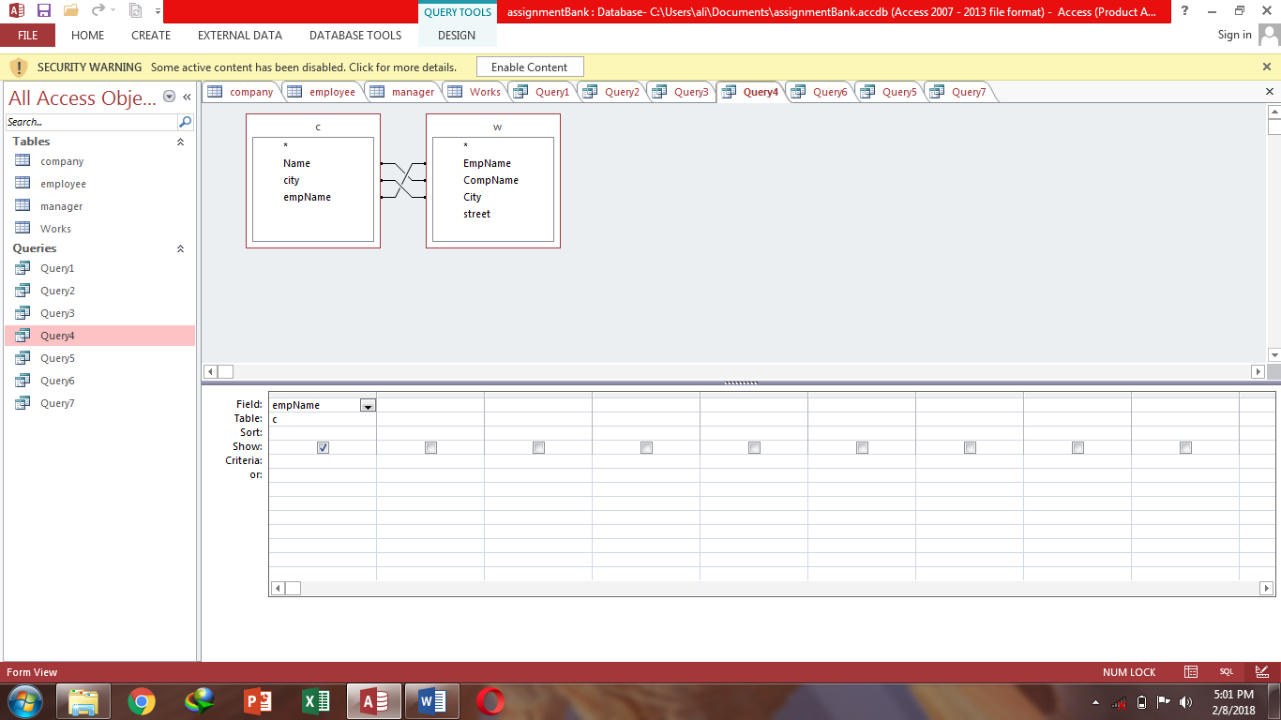

**Query5-** Show all employee names where company name is not First Bank Corporation.

**Datasheet view:**

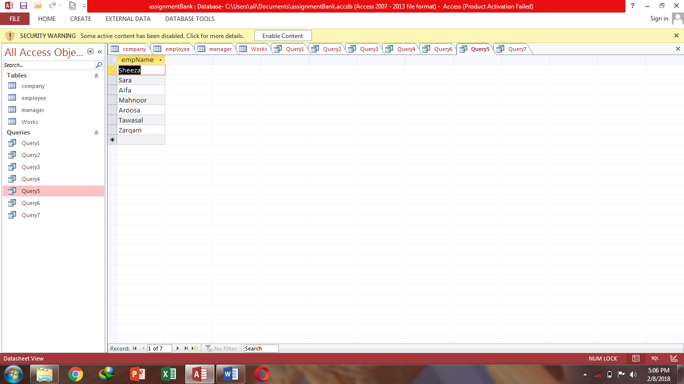

**Sql View:**

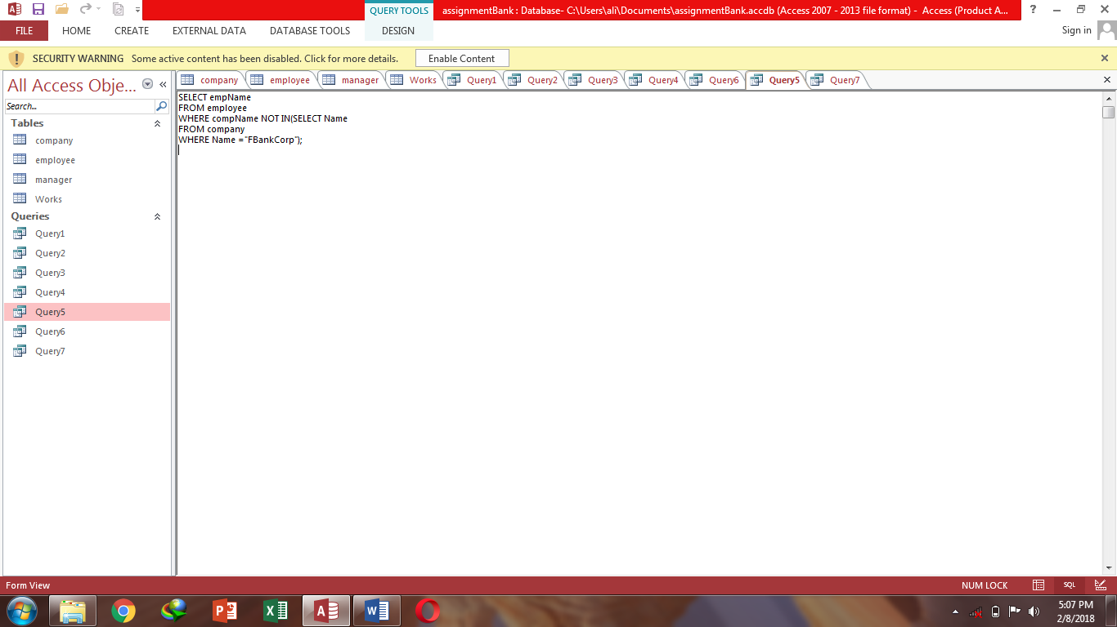

**Design view:**

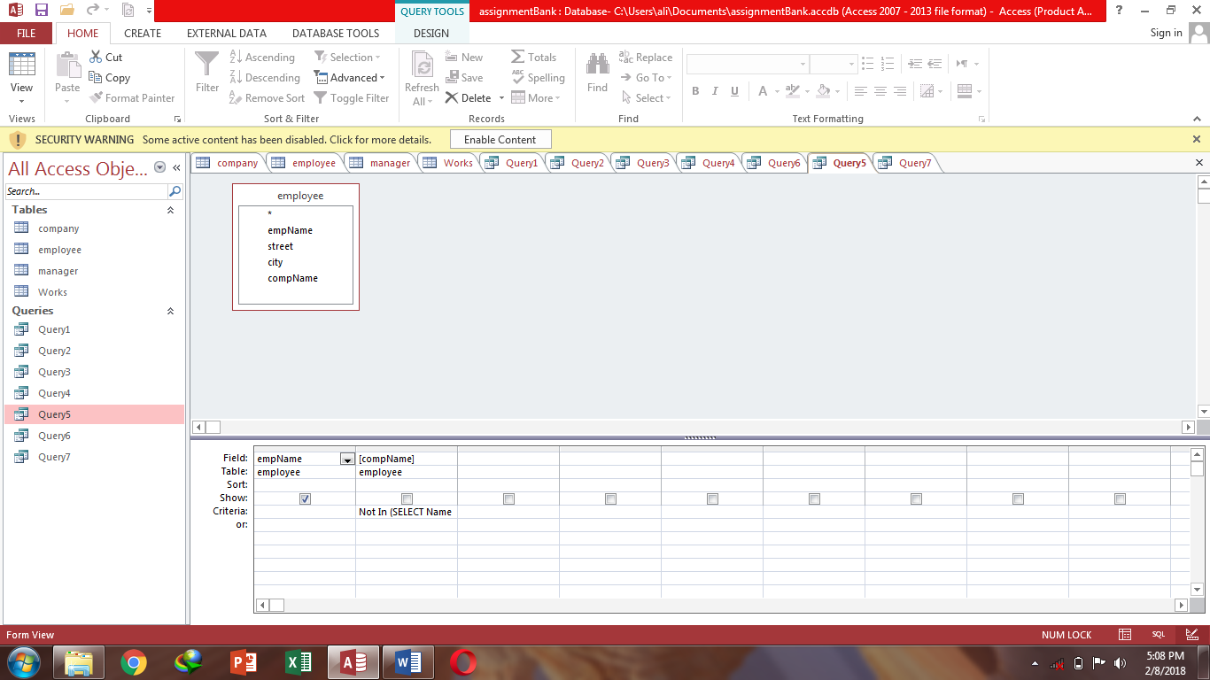

**Query6-** Show employee name where city of employee and manager is same.

**Datasheet view:**

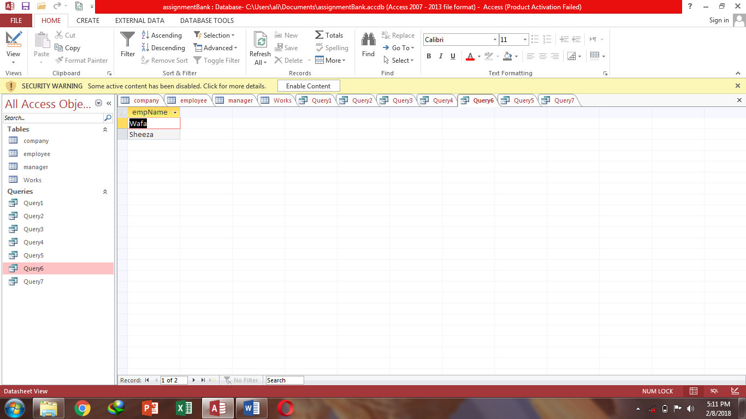

**Sql View:**

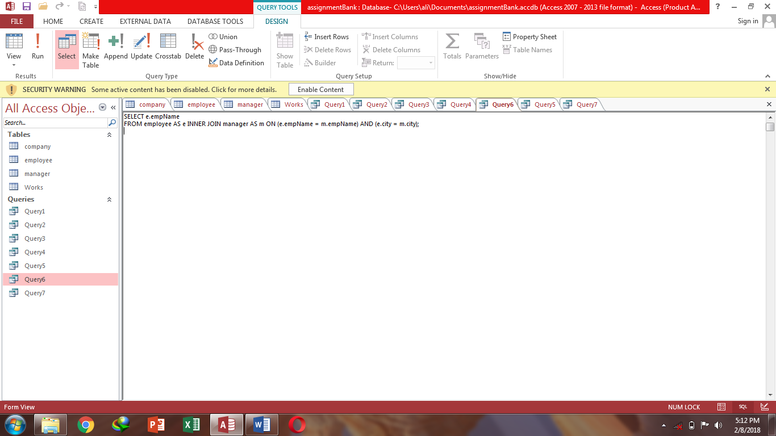

**Design view:**

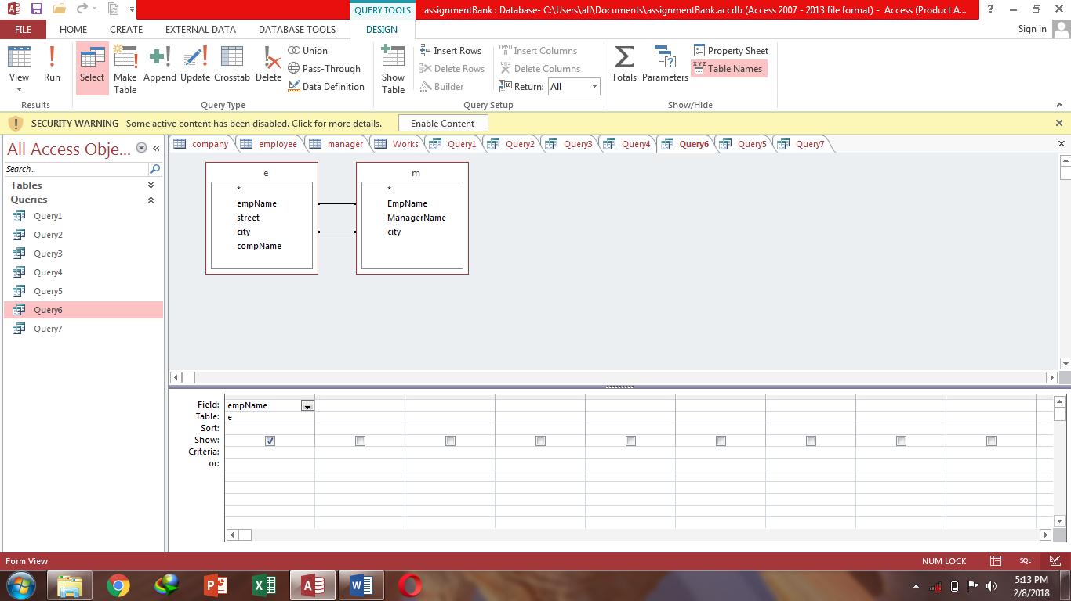

**Query7-** Show all employee name from table employee.

**Datasheet view:**

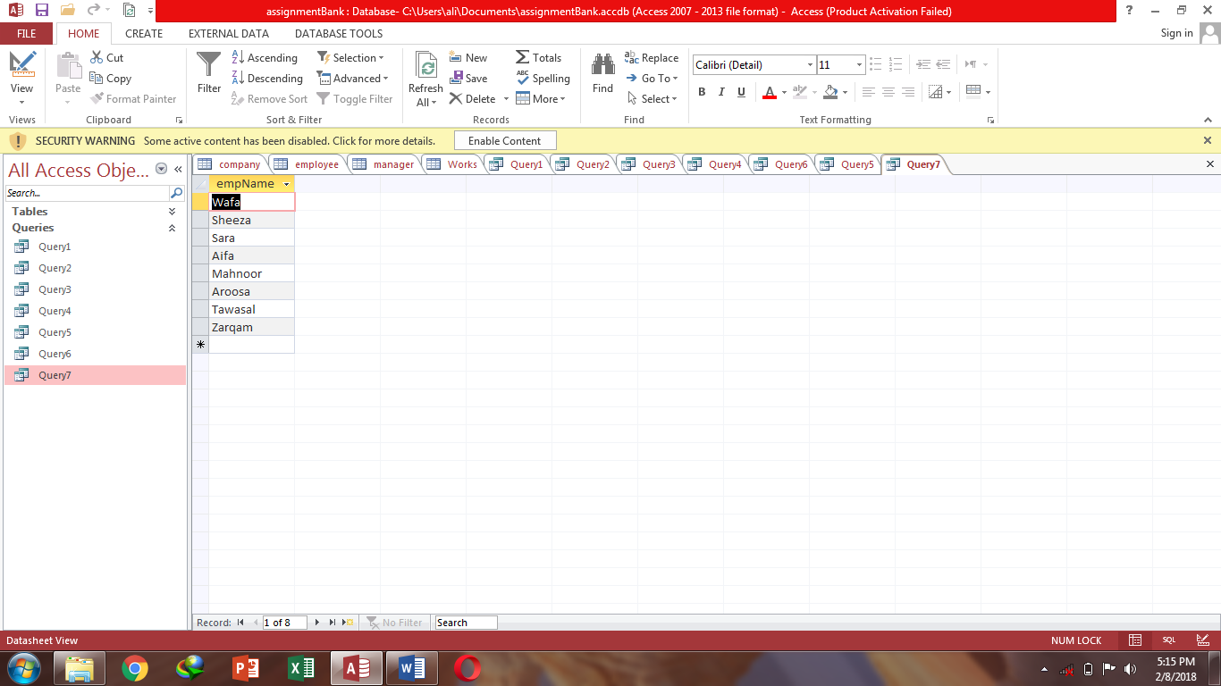

**Sql View:**

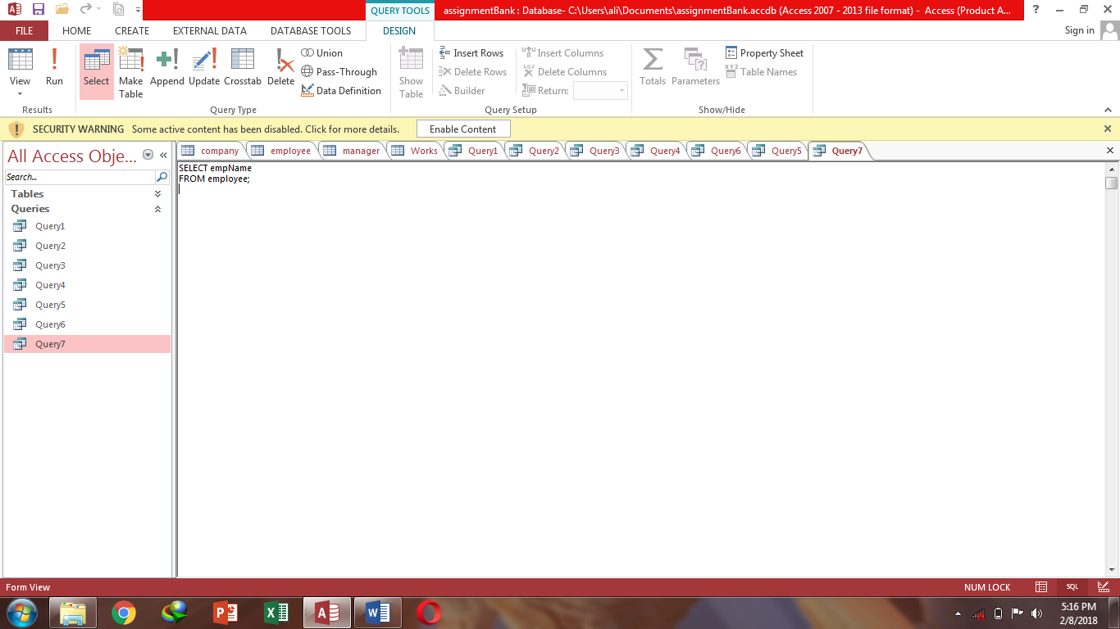

**Design view:**

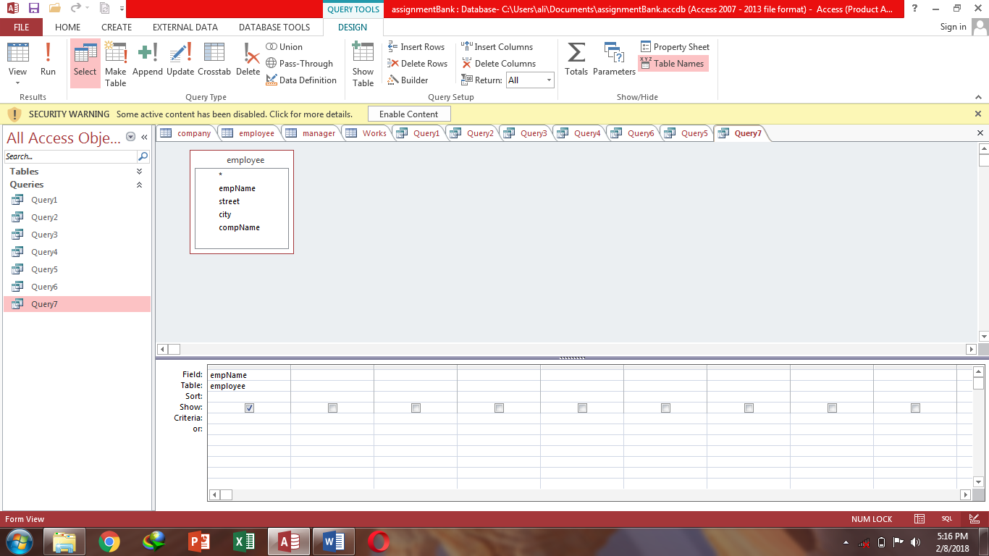

**Task 5:** Employee management system

**Tables**

**Table1:** Course

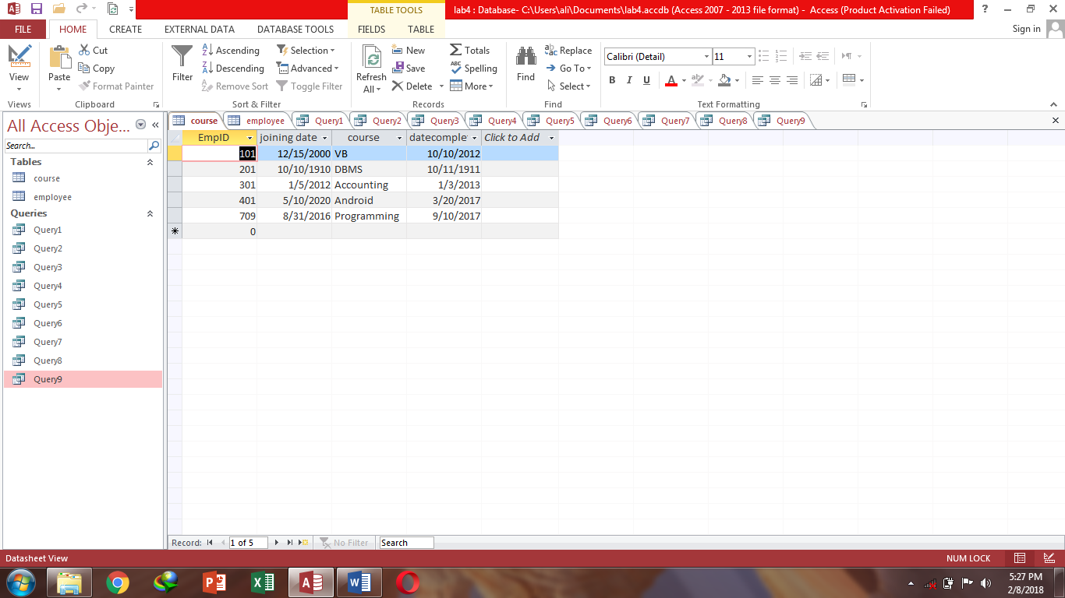

**Table2:** Employee

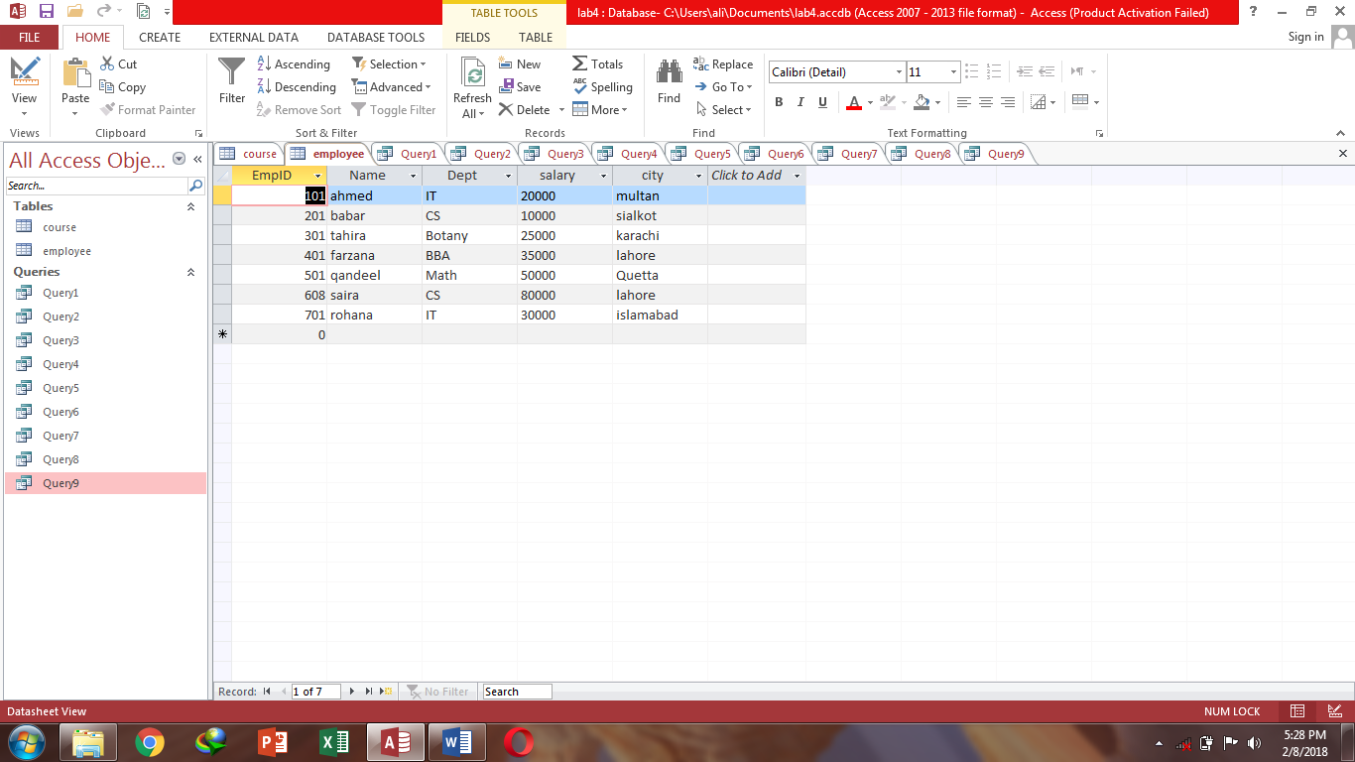

**Queries**

**Query1-** Show all from course table & name, department, salary & city from employee table.

**Datasheet view:**

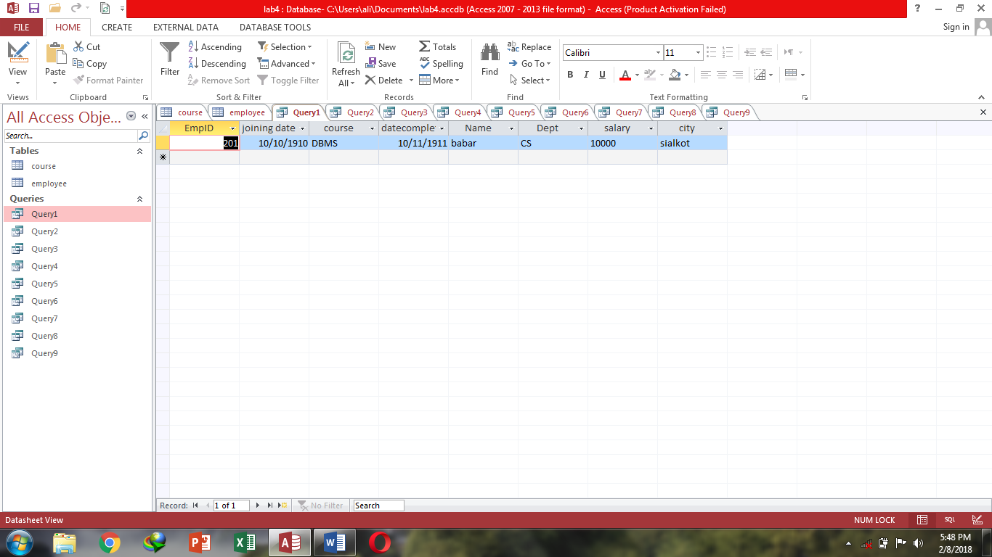

**Sql View:**

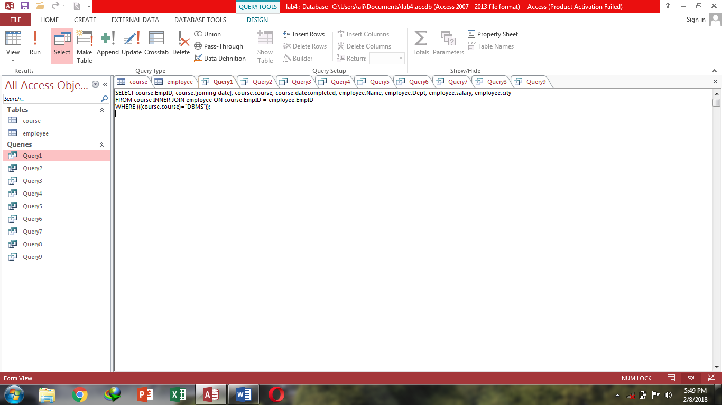

**Design view:**

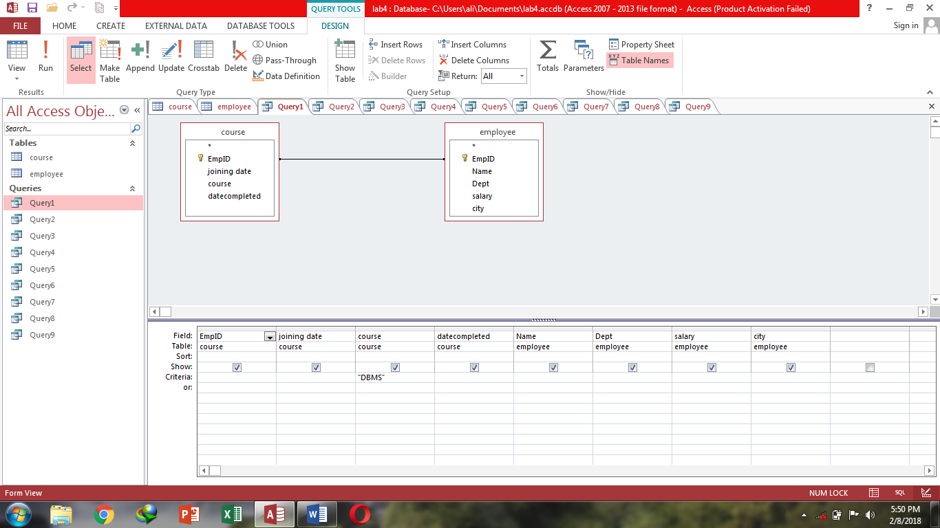

**Query2-** Show all from employee table & joining date, course & date completed from course table where employee salary greater than 20000.

**Datasheet view:**

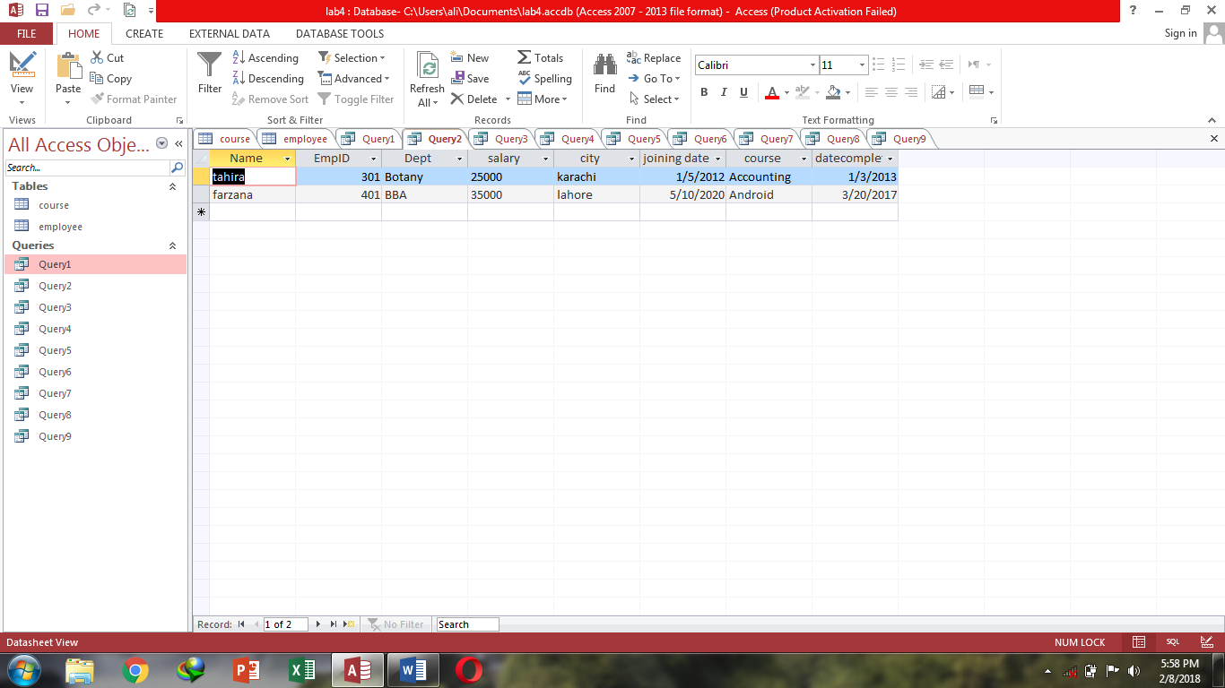

**Sql View:**

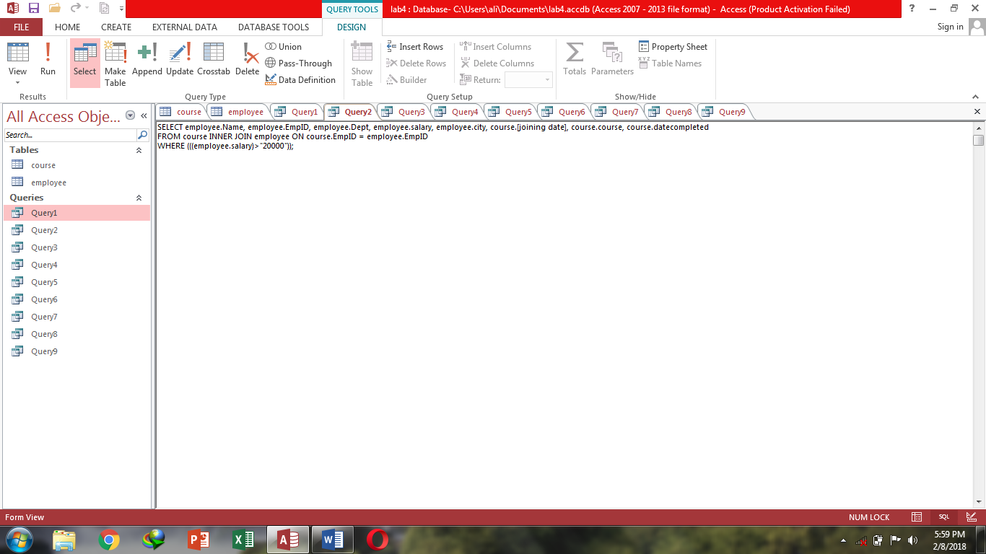

**Design view:**

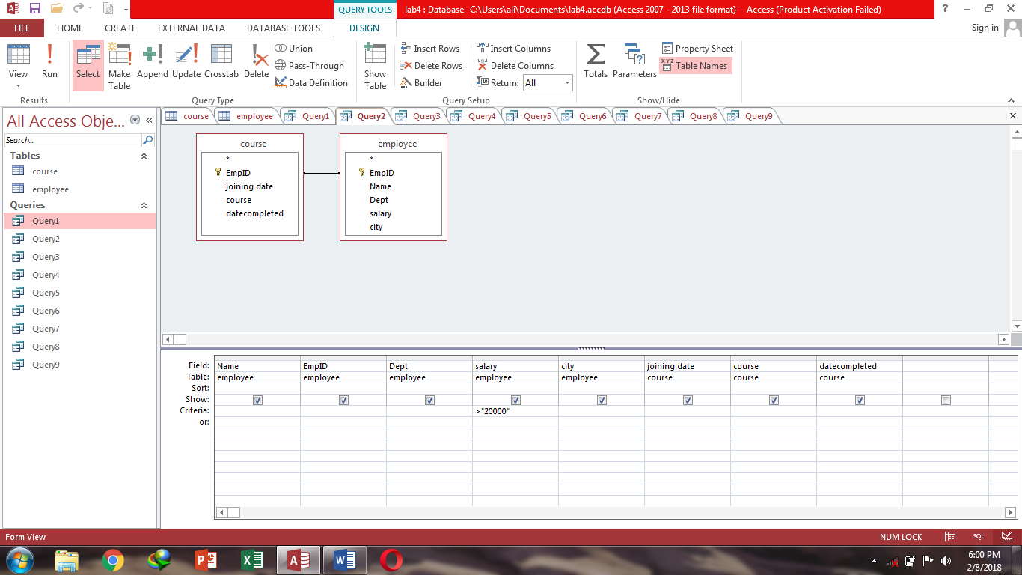

**Query3-** Show all from employee table & joining date, course & date completed from course table where employee name not contain ana at the last.

**Datasheet view:**

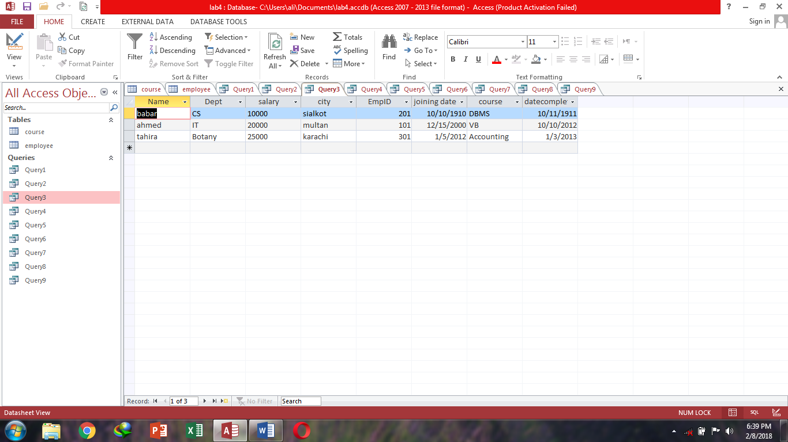

**Sql View:**

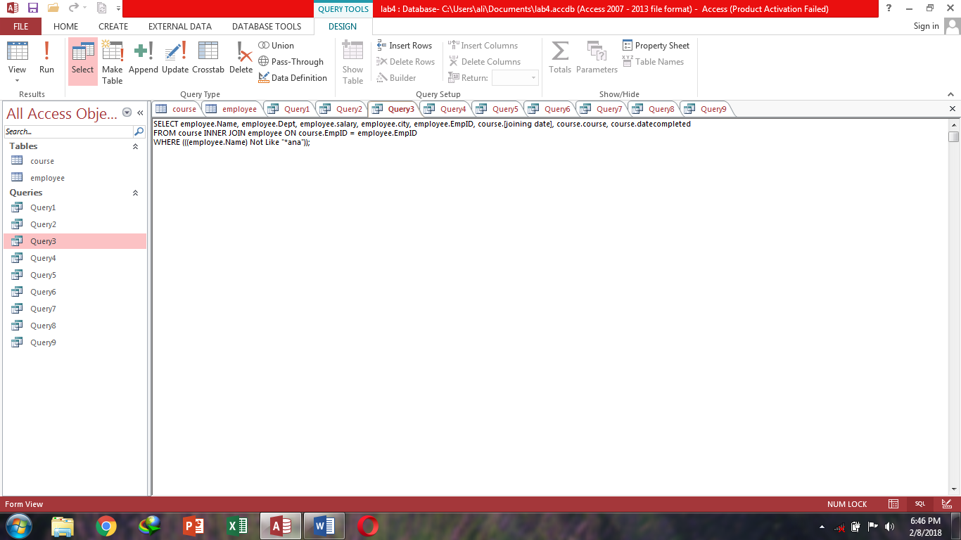

**Design view:**

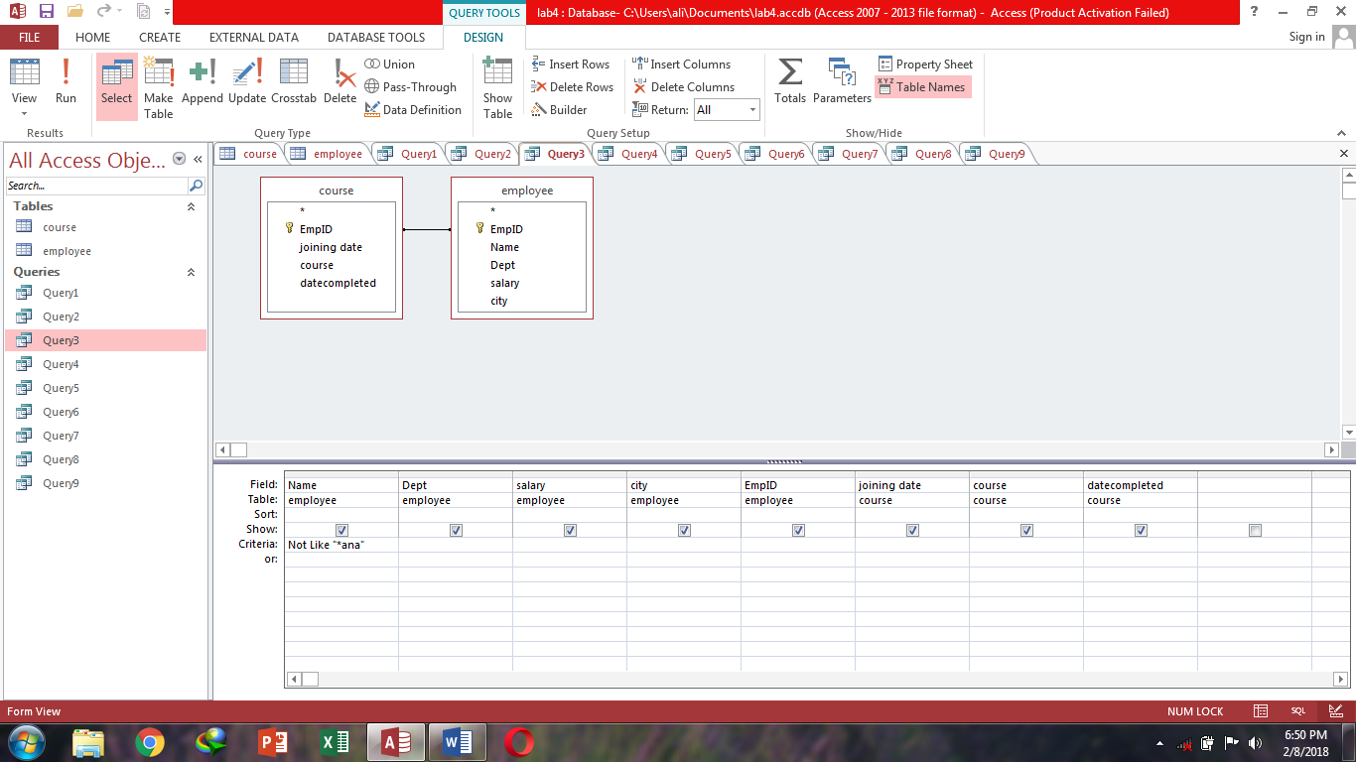

**Query4-** Show all from employee table & joining date, course & date completed from course table where joining date contains 2012.

**Datasheet view:**

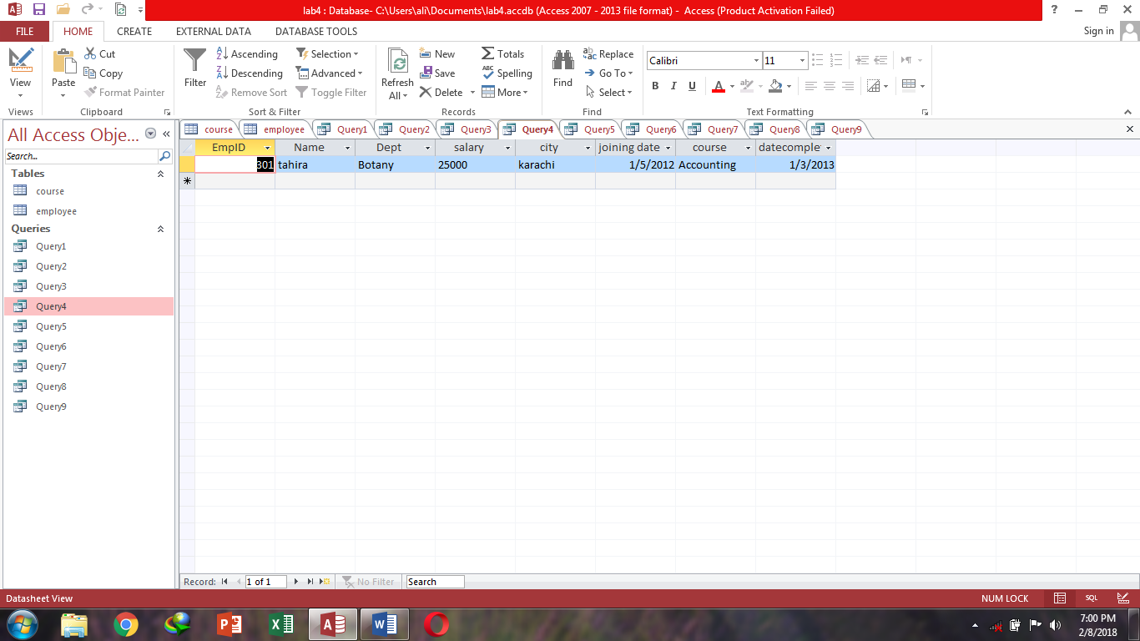

**Sql View:**

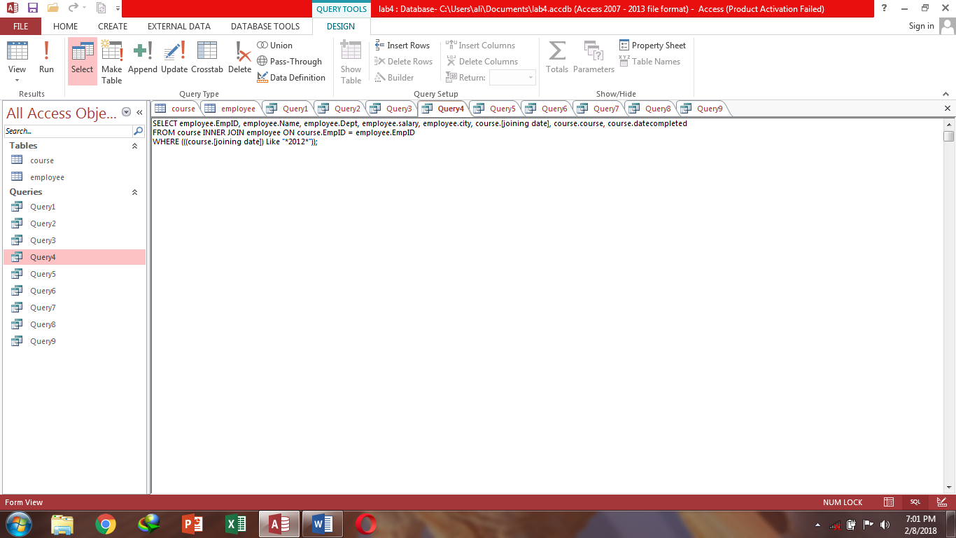

**Design view:**

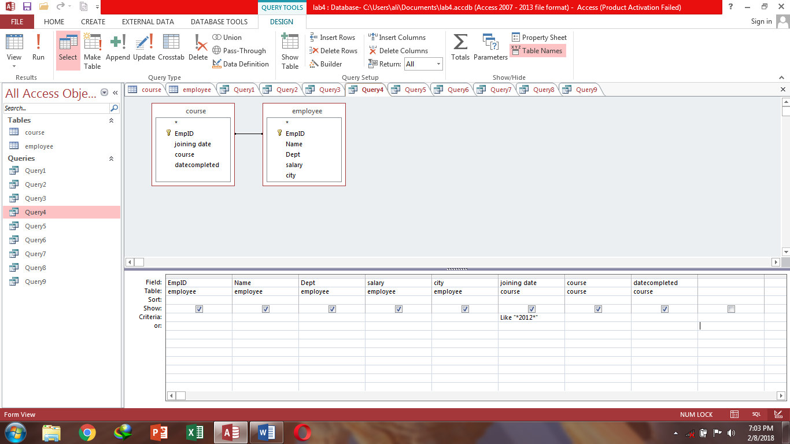

**Query5-** Show all from course table & salary & city from employee table where city is Lahore.

**Datasheet view:**

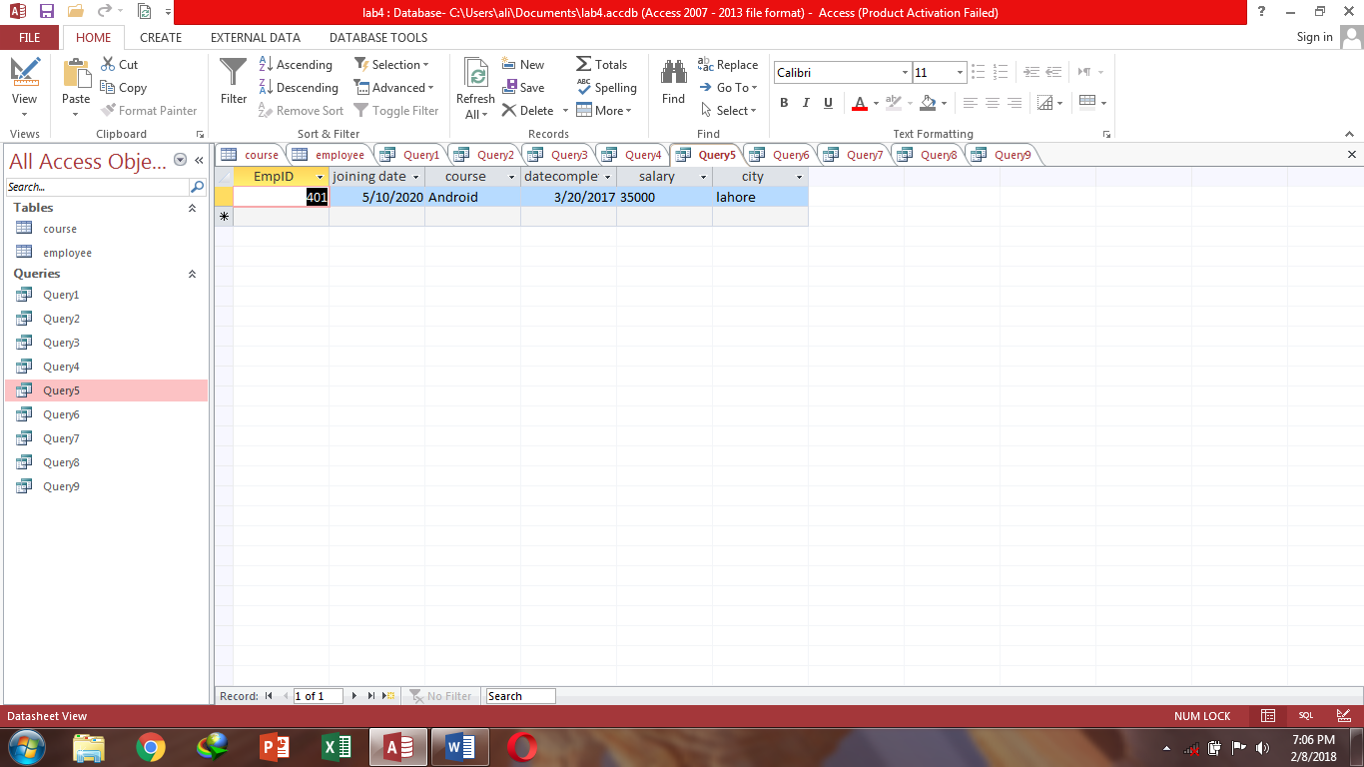

**Sql View:**

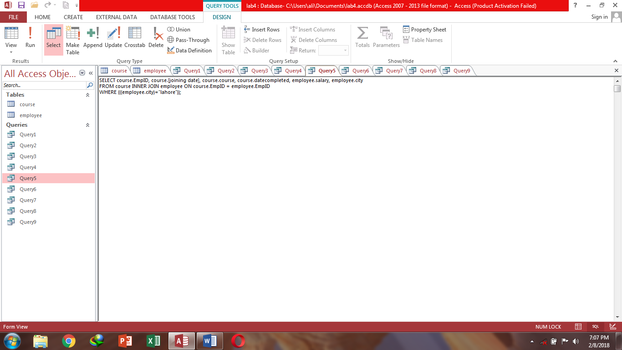

**Design view:**

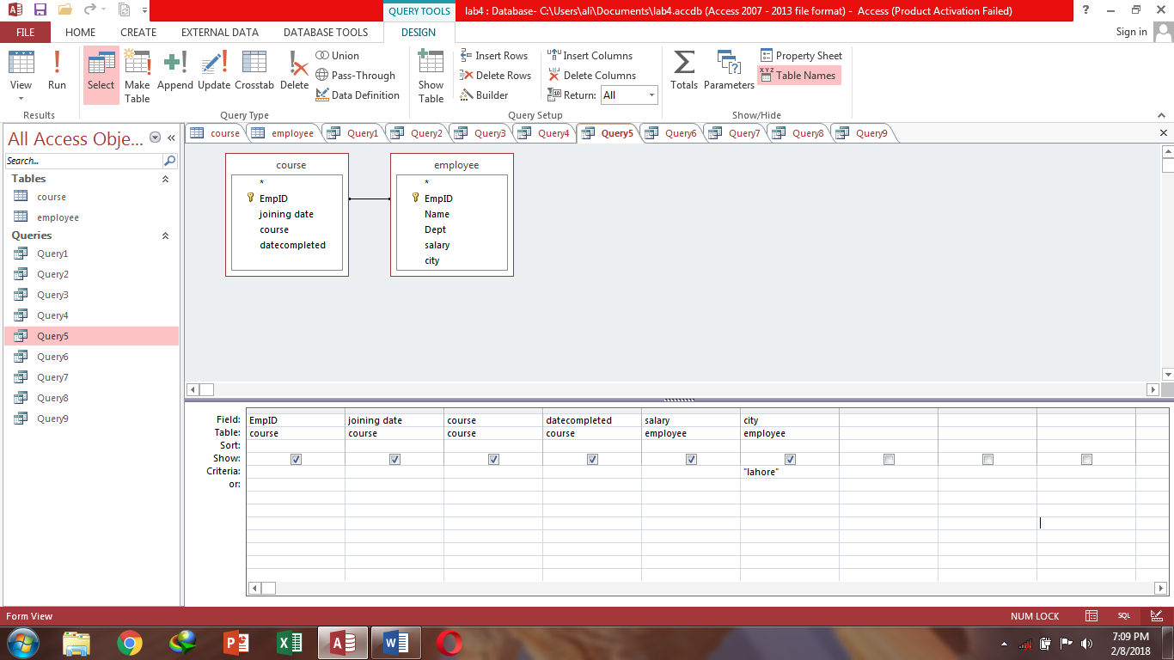

**Query6-** Show employee salary.

**Datasheet view:**

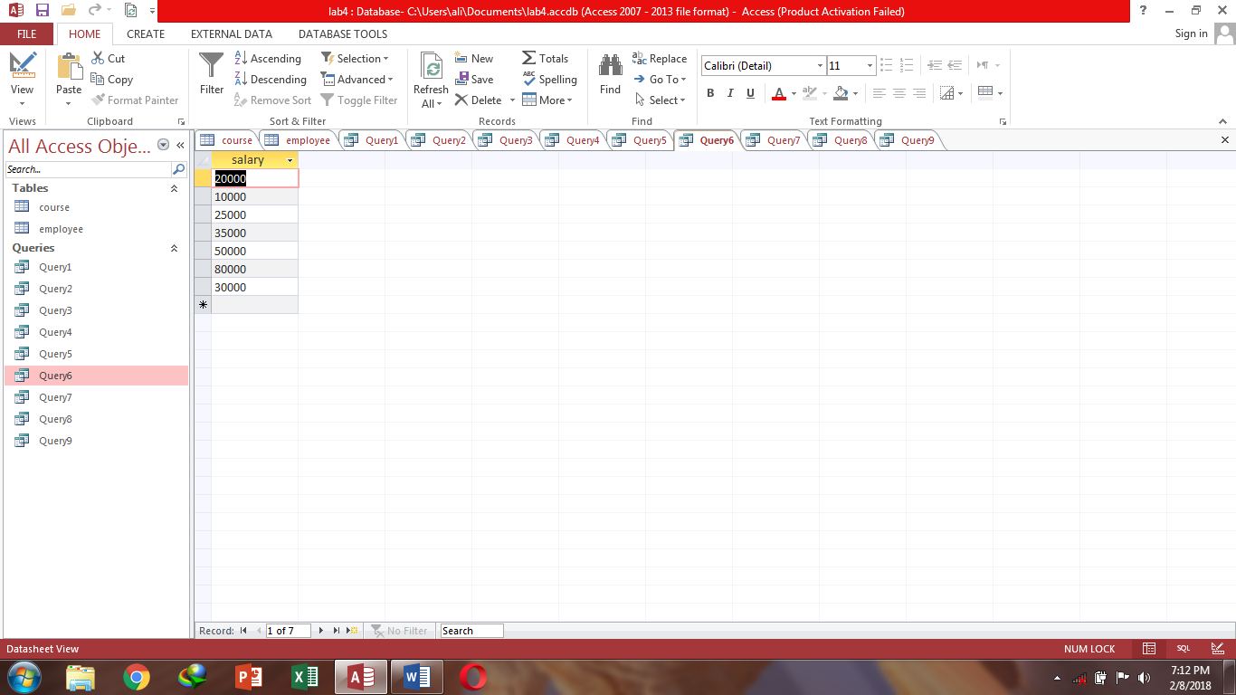

**Sql View:**

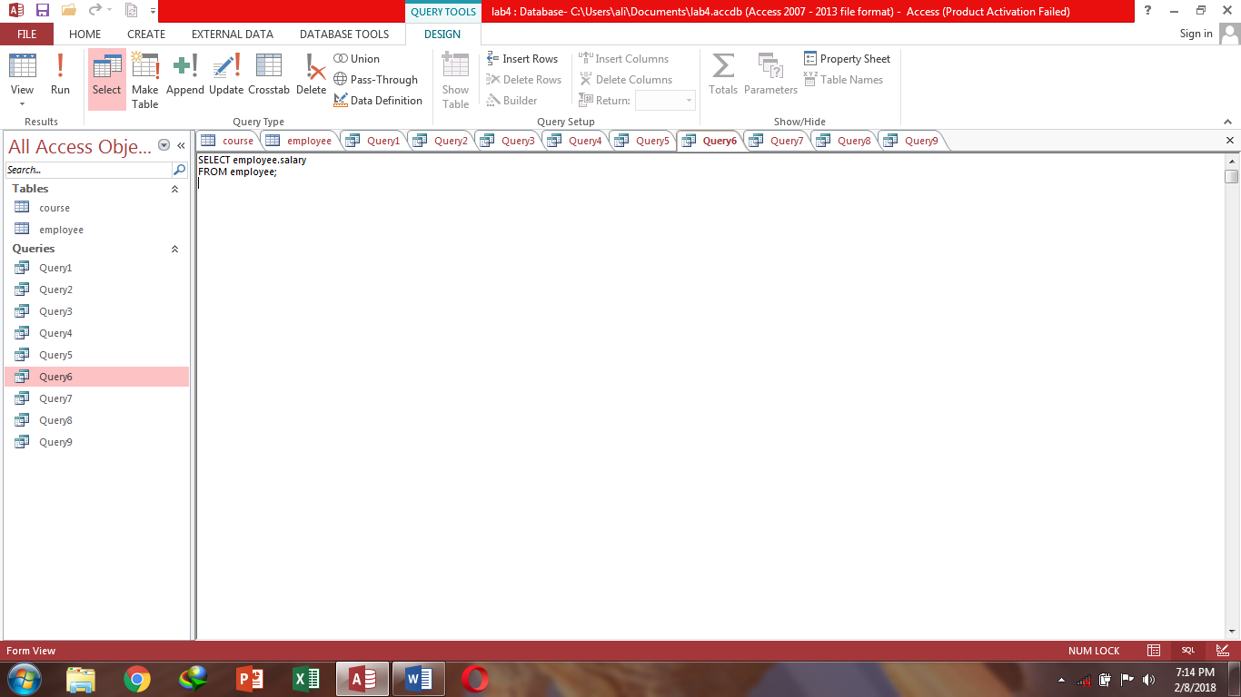

**Design view:**

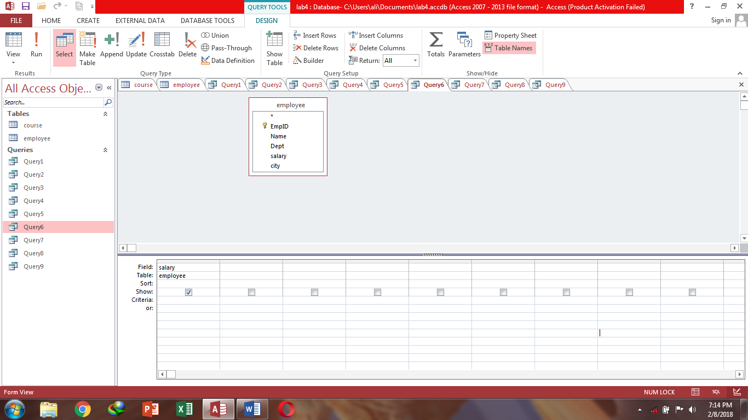

**Query7-**Show employee ID, course ID & employee name.

**Datasheet view:**

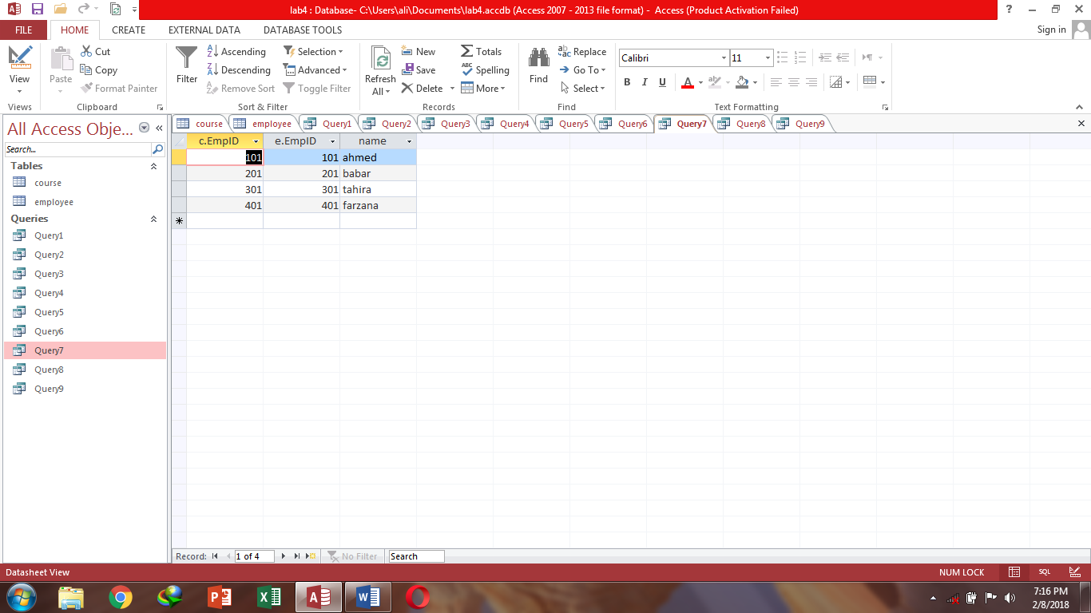

**Sql View:**

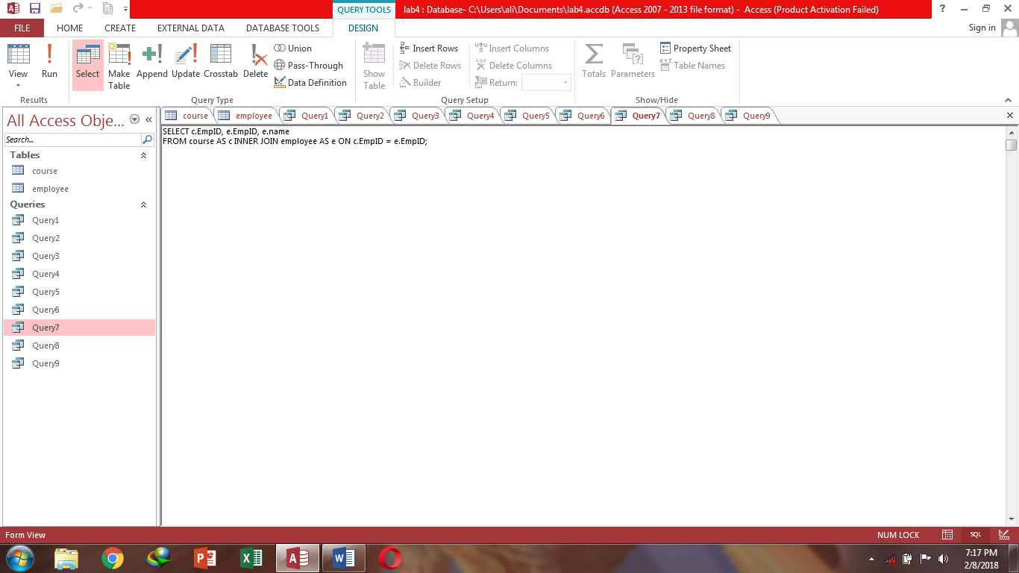

**Design view:**

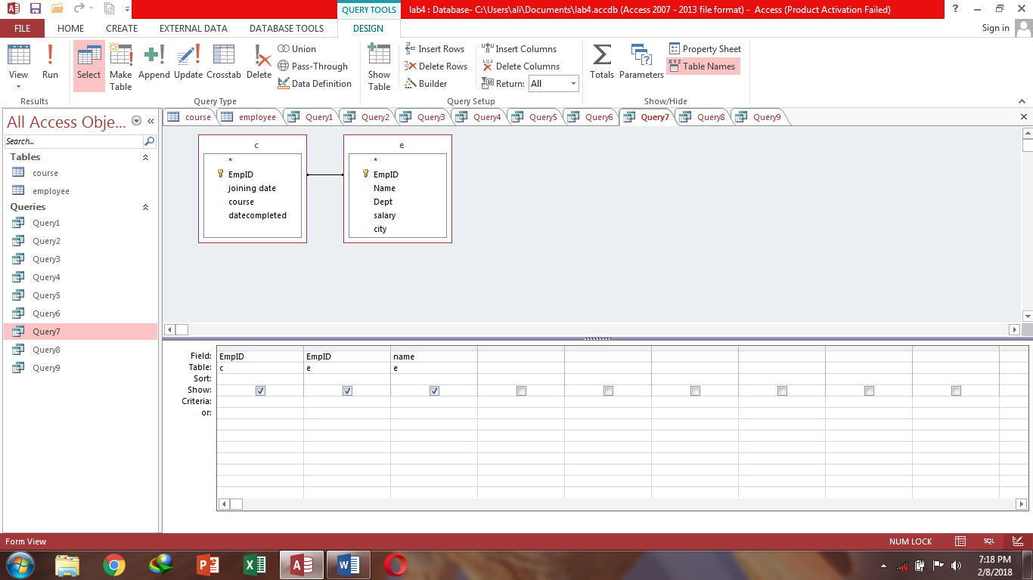

**Query8-** Show average salary of all employees.

**Datasheet view:**

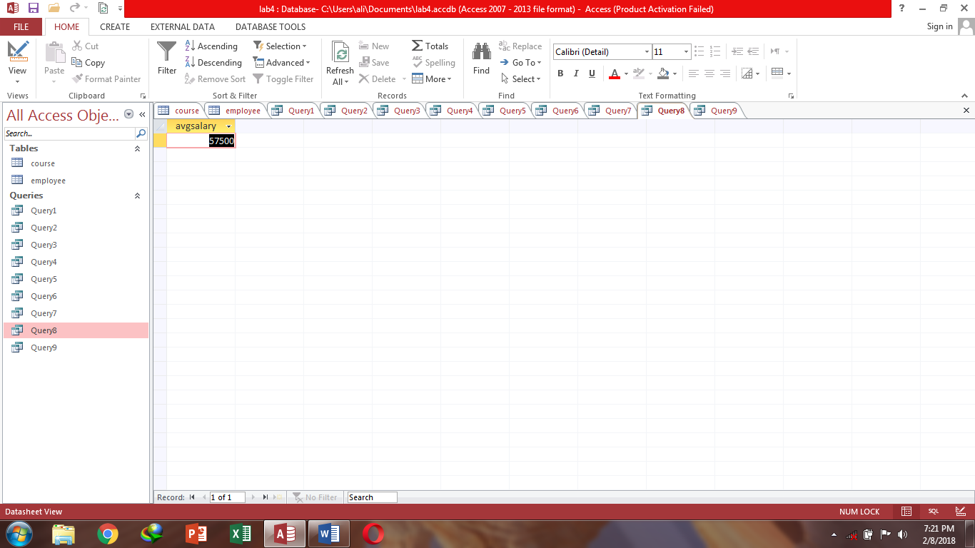

**Sql View:**

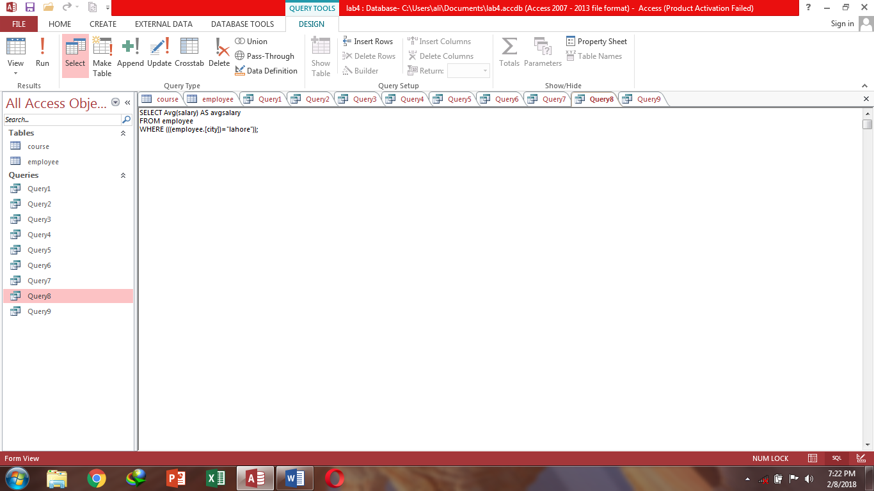

**Design view:**

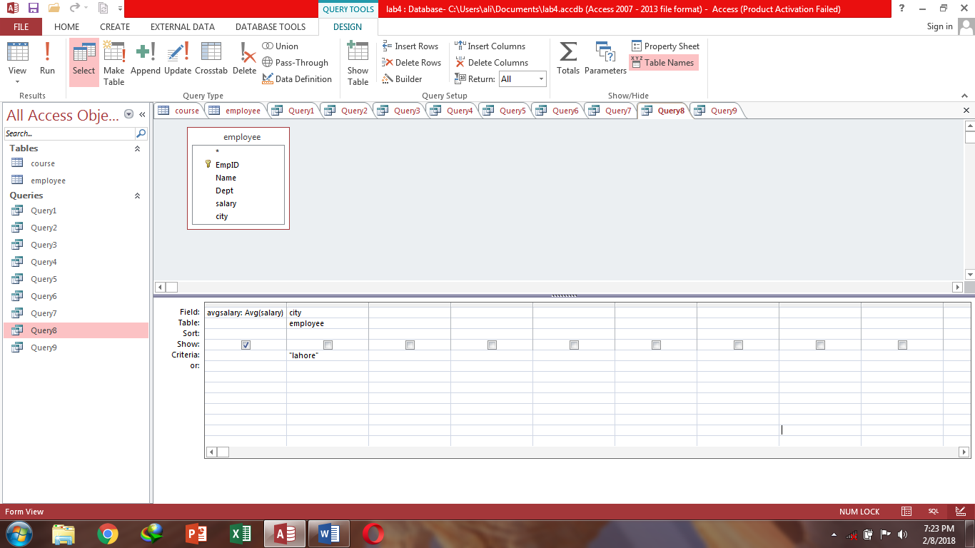

**Query9-** Show all detail of employee where course is accounting.

**Datasheet view:**

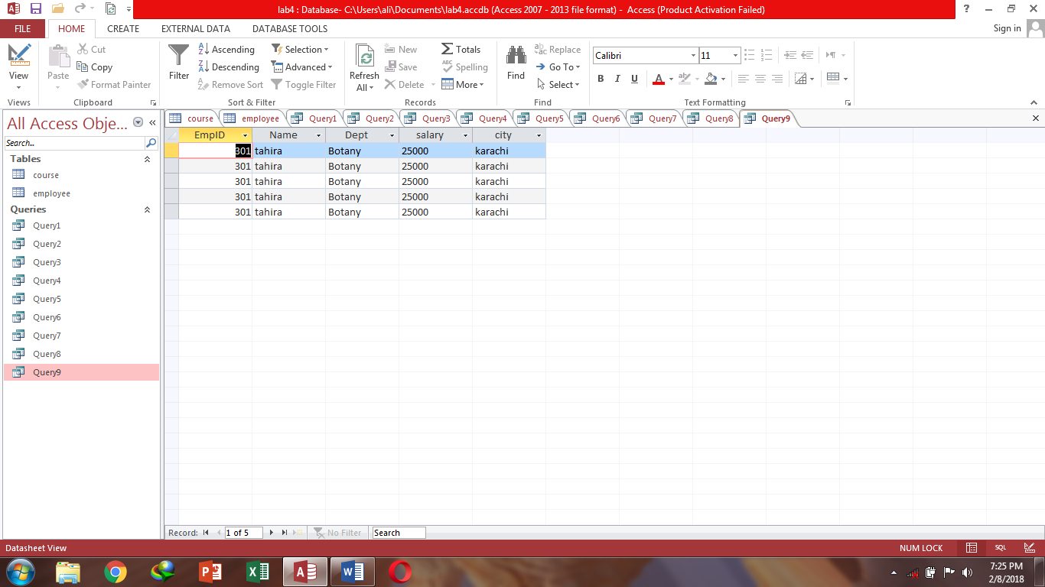

**Sql View:**

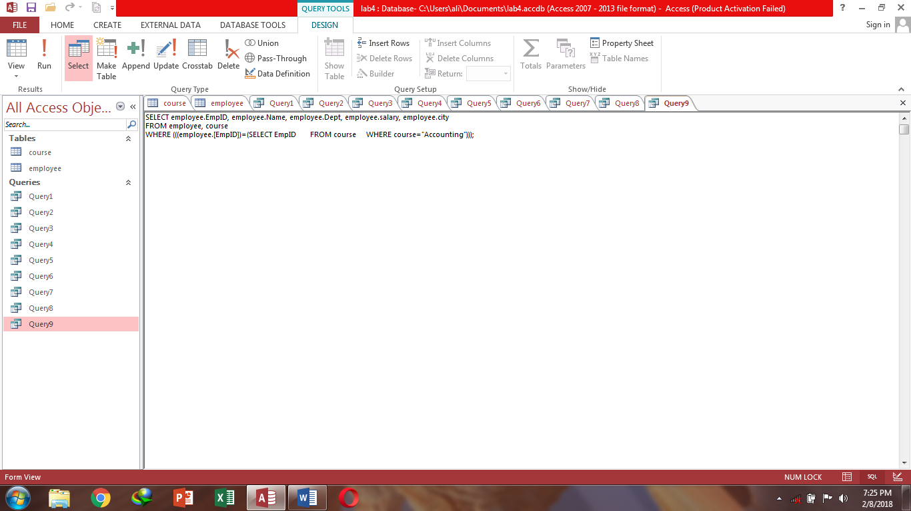

**Design view:**

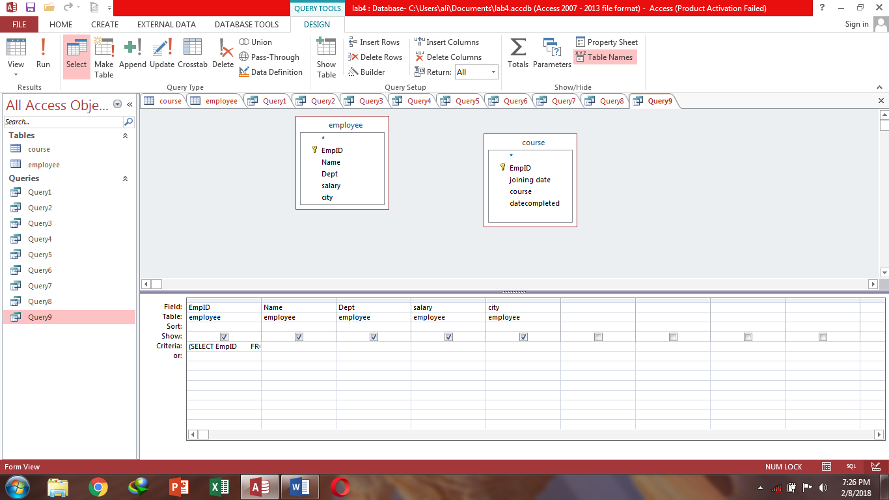

**Task 6:** Hotel management system.

**Tables**

**Table1: Hotel**

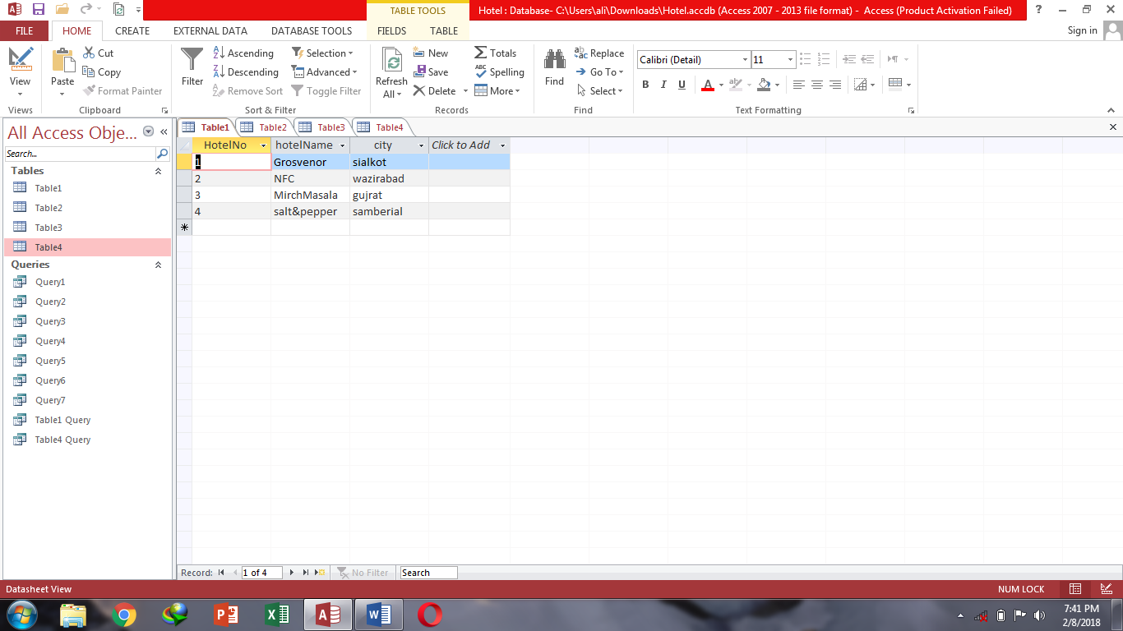

**Table2: Room**

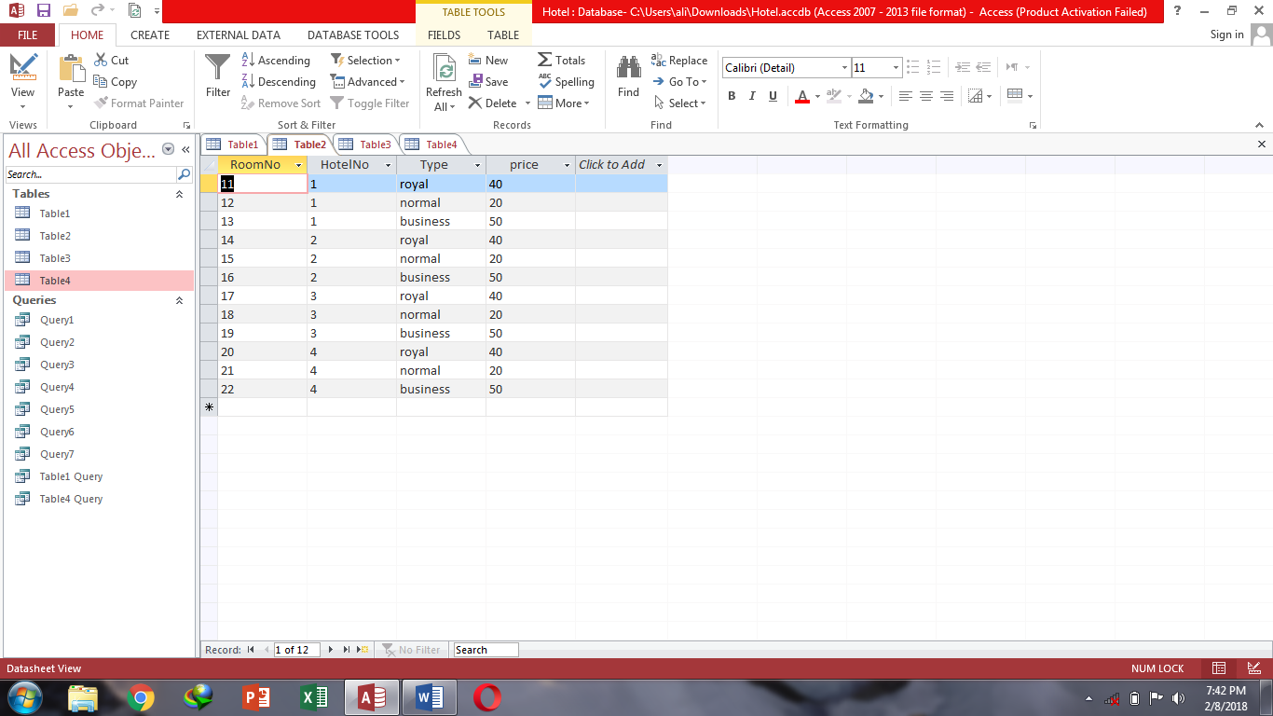

**Table3: Date**

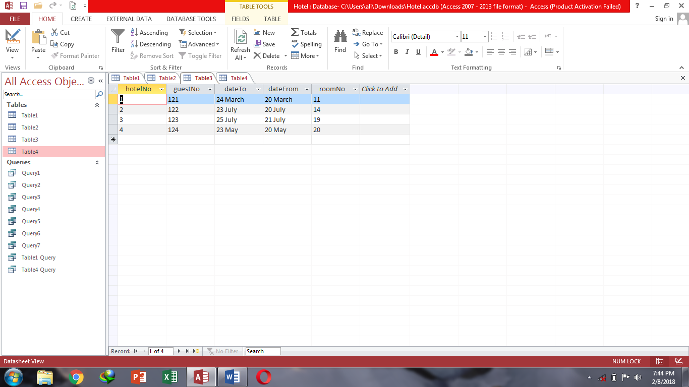

**Table4: Guest**

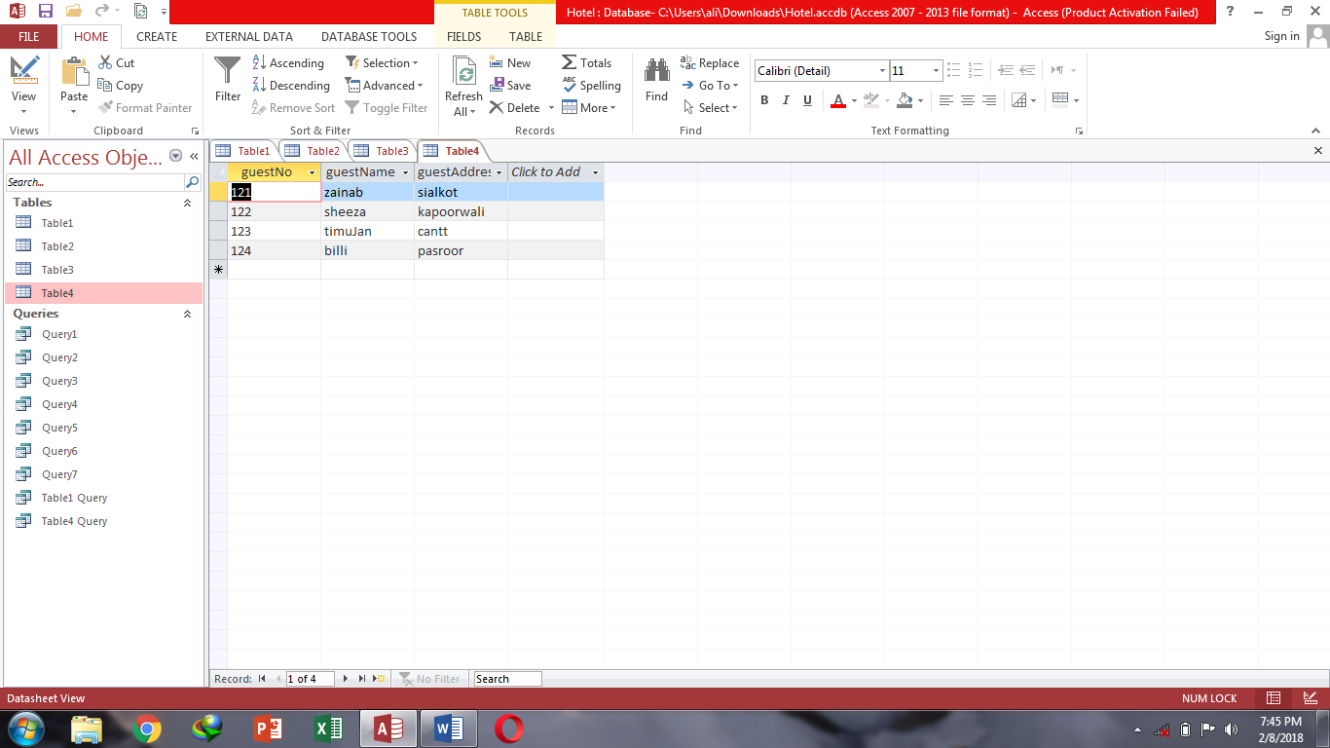

**Queries**

**Query1-** Show from room table room-no, type & price and price is less than and equal to 20.

**Datasheet view**

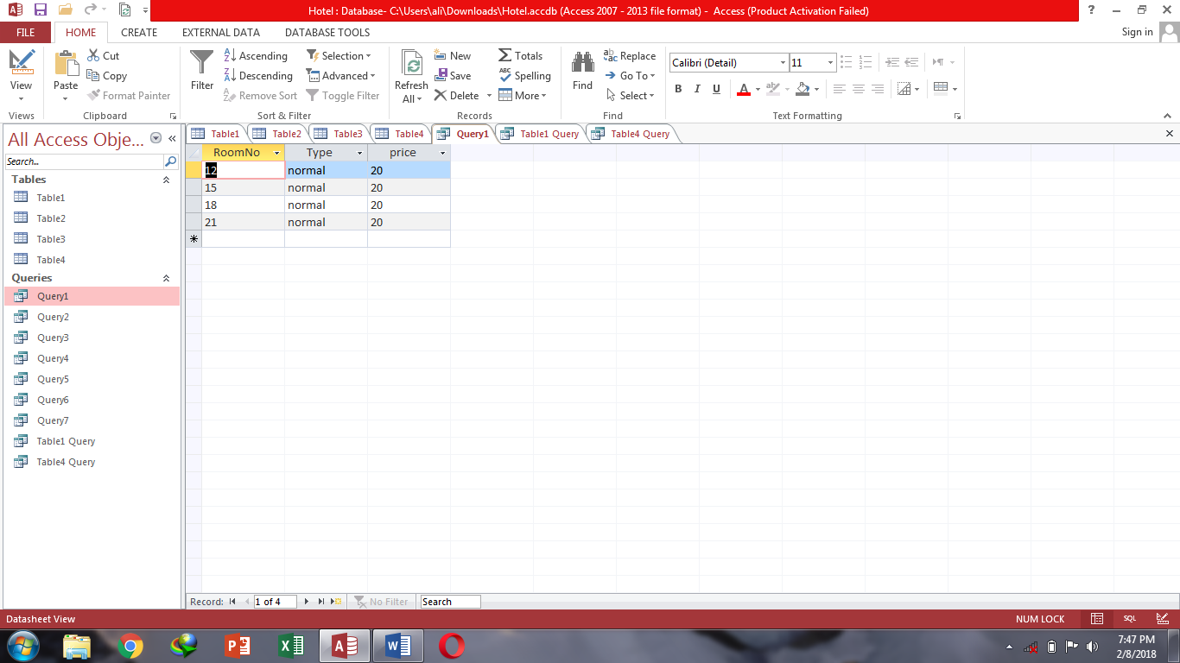

**Sql View:**

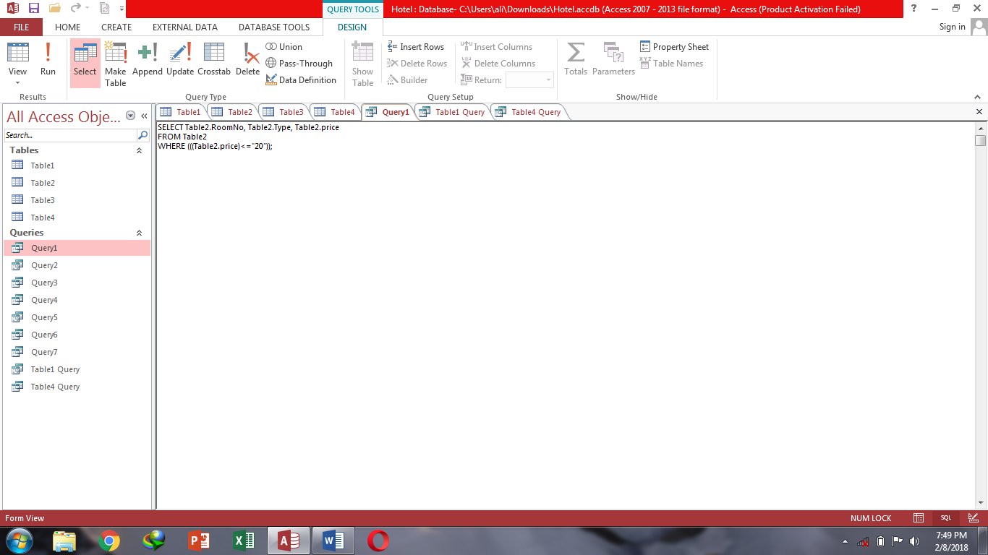

**Design view:**

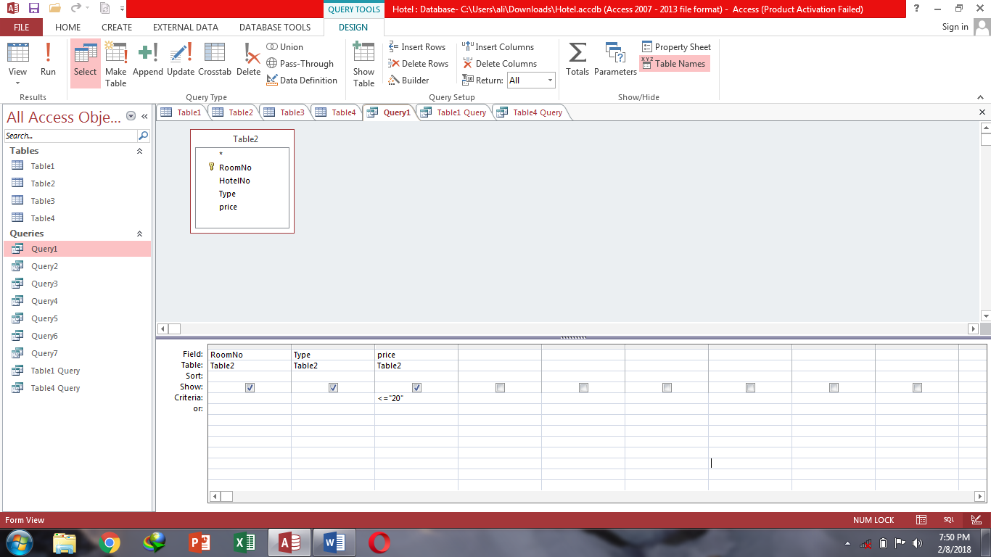

**Query2-**Show guest address and name from guest table.

**Datasheet view:**

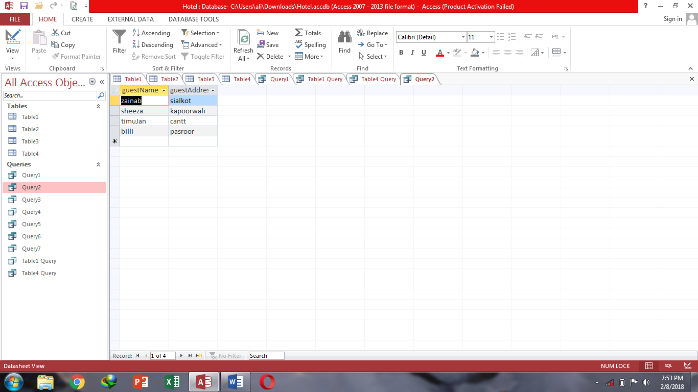

**Sql View:**

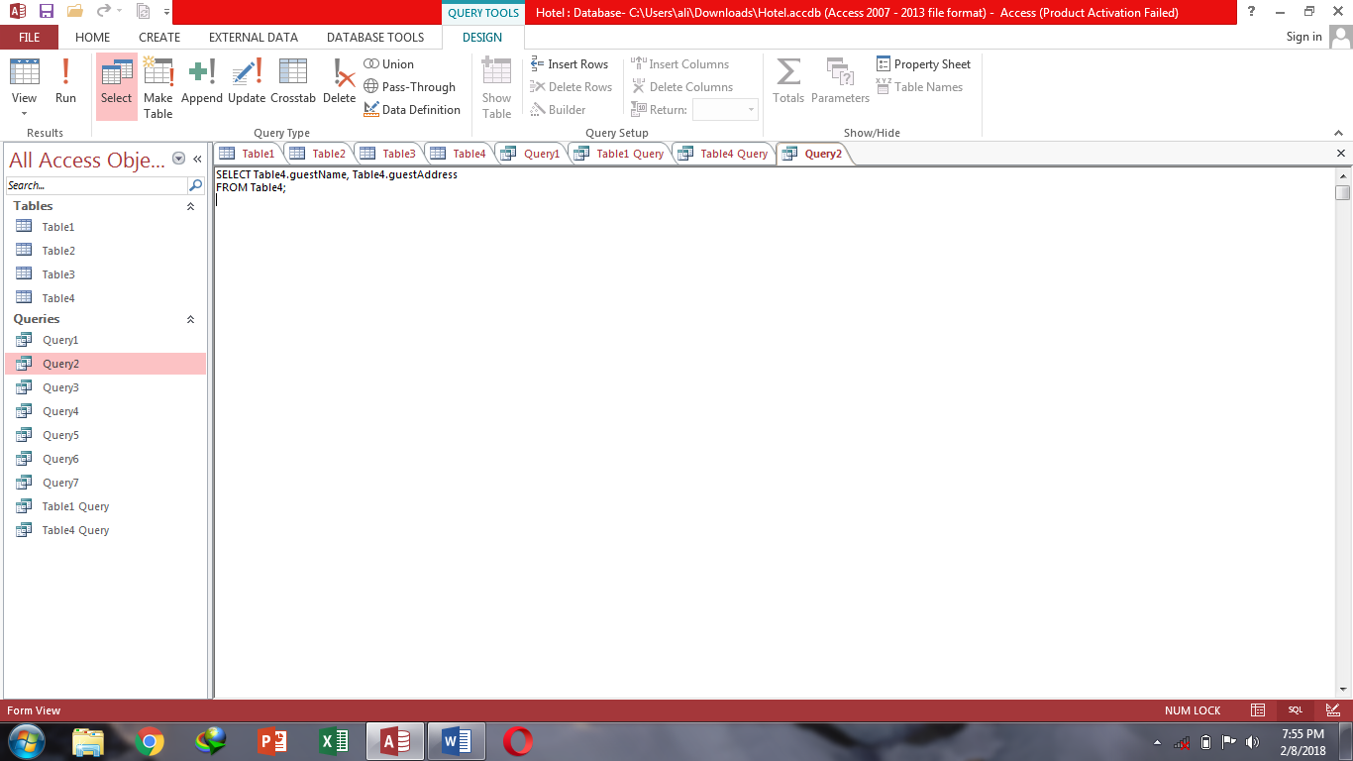

**Design view:**

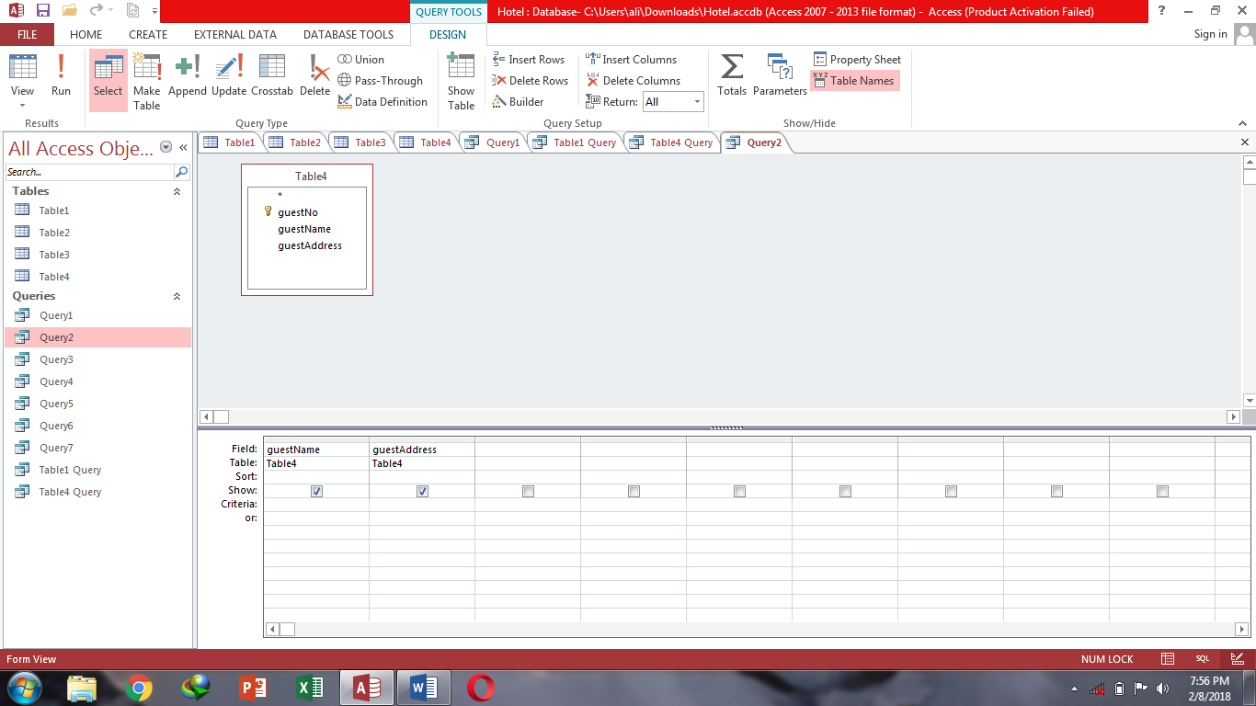

**Query3-**Show type, price & hotel-no of room table and hotel no is equal to 1.

**Datasheet view:**

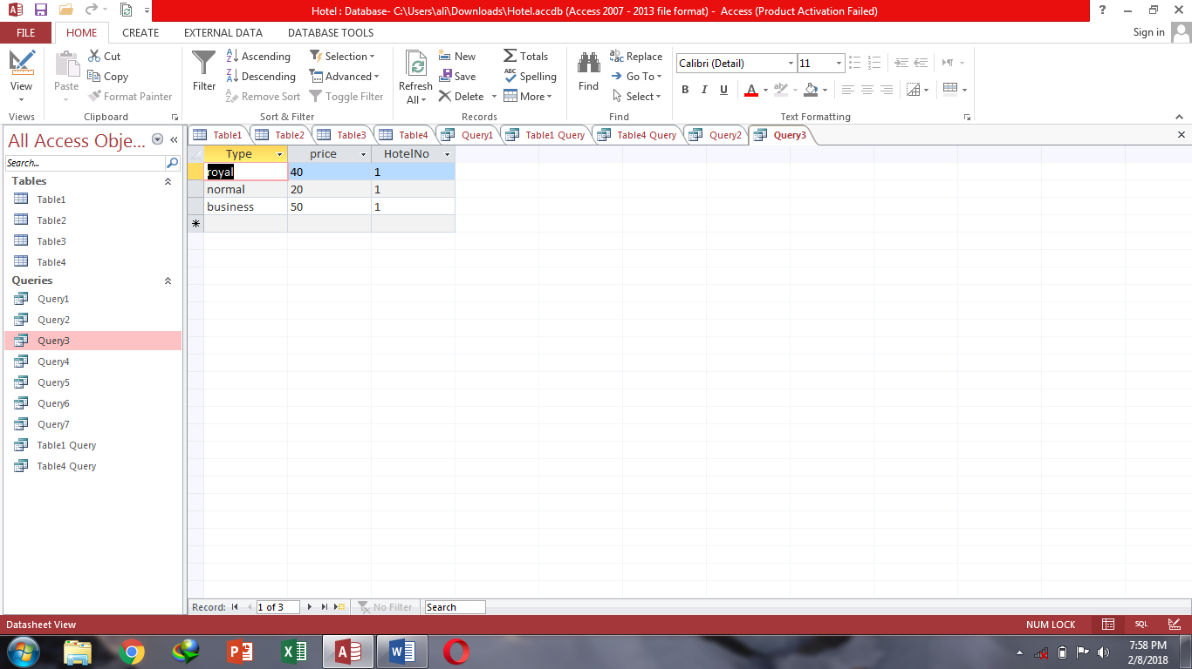

**Sql View:**

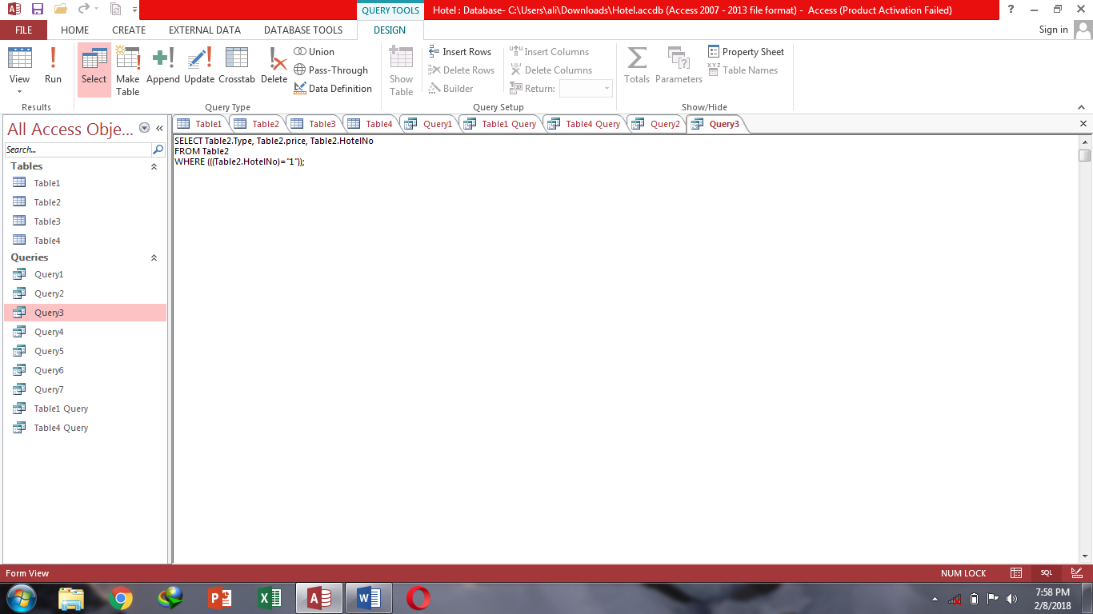

**Design view:**

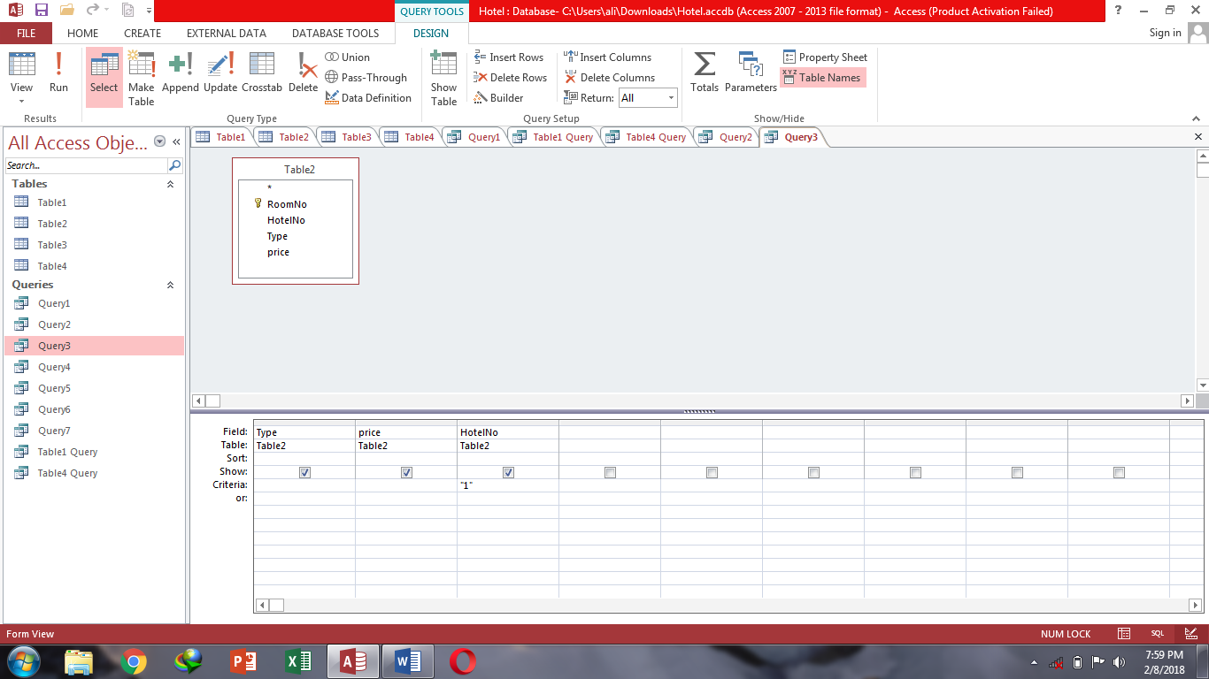

**Query4-**Show guest name from guest table & hotel no, room no, date from and date to from date table where hotel no is equal to 1.

**Datasheet view:**

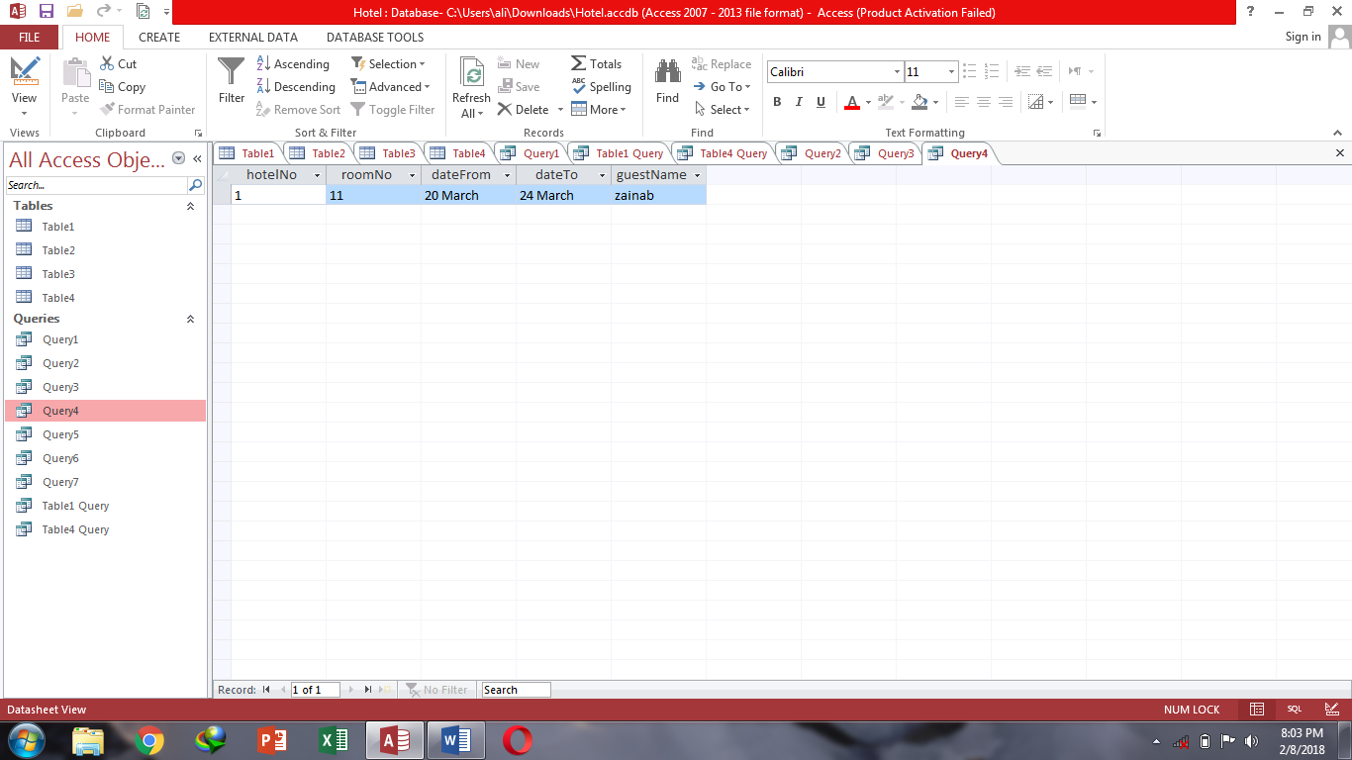

**Sql View:**

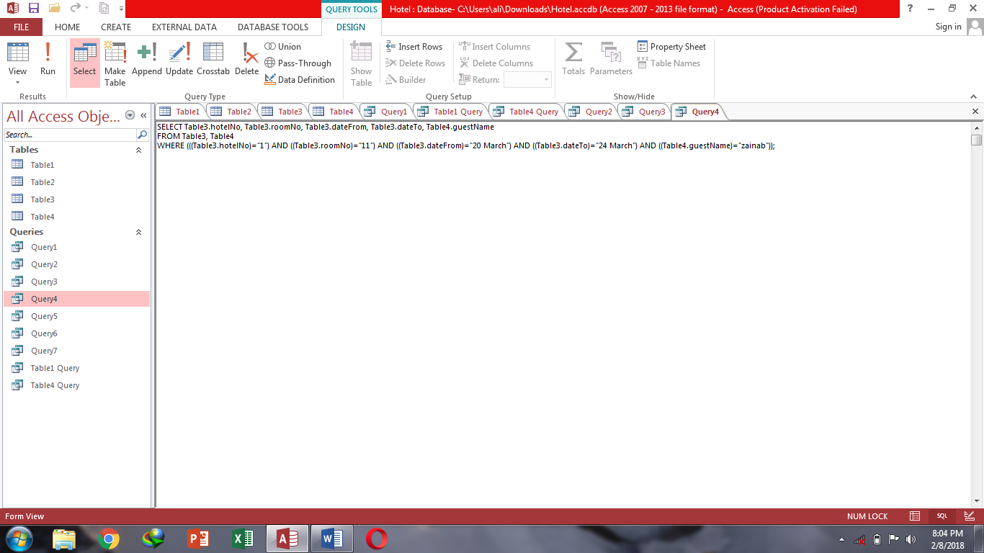

**Design view:**

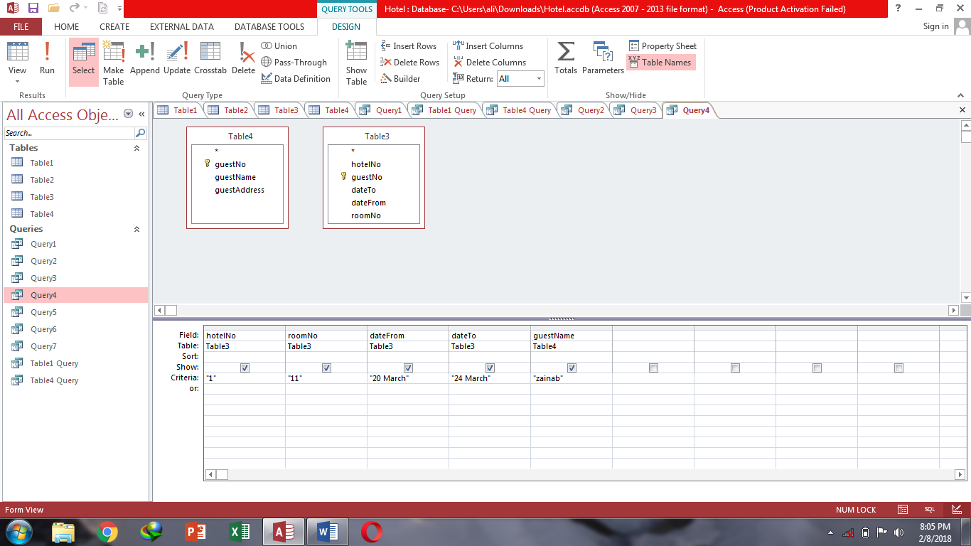

**Query5-**Show hotel no from hotel table & guest no, guest name and guest address from guest table where hotel no is equal to 1.

**Datasheet view:**

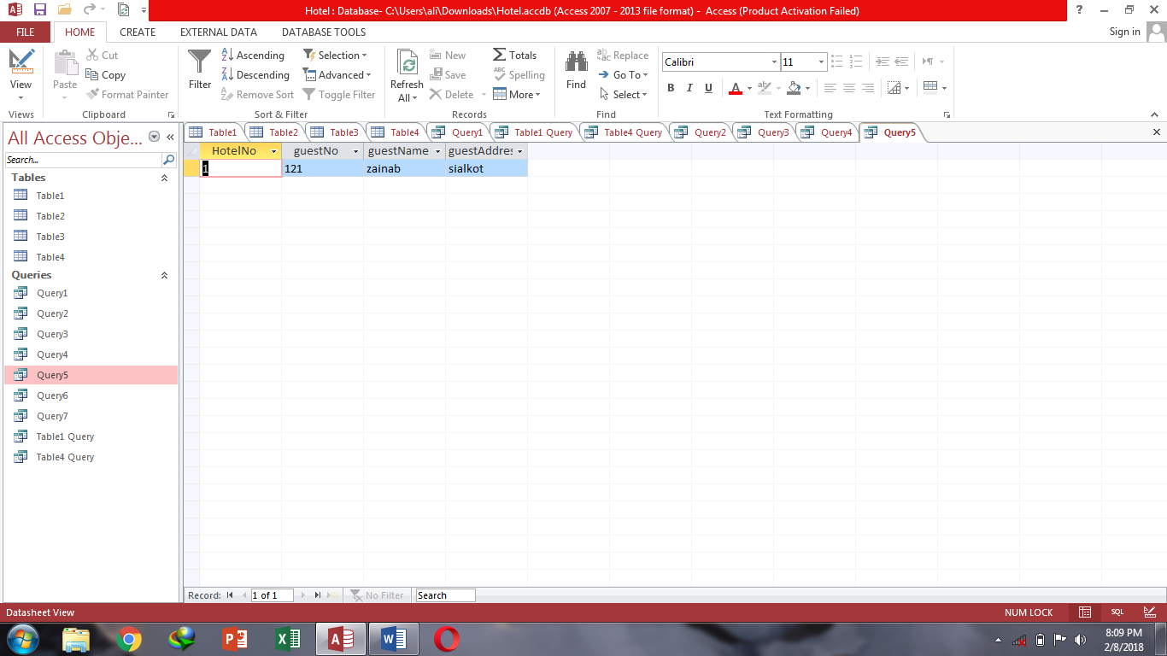

**Sql View:**

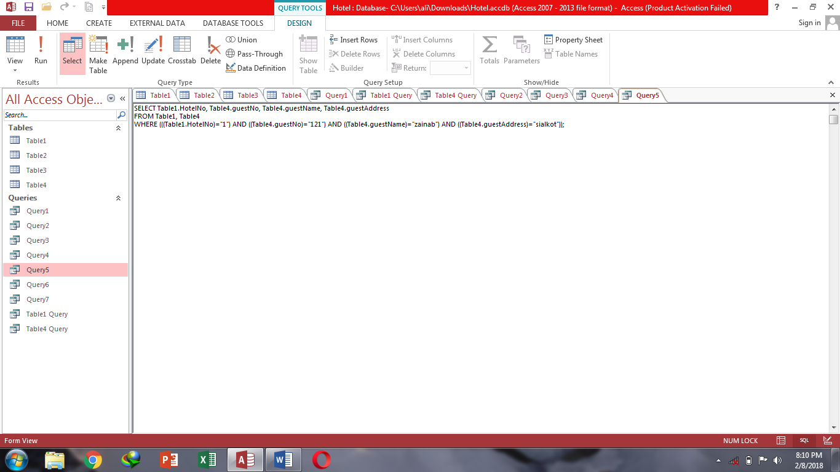

**Design view:**

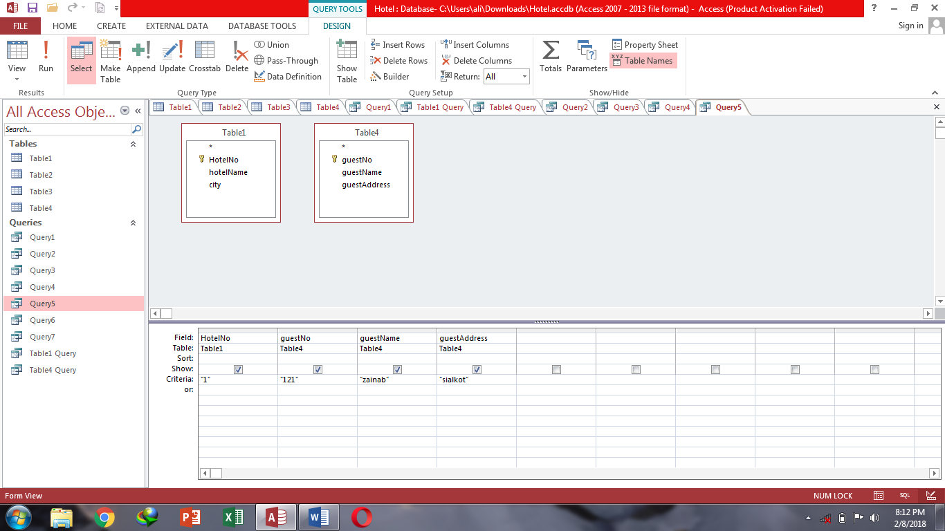

**Query6-**Show hotel no, room no & type from room table where hotel no is 1.

**Datasheet view:**

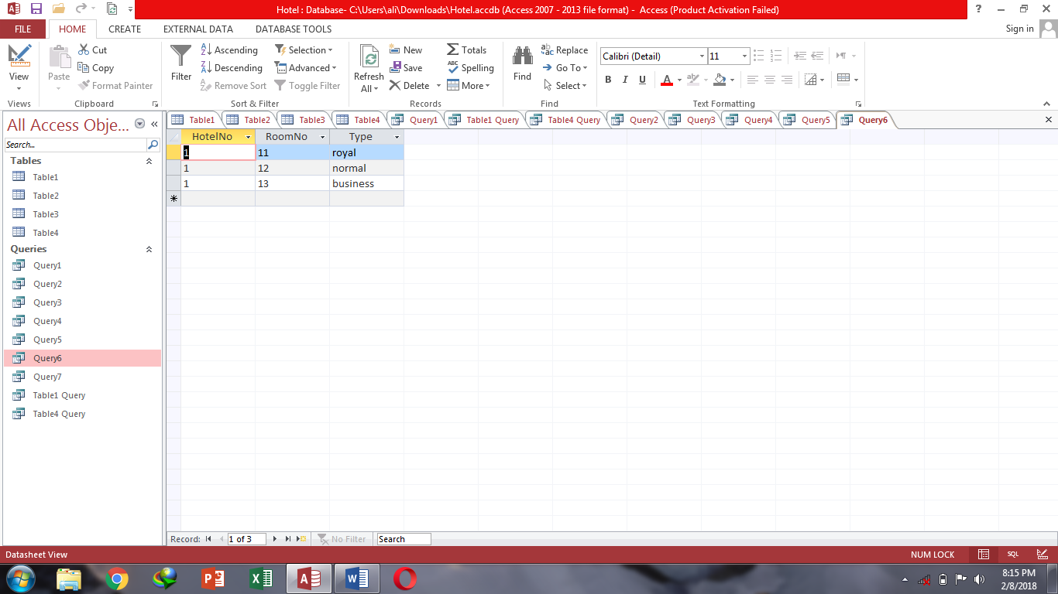

**Sql View:**

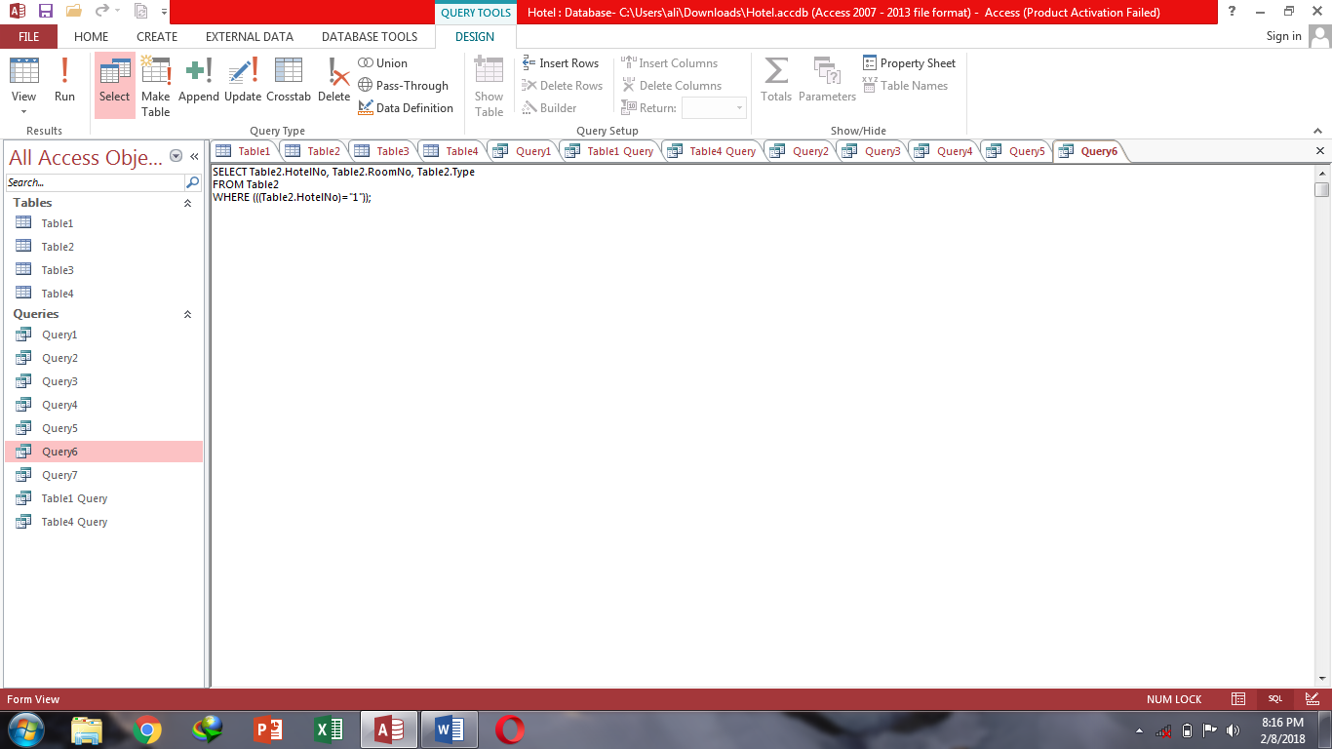

**Design view:**

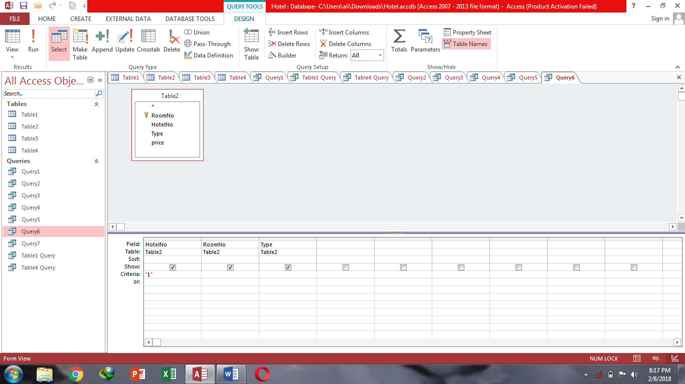

**Query7-**Show all hotel names from hotel table.

**Datasheet view:**

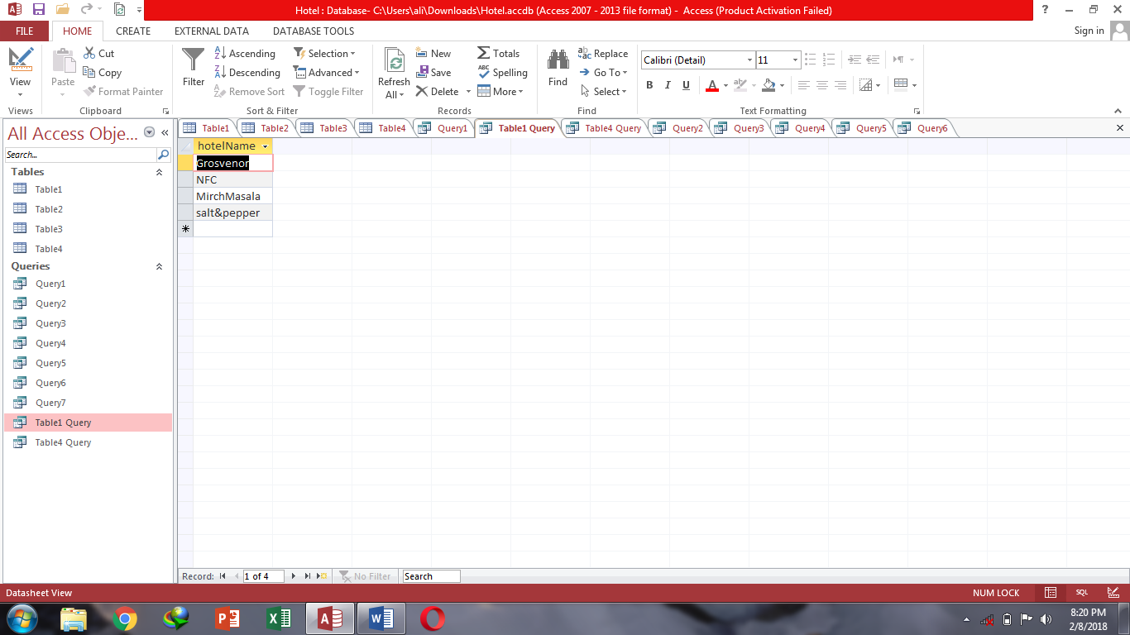

**Sql View:**

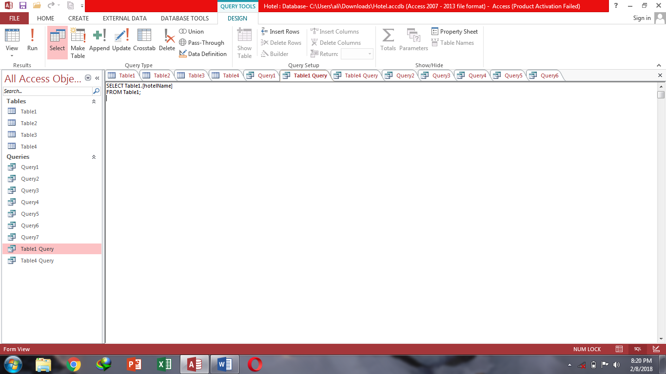

**Design view:**

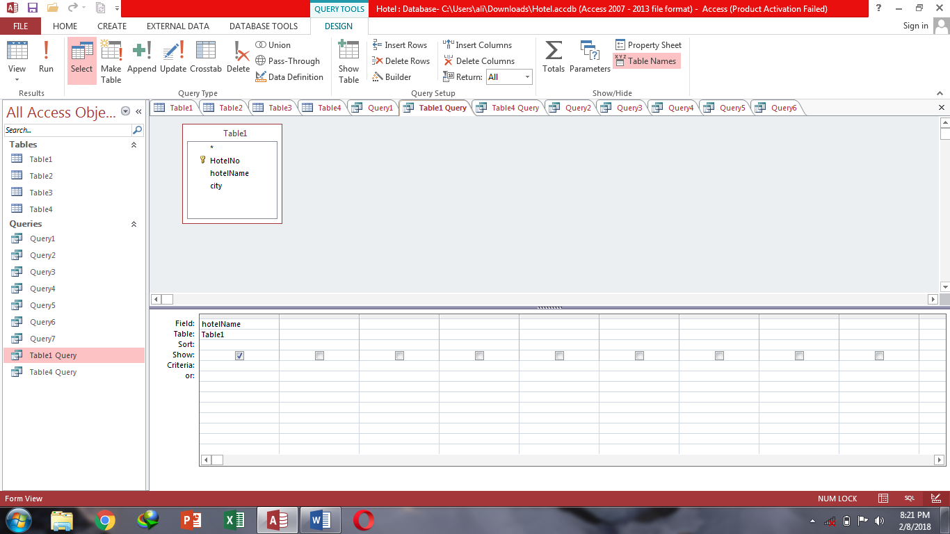

**Query8-**Show guest no, guest name & guest address from guest table.

**Datasheet view:**

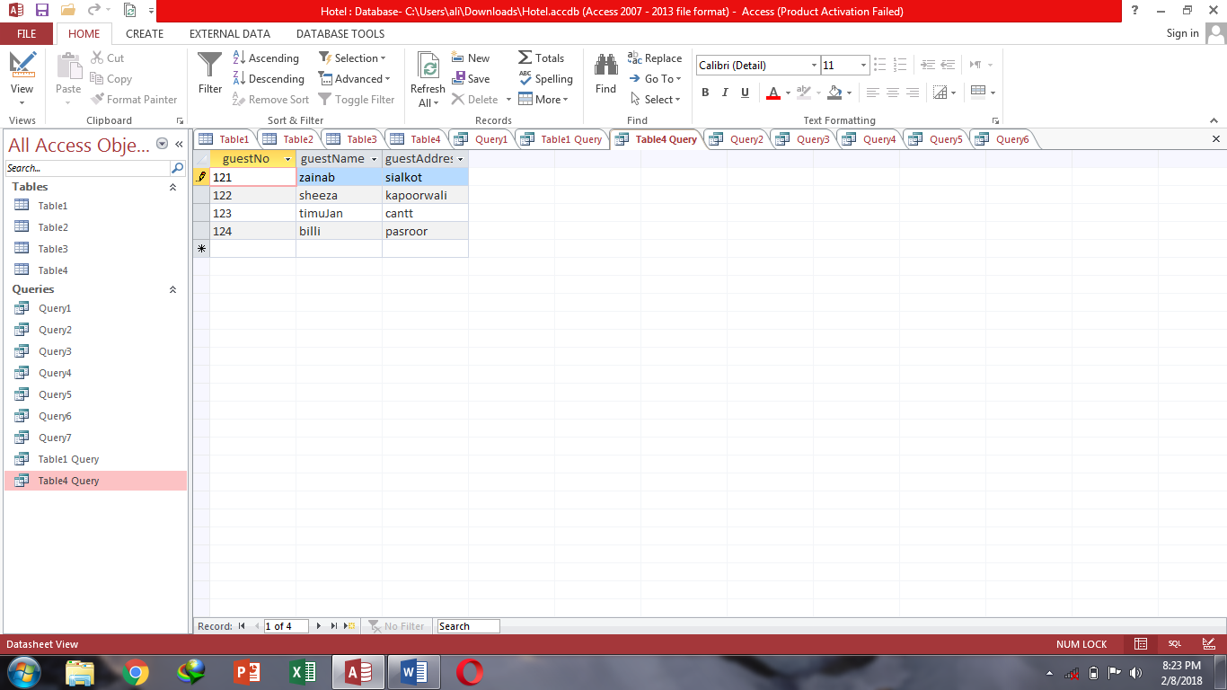

**Sql View:**

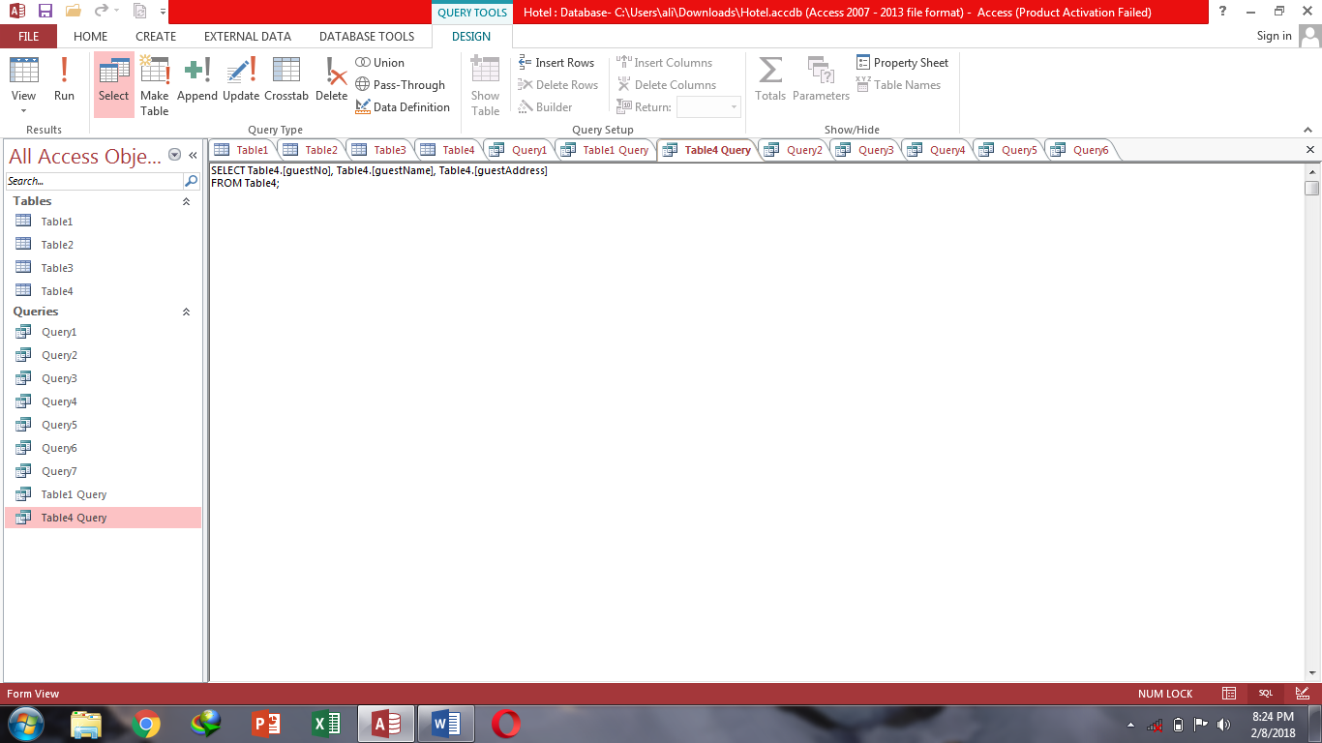

**Design view:**

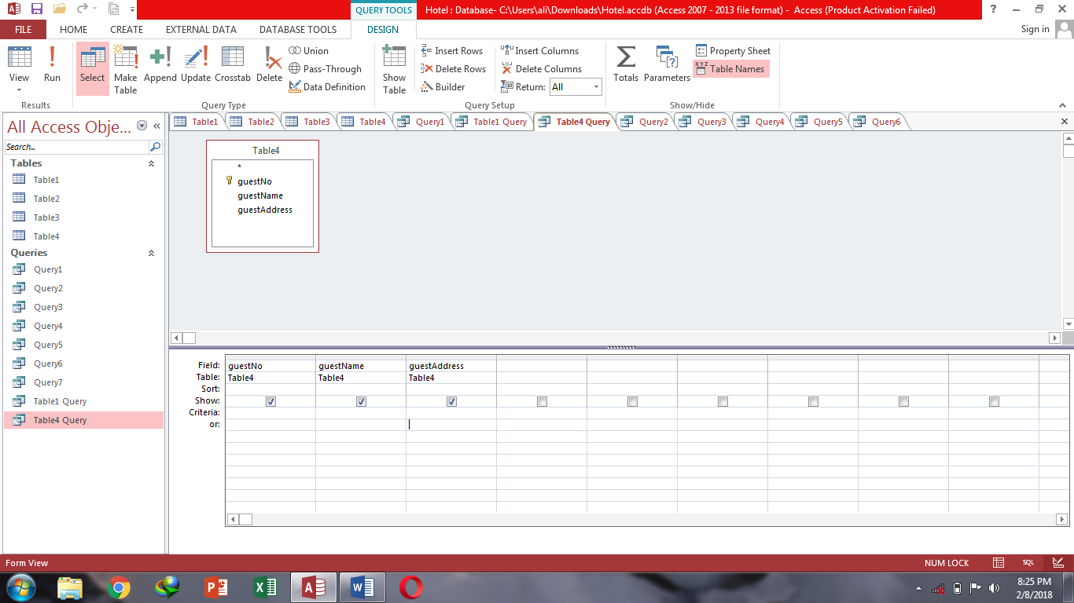

**Task 7:**

Work on SQL server create database concert or releasing song and also apply queries to show data in different ways.

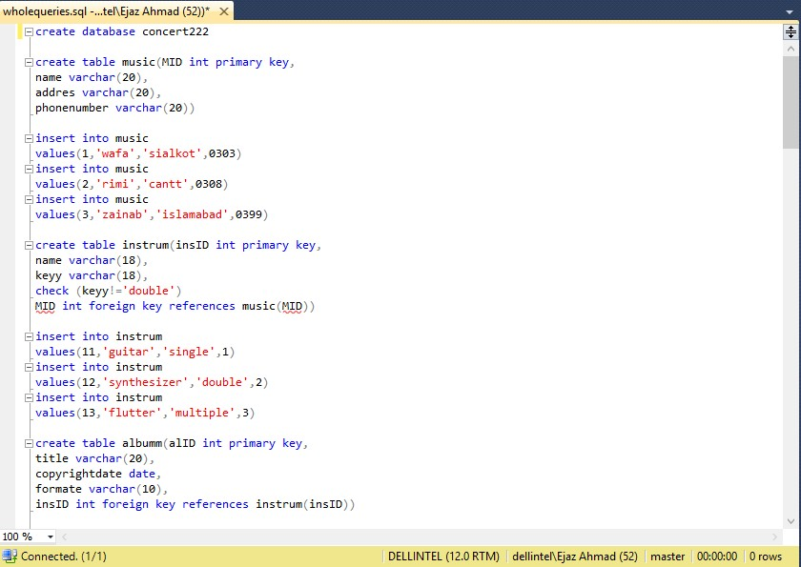

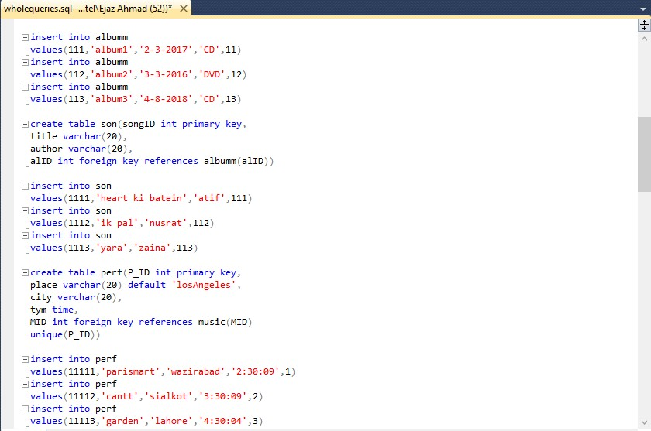

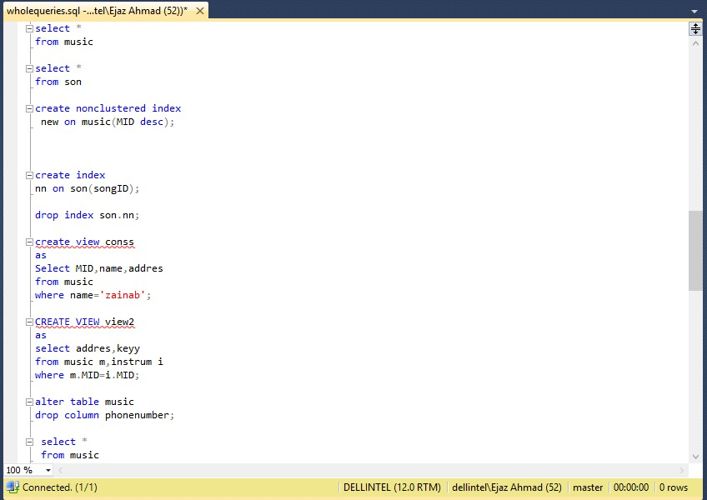

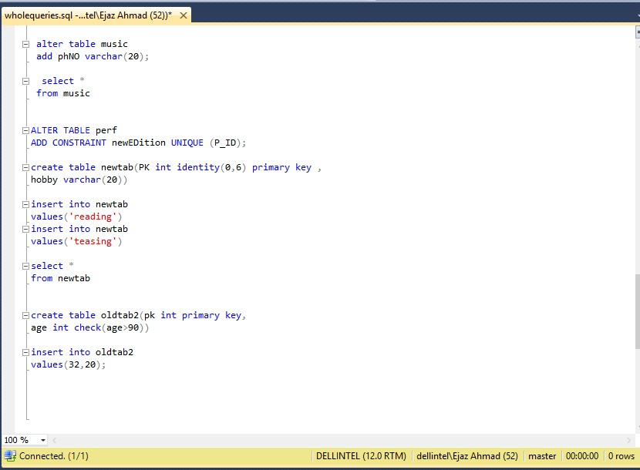

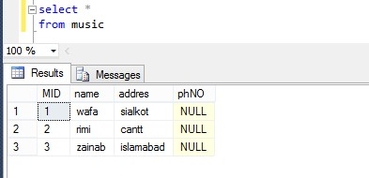

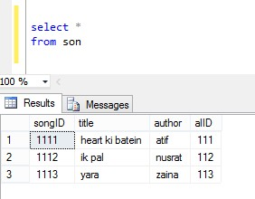

**THE END**